**SPRING BOOT**

**Spring Boot:**

Spring Boot is spring based framework.

It behave even parent project for every project we create in spring boot.

That reduces common work done project by developers like Database connection, Security Implementation (Login/Logout), Email Configuration, Message Queues, Cache, Pooling etc..,

* Our project is child project.
* We can create our project using Maven/Gradle Tool.
* Spring Boot provided by Team :Pivotal
* Spring Boot reduces programmer work, by providing

1. class files
2. Configuration code
3. jars
4. runtime environments(servers, dbs, plugins…etc)

**Spring Vs Spring Boot**

Small concept [ Database connection ]

**\*\* Spring Code \*\***

**[XML Configuration] => Legacy style**

<bean id=”dsObj” class =” org.sf….DriverManagerDataSource”>

<property name=”driverClassName” value=”oracle.jdbc.driver.OracleDriver”/>

<property name=”url” value=”jdbc:oracle:thin:@localhost:1521:xer”/>

<property name=”system” value=”system”/>

<property name=”password” value=”vine”/>

</bean>

We need add jars (dependencies)

**Maven:**

<!-- https://mvnrepository.com/artifact/org.springframework/spring-context -->

<dependency>

<groupId>org.springframework</groupId>

<artifactId>spring-context</artifactId>

<version>6.1.1</version>

</dependency>

<!-- https://mvnrepository.com/artifact/org.springframework/spring-jdbc -->

<dependency>

<groupId>org.springframework</groupId>

<artifactId>spring-jdbc</artifactId>

<version>6.1.1</version>

</dependency>

<!-- https://mvnrepository.com/artifact/ojdbc/ojdbc -->

<dependency>

<groupId>ojdbc</groupId>

<artifactId>ojdbc</artifactId>

<version>14</version>

</dependency>

**Gradle:**

// https://mvnrepository.com/artifact/org.springframework/spring-context

implementation group: 'org.springframework', name: 'spring-context', version: '6.1.1'

// https://mvnrepository.com/artifact/org.springframework/spring-jdbc

implementation group: 'org.springframework', name: 'spring-jdbc', version: '6.1.1'

// https://mvnrepository.com/artifact/ojdbc/ojdbc

implementation group: 'ojdbc', name: 'ojdbc', version: '14'

**[JAVA Configuration] =>new style**

@Configuration

public class AppConfig

{

@Bean

Public DriverManagerDataSource dsObj()

{

DiverManagerDataSource ds=new DiverManagerDataSource()

ds.setDiverClassName(“oracle.jdbc.driver.OracleDriver”);

ds.setUrl(“jdbc:oracle:thin:@localhost:1521:xe”);

ds.setUsername(“system”);

ds.setPassword(“vine”);

return ds;

}

}

**\*\* Spring Boot \*\***

Here, Database connection is handled using Spring Boot Parent Project using AutoConfiguration.

We have to create child project

* **Child Project:**

Add Spring JDBC Starter. [Starter indicates Readymade code as JAR File]

**Maven:**

<dependency>

<groupId>org.springframework.boot</groupId>

<artifactId>spring-boot-starter-jdbc</artifactId>

</dependency>

**Gradle:**

implementation group: 'org.springframework.boot', name: 'spring-boot-starter-jdbc', version: '3.2.0'

* Programmer must pass below file with inputs (key - val).

to write db details with Spring Boot AutoCofiguration we have file called application.properties

* application.properties (Autoloaded)

spring.datasource.driver-class-name=oracle.jdbc.driver.OracleDriver

spring.datasource.url=jdbc:oracle:thin:@localhost:1521:xe

spring.datasource.username=system

spring.datasource.password=vine

* application.yml

spring:

datasource:

driver-class-name:oracle.jdbc.driver.OracleDriver

url: jdbc:oracle:thin:@localhost:1521:xe

username:system

password:vine

* **AutoConfiguration:**

Providing common code/classes/setup/jars by parent project.

This is implemented using Starters [Readymade jar files]

spring-boot-starter-* [ * means not all, we have to provide a name ]

Ex:

spring-boot-starter-data-jpa

spring-boot-starter-web

spring-boot-starter-test

spring-boot-starter-security

spring-boot-starter-webflux

…etc

**Spring Boot Application : Types of Files**

* There will be 3 file for every Spring Boot Application.

1. class (Starter class / Main class / Execution class)
2. Input File (application.xml / application.yml)
3. Build Information (pom.xml / build.gradle)

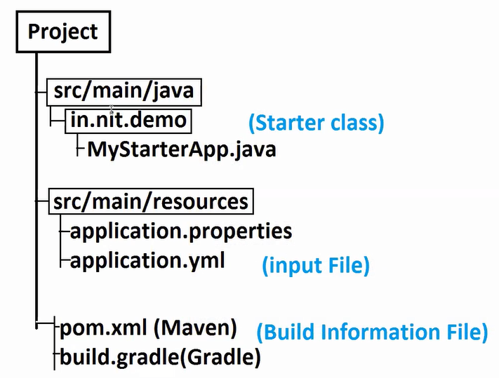

1. **Starter Class**

* This is entry point for application execution.
* It is a simple main method with Spring boot code.
* This code is generated while creating applicatiom
* Sample code looks like:

@SpringBootApplication

public class DemoApp{

public static void main(String[] args) {

SpringApplication.run(DemoApp.class, args);

}

}

* Starter class take care of **‘Spring Contaier’**

Spring Container?

1. Detect/Find your classes
2. Creating Object to your classes
3. Providing data to objects
4. Link one Object with another Object
5. Finally (While Stopping) Destroy the objects.
6. **Input File: application.properties / application.yml**

Spring Boot provides code for configuration.

spring-boot-starter-jbdc (JAR)

* application.properties (Autoloaded)

spring.datasource.driver-class-name=oracle.jdbc.driver.OracleDriver

spring.datasource.url=jdbc:oracle:thin:@localhost:1521:xe

spring.datasource.username=system

spring.datasource.password=vine

* application.yml ----(faster, less code, no duplicate)

spring:

datasource:

driver-class-name:oracle.jdbc.driver.OracleDriver

url: jdbc:oracle:thin:@localhost:1521:xe

username:system

password:vine

spring-boot-starter-mail

* application.properties

spring.mail.host=smtp.gmail.com

spring.mail.port=5678

spring.mail.username=vineeth@gmail.com

spring.mail.password=12345

* application.yml

spring:

mail:

host: smtp.gmail.com

port: 5678

username:vineeth@gmail.com

password: 12345

1. **Build Information:**

* Parent Project Details
* Your Project Details
* Version details (JDK, Cloud version, Admin version)
* Dependencies (starters / jars)
* Build Pulgins (Compiler, your code 🡪 jar/war).

**Spring Container (2 types)**

1. **Legacy Container (BeanFactory-I):**

* XML Configuration

**Impl class:** XmBeanFactory(C)

1. **New Container (ApplicationContext-I)**

* XML Config, Java Config and AnnotationConfig

ClassPathXmlApplicationContext (C)

AnnotationConfigApplicationContext(C)

…etc

**Distributed Applications:**

An application that runs in many devices

Ex: Bank Application

1. Net Banking/Web App
2. Manual Process
3. Mobile Application(SBI YONO APP)
4. Payment Integrations

Google Pay, Phone Pe (UPIs)

1. ATMs
2. IVR

Distributed Applications are implemented as client App [FrontEndApps] and Server App[BackEnd App].

Application Logics (Business Code) exist in backend application.

Spring Boot supports developing backend application using Layers Design.

We have 3 layers

DAL - Data Access Layer – DB Operations (insert, delete, update and select)

SL - Service Layer – Calculations/Operations, Logics, Transaction Managemet.

IL - Request processing Logic. (Read Http Request/Provide Http Response)

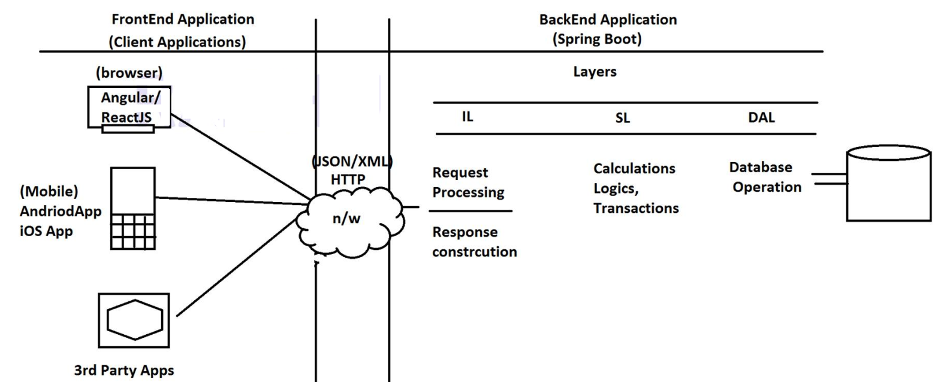

* Client Application interact with Server/Backend apps using HTTP Protocol and data in JSON/XML Format.

JSON - JavaScript Object Notation (Object in JavaScript)

XML - eXtensible Markup Language.

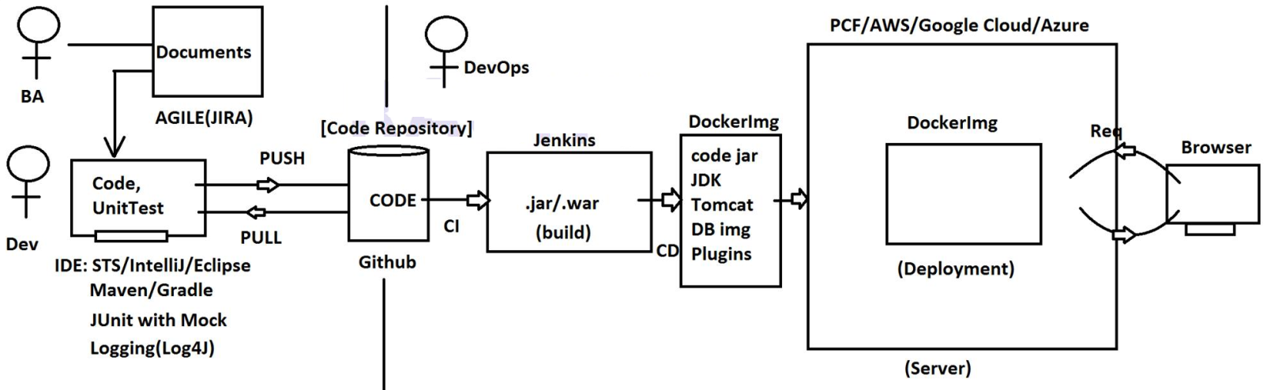

Is JDK software is for all OS?

Windows - JDK windows based

Linus - JDK Linux based

Mac - JDK Mac based

* Softwares are OS Depndent

JDK, Tomcat, DataBase (Oracle,MySQL) etc.,

* Run Your Application (In any OS software must be same then we have)

Docker – Image create once and run at any OS.

* Jenkins - CI/CD Pipe line

CI - Continues Integration – read code from github (on code modifications)

CD - Continues Deployment (Run latest build in server)

Build: Convert code into JAR/WAR Format.

* Code: Programming Languages + Design Patterns

(Spring Boot + MicroServices 🡪 Programming in Spring Cloud)

Application 🡪 .jar/.war 🡪 place in one computer 🡪 run 24 x 7 – 365 days 🡪 Cloud Computing (Environment for Rental).

Hardware, Softwares (OS, Tomcat, JDK)

AWS/Google Cloud/Azure

(Delpoyment Environmets)

**Spring Boot – Chapter1 (Core Concepts)**

* **Spring Container:** Memory/Program that works over JVM.

Spring Container executes below tasks

1. Detect your class (Spring Bean)
2. Create Object to detected classes
3. Provide Data and Link object (Injection)
4. Finally, (While Stopping the App) Destroy Object.

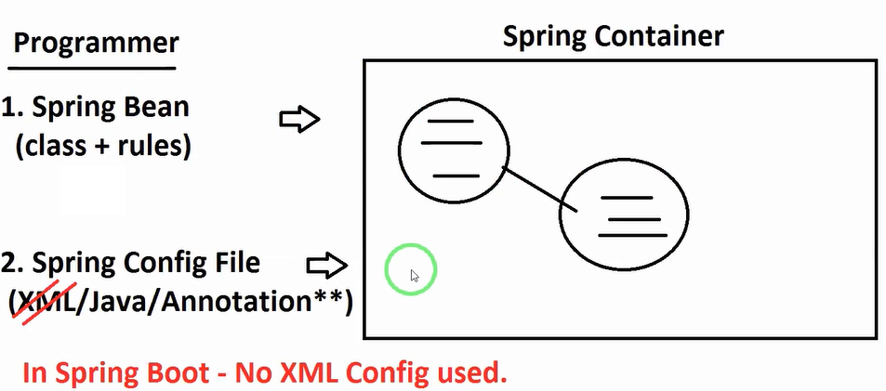

* Programmer as to provide 2 inputs to container

1. Spring Bean: class that follows rules given by Spring Framework.
2. Spring Configuration (XML[not supported in Spring Boot]/Java/Annotation)

* **Spring Bean:**
* Define public class
* Provide one package (basePackage Naming Rule).
* Provide default Constructor.
* Provide Variables with set/get methods.
* (Optional) We can override java.lang.Object(C) methods toString(), hashCode() and equals
* Class cannot inherit other Technologies related API’s (like Servlet API, EJB,JDBC API..etc)
* java.io.Serializable(I) is allowed.
* we can apply Spring Annotation + Spring Boot Annotation + Integrated framework Annotation
* *** (Spring Boot) param Constructor are recommended to avoid.
* **Spring Configuration:**
* **Annotation Configuration :** Programmer Defined class

**Ex:**

**@Component**

**@Value**

**@Autowired**

**@ConfigurationProperties**

**@Scope**

* **Java Configuration :** Pre-Defined class

**Ex:**

**@Configuration**

**@ComponentScan**

**@PropertySource**

**@Bean**

**Ex:**

1. **@Component:** It indicates to Spring Container to ‘Create Object’.

* Apply on top of class only.
* class must not be abstract.
* We cannot apply on top of interface.

**a)**

@Component

public class MyDataSource{

}

* **Internal code:**

MyDataSource myDataSource = new MyDataSource();

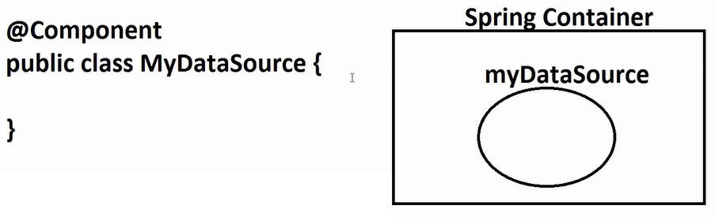

**b)**

@Component(“sf”)

public class SampleFormat{

}

* **Internal code:**

SampleFormat sf = new SampleFormat();

* We can provide object name using @Component, else class name is taken as object name (First letter small)

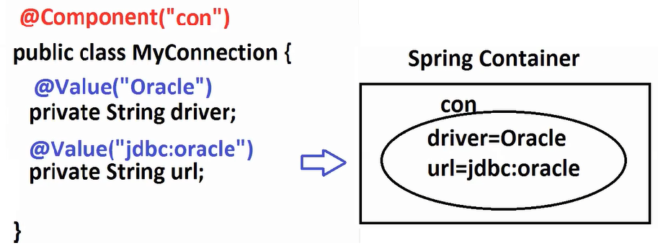

1. **@Value:**

* To provide static data to variable.
* ***To provide data from external sources (properties/ymal/CLA/System Args)
* To provide SpEL (expressions based data).
* When we use @Value (Annotation) variable do not need set method.

**Ex:**

**@**Component(“con”)

public class MyConnection{

@Value(“oracle.jdbc.driver.OracleDriver”)

private String driver;

@Value(“jdbc:oracle:thin:@localhost:1521:xe”)

private String url;

}

**Ex:**

@Component(“execlobj”)

public class EmpExcelExport

{

@Value(“MyEmps”)

private string bookName;

@Value(“EmpData”)

private string sheetName;

@Value(“EMPLOYEE”)

private string moduleName;

}

obj: excelobj[bookName=MyEmps, sheetName=EmpData, moduleName=EMPLOYEE]

**Softwares Required:**

* **JDK -** Java 8/11 or latest
* Eclipse/STS/Intellij IDE’s

**Step1:** Download JDK and Install, set path

**Step2:** Download Eclipse

* Extract folder 🡪Double click on Eclipse Option

**Step3:** Create a Spring Boot Project and Import into Eclipse.

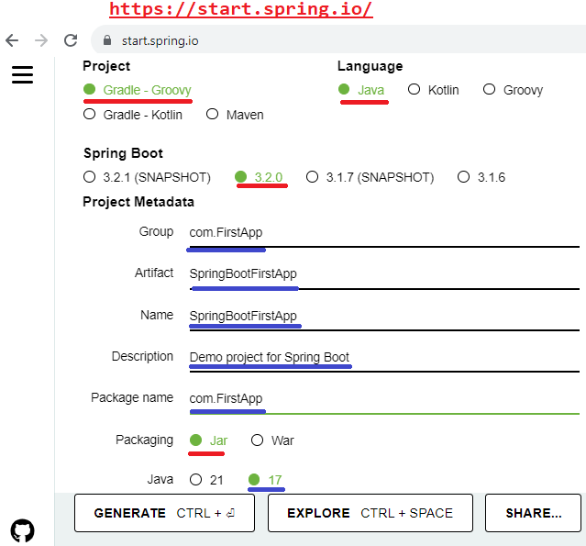

1. Goto Spring Initializer

<https://start.spring.io/>

1. Fill all details
2. Click on generate button

(Downloaded as ZIP Format)

1. Extract to a folder and copy folder location.

Ex: F:\SpringBoot Videos\Practice\SpringBootFirstApp

1. Import project into Eclipse

* File > Import > Search using Maven > Select Existing Project > Next > Enter above location > Press entry key > Finish

1. Open main class/starter class

(Run main class: ctrl + F11)

* Right click > Run as > Spring Boot Application.

1. Coding Part

Create class under package

* Right click on package name > New > class > Enter name > Finish

**package** com.FirstApp;

**import** org.springframework.beans.factory.annotation.Value;

**import** org.springframework.stereotype.Component;

// ctrl + shift + O (imports)

@Component("con")

**public** **class** MyConnection{

@Value("oracle.jdbc.driver.OracleDriver")

**private** String driver;

@Value("jdbc:oracle:thin:@localhost:1521:xe")

**private** String url;

// Source menu > generate toString() > Finsh

@Override

**public** String toString() {

**return** "MyConnection [driver=" + driver + ", url=" + url + "]";

}

}

---------Modified Starter class------

**package** com.FirstApp;

**import** org.springframework.boot.SpringApplication;

**import** org.springframework.boot.autoconfigure.SpringBootApplication;

**import** org.springframework.context.ApplicationContext;

@SpringBootApplication

**public** **class** SpringBootFirstAppApplication {

**public** **static** **void** main(String[] args) {

ApplicationContext ac= SpringApplication.*run*(SpringBootFirstAppApplication.**class**, args);

MyConnection m=ac.getBean("con", MyConnection.**class**);

System.***out***.println(m);

}

}

Right click on main class > Run as > Spring Boot Application

**Ex:**

@Component(“sob”)

public class Sample{

}

Container work:

Sample sob=new Sample();

* Using Input Files: (application.properties)
* properties file stores data in key=value format.
* Use symbol to indicate comment.
* To read data from properties file and assign to variable, follow syntax:

@Value(“${key}”)

* Key can contain symbol like dot(.), dash(-) and underscore(_)

Ex:  
-- application.properties ----

my.driver=oracle.jdbc.driver.OracleDriver

my.url=jdbc:oracle:thin:@localhost:1521:xe

my.username=system

my.password=root

--------------------

@Component(“con”)

public class DbConn{

@Value(“${my.driver}”)

public String driver;

@Value(“${my.url}”)

public String url;

@Value(“${my.username}”)

public String username;

@Value(“${my.password}”)

public String password;

}

Q) How can we load properties file in spring Framework?

A) By using @PropertySource annotation.

**Syntax:**

@PropertySource(“location+filename”)

**Ex:**

src/main/resources [classpath]

|-abcd.properties

@PropertySource(“classpath:abcd.properties”)

* All Spring Annotations we can use in Spring Boot also.
* In Spring Boot, we need not to load properties file manually for ‘application.properties’

@SpringBootApplication annotation will do this work.

* If file name is not ‘application.properties’, then we should write code loading.

**Task:**

-- application.properties ---

my.loc=INF-FOLDER

my.exe=.html

-------------

@Component(“myview”)

public class MyViewResolver{

@Value(“${my.loc}”)

private String location;

@Value(“${my.exe}”)

private String extension;

}

**Software:**

1. JDK 8/11/Latest version
2. STS (Spring Tool Suite)

<https://spring.io/tools>

* Download one Option
* Downloaded as JAR file.

(WARNING: This type of file may harm your computer.)

Accept it.

* Double click on jar file for Extract (Download File)

(Wait for unpacking)

* Now you can see one folder: sts-4.9.0.RELEASE
* Open this folder > Double click on > SpringToolSuite4

1. Workspace Setup (Folder that contains all projects)

**Ex:** F:\SpringBoot\Practice (Or browser for location)

1. * Font setup:

* Window > preferences > Search using ‘Font’ > select ‘Colors and Font’ > Expan ‘Basic’ option > Click on ‘Text Font’ > Edit option for details > Modify details > OK > Apply & Close.

(Key shortcuts: ctrl + , ctrl - )

1. Create Spring Starter Project

* File > New > Spring Starter Project > Enter all details > Next > Next > Finish

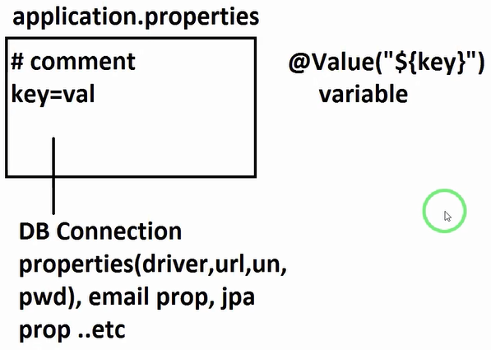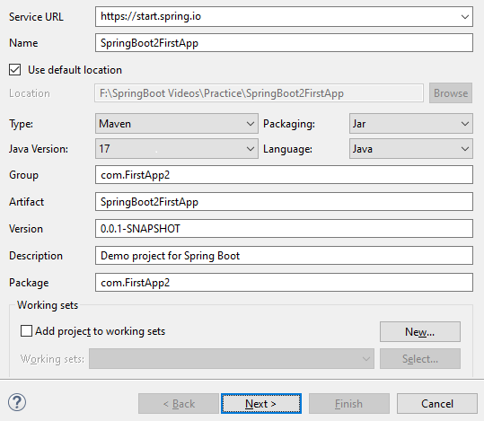

1. Coding part

-- Spring Bean ---

**package** com.FirstApp2;

**import** org.springframework.boot.SpringApplication;

**import** org.springframework.boot.autoconfigure.SpringBootApplication;

**import** org.springframework.context.ApplicationContext;

// ctrl + shfit + O

@SpringBootApplication

**public** **class** SpringBoot2FirstAppApplication {

**public** **static** **void** main(String[] args) {

ApplicationContext ac=SpringApplication.*run*(SpringBoot2FirstAppApplication.**class**, args);

MyViewResolver ob=ac.getBean("myview", MyViewResolver.**class**);

System.***out***.println(ob);

}

}

-- application.properties ----

my.loc=INF-FOLDER

my.exe=.html

-- Modified Main class/ Starter class ---

**package** com.FirstApp2;

**import** org.springframework.beans.factory.annotation.Value;

**import** org.springframework.stereotype.Component;

@Component("myview")

**public** **class** MyViewResolver{

@Value("${my.loc}")

**private** String location;

@Value("${my.exe}")

**private** String extension;

@Override

**public** String toString() {

**return** "MyViewResolver [location=" + location + ", extension=" + extension + "]";

}

}

**Q & A**

1. What if did not provide @Value on variable?
2. Default values. ie for int zero, double 0.0, String type null,… etc
3. We wrote @Value on variable, but key is not present then?
4. If key not present in properties file and trying to read using @Value then Execption.

BeanCreationException: Error creating bean with name 'myview'

Caused by: java.lang.IllegalArgumentException:

Could not resolve placeholder 'my.loc' in value "${my.loc}"

1. Can we define same key multiple times with different values in properties ?
2. YES. But not recommended.

If we write key duplicate then last combination is taken into application.

Ex:

my.loc=A

my.loc=B

my.loc=C

Output: my.loc=C

1. Who will load properties file in Spring Boot Application?
2. Here in starter class, @SpringBootApplication will load File using code like:

@PropertySource(“classpath:application.properties”)

** No need of writing this line in Spring Boot.

In Spring we should write this line.

1. Can we define file with any other name for application.properties?
2. YES. But Spring Boot will not detect. You should write manual loading.

Ex: @PropertySource(“classpath:abcd.properties”)

* Shortcut to rename file : F2

(Right click on file > Refactor > Rename )

1. What is ac.getBean() in code?
2. Here ‘bean’ object exist in container. To read such object use method getBean().
3. What is stereotype Annotation?
4. An annotation that indicates to Spring container create object is called as sterotype Annotation.

-- sterotype annotation list –

@Component : Creating object

@Repository : Creating object + DB Operation support

@Service : Creating object + cal/operation/logics

@Controller : Creating object + HTTP Req/Resp

@RestController : Creating object + webservices

@Value : application.properties + your own properties files

**properties files**

* We can define our own properties file along with application.properties

Ex: abcd.properties

application.properties

* If file name is application.properties then spring boot loads it. If your file is defined, then manually it should be loaded, using @PropertySource.
* Always 1st priority is given for application.properties for key searching.

application.properties

sid=10

abcd.properties

sid=30

@Value(“${sid}”) 🡪 10

* If either key or application.properties file is not present then search in your properties file.

1. Can we define muiltiple properties file in one Application?
2. YES.
3. Can we define same key in multiple properties file?
4. YES. Then last loaded combination is taken.
5. Can we use single property file for multiple project?
6. Config server (Spring Colud).
7. If we define custom properties file? Will it be loaded by default by Spring Container?
8. NO. Until we write @PropertySource + file

abcd.properties

sid=10

mno.properties

sid=20

pqr.properties

sid=30

@PropertySource({

“classpath:abcd.properties”,

“classpath:pqr.properties”

})

Output: 30

1. Can we change order of Annotation?
2. No need to follow order for Annotations.

Note: even we load application.properties manually then, finally priority is given for application.properties only.

Code:

Name: SpringBoot2PropesTest

abcd.properties

my.app.title=ABCD

xyz.properties

my.app.title=XYZ

mno.properties

my.app.title=MNO

application.properties

my.app.title=APP

-- Modified main class –

package com.FirstMulitProp;

import org.springframework.boot.SpringApplication;

import org.springframework.boot.autoconfigure.SpringBootApplication;

import org.springframework.context.ApplicationContext;

import org.springframework.context.annotation.PropertySource;

@SpringBootApplication

@PropertySource({"classpath:abcd.properties",

"classpath:xyz.properties",

"classpath:application.properties",

"classpath:mno.properties"

})

public class SpringBoot2MulitPropFileApplication {

public static void main(String[] args) {

ApplicationContext ac=SpringApplication.run(SpringBoot2MulitPropFileApplication.class, args);

//get - read, bean-object (objectName, classType)

ProductInfo pob=ac.getBean("pi", ProductInfo.class);

System.out.println(pob);

}

}

**-- Bean class –**

package com.FirstMulitProp;

import org.springframework.beans.factory.annotation.Value;

import org.springframework.stereotype.Component;

@Component("pi")

public class ProductInfo {

@Value("${my.app.title}")

private String title;

public String getTitle() {

return title;

}

public void setTitle(String title) {

this.title = title;

}

@Override

public String toString() {

return "ProductInfo [title=" + title + "]";

}

}

Pre-defined keys:

<https://docs.spring.io/spring-boot/docs/current/reference/html/application-properties.html>

**Runners: In Spring Boot.**

**Runners:**

Execute any logic only once when application is started.

Testing Purpose, Setup data.. etc

* Runners not used in web based Apps, only console based we use generally.
* In Spring Boot Batch Processing, one pre-defined Runner exist.
* Types of Runner(2)

1. CommandLineRunner (I)
2. ApplicationRunner (I)
3. **CommandLineRunner (I)**

* This is a functional Interface
* We should define one class and override abstract method given by CommandLineRunner (I) ie run() method.
* Must add @Component on top of runner. So, that Spring Container detect the class and create object.
* SpringApplication.run(SpringBootRunnerApplication.class, args); logic will all runners and executes in order.
* ** we can define multiple runners. Executed in order.

**Code:**

**Step1:** Create Spring Starter Project

**Name:** SpringBootRunner

**Package:** com.SpringBootRunner

**Step2:** Define one class for Runner

package com.SpringBootRunner;

import org.springframework.beans.factory.annotation.Autowired;

import org.springframework.boot.CommandLineRunner;

import org.springframework.stereotype.Component;

@Component

public class MessageRunner implements CommandLineRunner {

@Autowired

DbConnection dbc;

@Override

public void run(String... args) throws Exception {

System.out.println("FROM RUNNER!");

System.out.println(dbc);

//System.out.println(dbc.toString());

}

}

**--** Java class (Ex: DbConnection) –

**package** com.SpringBootRunner;

**import** org.springframework.beans.factory.annotation.Value;

**import** org.springframework.stereotype.Component;

@Component

**public** **class** DbConnection {

@Value("${my.db.driver-class}")

**private** String driver;

@Value("${my.db.url}")

**private** String url;

@Override

**public** String toString() {

**return** "DbConnection [driver=" + driver + ", url=" + url + "]";

}

}

**--** Main class/Starter class –

package com.SpringBootRunner;

import org.springframework.boot.SpringApplication;

import org.springframework.boot.autoconfigure.SpringBootApplication;

@SpringBootApplication

public class SpringBootRunnerApplication {

public static void main(String[] args) {

SpringApplication.run(SpringBootRunnerApplication.class, args);

}

}

**Step3:** Run main class (ctrl + F11)

Note: Internal code for calling Runner

(C) SpringApplication [ctrl + shift + T]

(M) callRunners(…) [ctrl + L (Goto line number) 778]

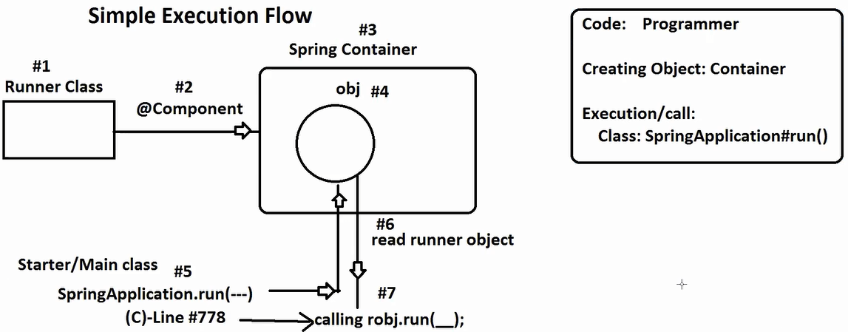

* When we define @Component on top of class, container is creating object and all runner objects are read and executed by callRunners() method defined in class SpringApplication.

ctrl + L Goto line number

ctrl + O Overview, all members of a class

**Component Scanning**

**[base package]**

* Spring Container will not read all classes defined in workspace/project.
* It will read classes only from one common package name i.e., also called as BasePackage given using **@ComponentScan** Annotation.

**basePackage:** It is a package name, that will read classes from current package and sub package only.

* In Spring Boot (Starter class)/Main class package name taken default as basePackage.

i.e., main class() --- **com.SpringBoot.Runner** [Package].

Our class must be in same package or its subpackage.

In simple way your class package = starter class package + subpackage

Ex: Test (C) -- com.SpringBoot.Runner (Detected)

Process (C) -- com.SpringBoot.one (Not Detected)

MyExport (C) -- com.SpringBoot.Runner.export (Detected)

Ex:

Main class () -- org.myapp.vei.sam [basePackage]

MyaGrade (C) -- com.app.test.one [Not Detected]

MyJobRunner (C) -- com.myapp.vei.sam [Detected]

DataImport (C) -- com.myapp.sam.vei [Not Detected]

* basePackage: To provide one common package name to container. So that it can find all classes from given package and sub package.
* *** In Spring Boot, by default starter/main class package is set to basePackage. We can even modify/can provide multiple basePackages.

1. Can we modify basePackage in Spring Boot?
2. YES, by using @ComponentScan(“”) at starter class

** If we define @ComponentScan(basePackage=” ”) externally at starter class, then default rule is ignored/overridden.

Now, do consider starter class package as basePackage.

Ex:

* Default rule

Starter class -- com.springboot.vie

Process -- com.springboot.vie.runner (Detected)

Message -- com.springboot.vie (Detected)

Format -- com.app.test (Not Detected)

Export -- com.springboot.export (Not Detected)

* Externally Provided @ComponentScan at starter

@ComponentScan(basePackage= “com.app.test”)

Process -- com.springboot.vie.runner (Not Detected)

Message -- com.springboot.vie (Not Detected)

Format -- com.app.test (Detected)

Export -- com.springboot.export (Not Detected)

Q. Can we provide multiple basePackages?

A) YES, Using Array style.

Ex Code:

Step1: Create one Spring Starter Project

* File > New > Spring Starter Project > Enter name and Package

Name: SpringBootRunner

Package: com.SpringBoot.Runner

Step2: Classes

package com.SpringBootRunner.execute;

import org.springframework.beans.factory.annotation.Autowired;

import org.springframework.boot.CommandLineRunner;

import org.springframework.stereotype.Component;

import com.SpringBootRunner.DbConnection;

@Component

public class Export implements CommandLineRunner {

@Override

public void run(String... args) throws Exception {

System.out.println("EXPORT");

}

}

--------

package com.SpringBootRunner.Runner;

import org.springframework.beans.factory.annotation.Autowired;

import org.springframework.boot.CommandLineRunner;

import org.springframework.stereotype.Component;

import com.SpringBootRunner.DbConnection;

@Component

public class Message implements CommandLineRunner {

@Override

public void run(String... args) throws Exception {

System.out.println("MESSAGE");

}

}

--------

package com.app.test;

import org.springframework.beans.factory.annotation.Autowired;

import org.springframework.boot.CommandLineRunner;

import org.springframework.stereotype.Component;

import com.SpringBootRunner.DbConnection;

@Component

public class Format implements CommandLineRunner {

@Override

public void run(String... args) throws Exception {

System.out.println("FORMAT");

}

}

-------

package com.SpringBootRunner.Runner;

import org.springframework.beans.factory.annotation.Autowired;

import org.springframework.boot.CommandLineRunner;

import org.springframework.stereotype.Component;

import com.SpringBootRunner.DbConnection;

@Component

public class Process implements CommandLineRunner {

@Override

public void run(String... args) throws Exception {

System.out.println("PROCESS");

}

}

Step3:

package com.SpringBootRunner;

import org.springframework.boot.SpringApplication;

import org.springframework.boot.autoconfigure.SpringBootApplication;

@SpringBootApplication

//@ComponentScan(basePackage= “com.app.test”)

@ComponentScan(basePackage= {

“com.app.test”,

“com.SpringBootRunner”,

“com.SpringBootRunner.Runner”

})

public class SpringBootRunnerApplication {

public static void main(String[] args) {

SpringApplication.run(SpringBootRunnerApplication.class, args);

}

}

Q) How can we simplify below bas ePackage concept?

@ComponentScan(basePackage= {

“com.SpringBoot.excel”,

“com.SpringBoot.pdfs”,

“com.SpringBoot.models

})

1. @ComponentScan(basePackage= “com.SpringBoot”)

basePackage

| - model

| - repo

| - controller

| - service

| - utils

| - views

| - validator

Note:

1. if we provide external basePackage which is not present in Application then it is ignored.
2. Even our class is detected by @Component (or its sub types) is missing then object is not created and not executed.

Softwares: Java 11, STS(Spring Tool Suite)

-- Eclipse/STS keys --

ctrl + shift + T (open type) To open any pre-defined class file.

ctrl + shift + R (open resource) To open code files exist in projects

ctrl + / ctrl – (Front size adjustment )

ctrl + shift + O (to handle imports)

ctrl + M (Restore/Maximise)

ctrl + space (code suggestions)

**Multiple Runner Concepts**

* By default Multiple Runners are executed in name sorting order.
* SpringApplication#run is reading all Runners as List, then sorting them using ASC ORDER using Comparator, at last they are executed in order.

Logic : SpringApplication (C) , Line #782 (ctrl + L – Goto Line Number)

* To provide our own execution order for multiple runners use annotation : @Order over Runner class.

**-- Code --------**

* **Runner classes**

**package** com.SpringBootMultiRunner.runner;

**import** org.springframework.boot.CommandLineRunner;

**import** org.springframework.core.annotation.Order;

**import** org.springframework.stereotype.Component;

@Component

@Order(6)

**public** **class** ExportRunner **implements** CommandLineRunner {

@Override

**public** **void** run(String... args) **throws** Exception {

System.***out***.println("Export Runner");

}

}

------------

**package** com.SpringBootMultiRunner.runner;

**import** org.springframework.boot.CommandLineRunner;

**import** org.springframework.core.annotation.Order;

**import** org.springframework.stereotype.Component;

@Component

@Order(20)

**public** **class** MessageRunner **implements** CommandLineRunner {

@Override

**public** **void** run(String... args) **throws** Exception {

System.***out***.println("Message Runner");

}

}

------------

**package** com.SpringBootMultiRunner.runner;

**import** org.springframework.boot.CommandLineRunner;

**import** org.springframework.core.annotation.Order;

**import** org.springframework.stereotype.Component;

@Component

@Order(-41)

**public** **class** PdfRunner **implements** CommandLineRunner {

@Override

**public** **void** run(String... args) **throws** Exception {

System.***out***.println("PDF Runner");

}

}

-------

**package** com.SpringBootMultiRunner.runner;

**import** org.springframework.boot.CommandLineRunner;

**import** org.springframework.core.annotation.Order;

**import** org.springframework.stereotype.Component;

@Component

@Order(-23)

**public** **class** ModuleRunner **implements** CommandLineRunner {

@Override

**public** **void** run(String... args) **throws** Exception {

System.***out***.println("Module Runner");

}

}

----

Execution Order: -41, -23, 6, 20

Q) Can we define two or more runners using same order?

A) YES, In this case again name sorting is applied.

Ex:

ARunner @Order(10)

BARunner @Order(10)

CRunner @Order(-32)

Execution Order: C, A, B Runners.

* @Order(int value): If we do not provide @Order on runner then default value is set to

Ordered.LOWEST_PRESIDENCE = Integer.MAX_VALUE

(i.e., 2147483647)

* In simple Runner not assigned with @Order are executed last.
* Even if we define @Order(without any value) only then also same process.

[Execute last]

i.e., @Order === No Order Annotation (same propriety number)

-- Task ---

Find Execution order of below Runners

Runner Name Order

A No Order

B @Order

C @Order(10)

D @Order(-9)

E @Order(34)

F @Order(-11)

G @Order

H No Order

I Order(0)

Execution Order: F, D, I, C, E, A, B, G, H

1. What is Functional Interface (JDK-8)?
2. An interface that contains

Exactly one abstract method

Zero or more default methods

Zero or more static methods

Zero or more abstract methods taken from java.lang.Object.

1. What is 3 dots (…) in java?

What is var-args in java?

1. We can store multiple arguments without creating array.
2. What is @Scope/ What are Spring and Boot Scope?

What is default scope in Spring?

1. @Scope indicates when object should be created in container and how many times.
2. singleton (default scope): Object created once while starting app
3. prototype: on every access create new object in container

[in multi-thread environment, shared data]

1. request (web only): When request comes create object and destroy once response given.
2. session (web only): When login Success(Http Session created) then object is created maintained until logout.
3. context (not exist now)

**@Autowired:**

**@**Autowired annotation is used to read object from Spring Container into current variable

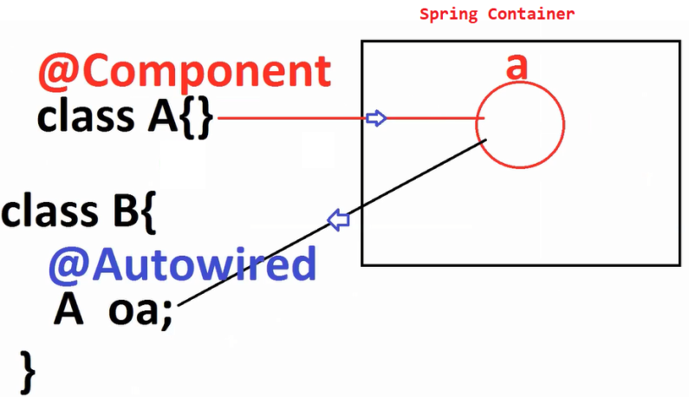

1. How can we provide basePackage in Spring Framework?
2. @ComponentScan(basePackage=”com.SprinBoot.Runner”)

** But in Spring Boot above code is given by @SpringBootApplication

1. What is difference between @Component and @ComponetScan ?
2. @Component: It indicates to Spring Container create object

@ComponentScan: Container detect/find/read class from given base-Package.

Spring Container:

* Detect the class
* Create object
* Provide data

**Fnctional Interface:** 1 abstract method

interface sample{ //Not valid Functional Interface

}

2.

interface Process{ //Valid Functional Interface

void test();

}

3.

interface Process{ //Valid Functional Interface

void test();

}

interface Export extends Sample { } //Valid Functional Interface

4. We can add default and static methods too

interface Process{ //Valid Functional Interface

void test();

default void print() {sysout(“Hi”)}

static void count() {sysout(“OK”)}

}

5. We can add java.lang.Object (C) methods as abstract methods.

interface Export{ //100% it is a Functional Interface

void test();

String toString();

int hashCode();

boolean equals(Object ob);

}

* Why java.lang.Object(C) method are valid as abstract methods in Function Interface?

A)

* Why Functional Interface?

1. Lambda Expression, methods references used in Stream.

* Is this @FuctionalInterface must at Functional Interface?

1. No, it is optional, if we add the java compiler will check that all the rules.

Q) What is the difference between ApplicationContext, IOC and DI?

A) Therory Programming

OOPs JAVA

ORM Hibernate

DI IOC/Spring Container (2 types)

(Dependency Injection) (Inversion of Control)

1. BeanFactory (old container – XML Supporting)
2. ApplicationContext (new container – XML, Annotation, Java Config)

Q) What is default method in Function Interface(FI)?

A) To avoid abstract classes, between Interface and classes. Concrete methods and abstract methos are moved to interface in Java#*8. Such Concrete methods are called as Default methods which can be overridden in subclass.

** default and final combination is invalid in interface.

Q) what is difference between abstract class and interface?

A) abstract class = abstract methods + non–abstract methods + constructors, blocks, variables .. etc.

Interface = abstract methods (Java 8, default, static, methods too)

* To give specification: interface [Servlet Interface]
* To give partial implementation: abstract class [Generic Servlet]

Q) what is difference between interface and functional interface?

A) interface : zero or more abstract methods

functional interface : exactly one abstract method.

Q) what is the properties of default methods?

A) Default method can have body/empty body

Must be added with keyword default. These can be override in sub classes. They can provide common logic to all sub-classes

Default method can never be abstract, final or private.

Q) What is the difference between jersey rest web service and spring rest

A) jersey follows JAX-RS Standard and fully manual code by programmer.

Spring rest is latest concept of JAX-RS that gives performance to implement webservices (with new annotations)

Q) what is difference between Lambda and FI?

A) By using FI only we create Lambda Expression.

**Project Lombok**

* This is Open Source Java API. To provide list of annotations, these source code for

set/get methods

toString() method

equals()

hashCode()

constructors

etc..,

**Concepts Annotation**

Set methods @Setter

Get methods @Getter

toString @ToString

equalsandhashCode @hashCodeAndEquals

constructors @NoArgsConstructor

@AllArgsConstructor

@RequiredArgsConstructor + @NotNull

* Spring Boot supports Integrated API for Project Lambok

-- Project Lambok Activation : onetime setup

Step1: Create one starter project

* File > New > Spring Starter Project

Name: SpringBootLombok

(Other details)

* Next > Serch ‘lombok’ and choose check
* Next > Finish

Step2: Define one Dummy class

**package** com.SpringBootLombok.model;

**import lombok.Getter;**

**import lombok.Setter;**

**import lombok.ToString;**

@Setter

@Getter

@ToString

**public** **class** Employee {

**private** Integer empId;

**private** String empName;

**private** Double empSal;

}

Step3: Goto Lombok jar location

C:\Users\vinee\.m2\repository\org\projectlombok\lombok\1.18.26

Step4: Double click on jar : lombok- 1.18.26

Or

Open cmd for above location

cmd > java –jar lombok-1.18.26.jar

Step5: Click on ‘Specify Location’ Button

Select Eclipse/STS Download and Extracted Folder

Ex: C:\Users\vinee\Downloads\sts-4.16.1.RELEASE

Step6: Click on Install or Update Button

Click on Quit Installer/Finish

Step7: Open STS/Eclipse, Start Coding…

Q) How will provide default constructor? and when?

A) Java Compiler. If there is no constructor provided in code.

Q) What is difference between equals() and == operator?

A) SAME.

Object (C) has equals() method that has logic for == operator

Here it will compare two object references, are thy pointing to same object or different object (NOT HASHCODE).

* This method is non-static, non-final, non-private. So, we can override in our class such that it compares data not object references.
* Operator == will not compare hashCodes. They will compare object reference.
* *** Even two objects can have same hashCode which might be referring to different objects.

**CODE**

1. **Model class**

**package** com.SpringBootLombok.model;

**import** lombok.EqualsAndHashCode;

**import** lombok.Getter;

**import** lombok.Setter;

**import** lombok.ToString;

@Setter

@Getter

@ToString

@EqualsAndHashCode

**public** **class** Employee {

**private** Integer empId;

**private** String empName;

**private** Double empSal;

}

1. **Runner class**

**import** com.SpringBootLombok.model.Employee;

@Component

**public** **class** TestRunner **implements** CommandLineRunner {

@Override

**public** **void** run(String... args) **throws** Exception {

Employee e1=**new** Employee();

e1.setEmpId(10);

e1.setEmpName("Katherine");

e1.setEmpSal(45.05);

Employee e2=**new** Employee();

e2.setEmpId(10);

e2.setEmpName("Katherine");

e2.setEmpSal(45.05);

System.***out***.println(e1.equals(e2)); // Compare data

System.***out***.println(e1==e2); // Compare references

//System.out.println(e1.hashCode());

//System.out.println(e2.hashCode());

System.***out***.println(e1.getEmpId());

System.***out***.println(e1.getEmpName());

System.***out***.println(e1.getEmpSal());

}

}

1. **Starter Class**

package com.SpringBootLombok;

import org.springframework.boot.SpringApplication;

import org.springframework.boot.autoconfigure.SpringBootApplication;

@SpringBootApplication

public class SpringBootLombokTestApplication {

public static void main(String[] args) {

SpringApplication.run(SpringBootLombokTestApplication.class, args);

}

}

…OCPJC Certificate Exam…

*** Core Java hashCode() v/s == ***

**package** com.SpringBootLombok;

**public** **class** Test {

**public** **static** **void** main(String...args)

{

String s1=**new** String("A");

String s2=**new** String("A");

System.***out***.println(s1.hashCode());

System.***out***.println(s2.hashCode());

System.***out***.println(s1==s2);

}

}

Output:

65

65

false

**Examples:**

**@NoArgsConstructor:** Generates Default Constructor before giving to Java Complier

**@AllArgsConstructor:** Generates all variables/params Constructor

1. **Code:**

@NoArgsConstructor

@AllArgsConstructor

**public** **class** Student {

**private** Integer id;

**private** String sname;

}

**Generated By Lombok:**

@NoArgsConstructor

@AllArgsConstructor

**public** **class** Student {

**private** Integer id;

**private** String sname;

**public Student(){**

**Super();**

**}**

**public Student(**Integer id, String sname**){**

**Super();**

**this.id=id;**

**this.sname=sname;**

**}**

}

* **@RequiredArgsConstructor:** is used to generate selected variables constructor. To select variable apply @NonNull

**Code:**

@RequiredArgsConstructor

**public** **class** Student {

@NonNull

**private** Integer id;

**private** String sname;

}

**Generated By Lombok:**

**public** **class** Student {

**private** Integer id;

**private** String sname;

**public Student(**Integer id**){**

**this.id=id;**

**}**

}

**FAQ’S**

1. **Code:**

@AllArgsConstructor

public class Student() { }

@AllArgsConstructor: if there are no variables in class then it generates default constructor. only

**Generated Code:**

public class Student{

public Student(){

super();

}

}

1. **Code:**

@NoArgsConstructor

@AllArgsConstructor

public class Student() { }

**Generated Code: //** Lombok did its work, but java compiler gives error

**//** Duplicate method Student() in Student class

public class Student{

public Student(){

super();

}

public Student(){

super();

}

}

1. **Code:**

@RequiredArgsConstructor

public class Student() { }

**@RequiredArgsConstructor:**

Even generates Default constructors.

* If class has no variables
* Or class has variable but not having @NotNull

**Generated Code:**

public class Student{

public Student(){

super();

}

}

1. **Code**

@RequiredArgsConstructor

public class Student{

private Integer sid;

private String sname;

}

**Generated Code:**

public class Student{

private Integer sid;

private String sname;

public Student(){

super();

}

}

1. **Code**

@AllArgsConstructor

@RequiredArgsConstructor

public class Student{

@NonNull

private Integer sid;

@NonNull

private String sname;

}

**Generated Code:**

public class Student{

private Integer sid;

private String sname;

public Student(Integer sid, String sname){

super();

this.sid=sid;

this.sname=sname;

}

public Student(Integer sid, String sname){

super();

this.sid=sid;

this.sname=sname;

}

}

**@Data** is a simplified Lombok Annotation. That provides multiple source code concepts, given as:

**@Data = @Getter + @Setter + @ToString + @RequiredArgsConstructor + @EqualsAndHashCode**

1. **Code:**

@Data

**public** **class** Student {

**private** Integer id;

**private** String sname;

}

**Generated Code:**

public class Student{

private Integer sid;

private String sname;

public Student(){

super();

}

//set, get, toString, equal, hashCode..

**}**

1. **Code**

@Data

**public** **class** Student {

@NonNull

**private** Integer id;

**private** String sname;

}

**Generated Code:**

public class Student{

private Integer sid;

private String sname;

public Student(Integer id){

this.id=id;

}

//set, get, toString, equal, hashCode..

**}**

**Example:**

1. **Model**

**package** com.SpringBootLombok.model;

**import** lombok.AllArgsConstructor;

**import** lombok.Data;

**import** lombok.EqualsAndHashCode;

**import** lombok.Getter;

**import** lombok.NoArgsConstructor;

**import** lombok.NonNull;

**import** lombok.RequiredArgsConstructor;

**import** lombok.Setter;

**import** lombok.ToString;

@Setter

@Getter

@ToString

@NoArgsConstructor

@AllArgsConstructor

@EqualsAndHashCode

//@RequiredArgsConstructor

//@Data

**public** **class** Student {

//@NonNull

**private** Integer id;

**private** String sname;

}

1. **Runner class:**

**package** com.SpringBootLombok.Runner;

**import** java.util.HashSet;

**import** java.util.Set;

**import** org.springframework.boot.CommandLineRunner;

**import** org.springframework.stereotype.Component;

**import** com.SpringBootLombok.model.Student;

@Component

**public** **class** TestRunner **implements** CommandLineRunner {

@Override

**public** **void** run(String... args) **throws** Exception {

Set<Student> set=**new** HashSet<>();

set.add(**new** Student(10, "A"));

set.add(**new** Student(10, "A"));

set.add(**new** Student(10, "A"));

System.***out***.println(set);

System.***out***.println(set.size());

}

}

**Config – Properties**

**@Value :** To read one value data from properties we use this annotation.

* If class has 5 variables then 5 times we should write @Value
* To load multiple keys at a time we use Config – Properties

@ConfigurationProperties(prefix= “ __”).

* @ConfigurationProperties is also called as bulk loading. This is used to read data from properties file to java class using one common prefix.
* At a time one class can load only one prefix based variables/keys.
* Key name and variable must match else no data is provided. Those hold default values.
* If duplicates found, then last combination is taken.

Ex:

1. Create Spring Starter Project

Name: SpringBootConfigProps

Dependencies: Lombok

1. Runner class

**package** com.SpringBootConfigProps.Runner;

**import** org.springframework.beans.factory.annotation.Value;

**import** org.springframework.boot.CommandLineRunner;

**import** org.springframework.boot.context.properties.ConfigurationProperties;

**import** org.springframework.stereotype.Component;

**import** lombok.Data;

@Component

@Data

@ConfigurationProperties(prefix = "my.app")

**public** **class** DataReadRunner **implements** CommandLineRunner {

//@Value("${my.app.id}")

**private** Integer id;

//@Value("${my.app.code}")

**private** String code;

//@Value("${my.app.version}")

**private** Double version;

@Override

**public** **void** run(String... args) **throws** Exception {

System.***out***.println(**this**);

}

}

1. application.properties

my.app.id=10

my.app.code=VIE-1

#my.app.code=VIE-2

my.app.version=2.0

**Configuration Properties:**

* Key must be defined using : prefix.variable=value
* At class level @ConfigurationProperties(prefix= “”)
* Generate set/get methods for variables.

List -- ArrayList

Set -- LinkedHashSet

Map -- Linked

**Working with Complex Types:**

1. Using List/Set/Array

Properties: prefix.variable[index]=value

YAML: (Here dash indicates index)

prefix:

variable:

-val1

-val2

-val3

1. Using Maps

Properties: prefix.variable.mapKey=mapValue

YAML:  
prefix:

variable:

mapKey: mapValue

1. Using HAS-A / Association

Properties: prefix.HasAvariable.variable=value

YAML:

prefix:

HasAvariable:

variable: value

**Note:** if we see any error at pom.xml (maven goals problem) Update maven Project.

* Right click on project > Maven > Update Project (or Alt + F5 | Alt + Fn + F5) Update button / Finish.

**== Code ===**

**Name:** SpringBootConfigPropsCollection

**Dependencies:** Lombok

1. **Model**

**package** com.SpringBootConfigProps.model;

**import** lombok.Data;

@Data

**public** **class** ProductInfo {

**private** Integer pid;

**private** String pcode;

**private** String pvendor;

}

1. **Runner class**

**package** com.SpringBootConfigProps.runner;

**import** java.util.List;

**import** java.util.Map;

**import** java.util.Set;

**import** org.springframework.boot.CommandLineRunner;

**import** org.springframework.boot.context.properties.ConfigurationProperties;

**import** org.springframework.stereotype.Component;

**import** com.SpringBootConfigProps.model.ProductInfo;

**import** lombok.Data;

@Component

@Data

@ConfigurationProperties(prefix = "my.app")

**public** **class** CollectionTestRunner **implements** CommandLineRunner {

**private** List<String> details;

//private Set<String> details;

//private String[] details;

**private** Map<String, Integer> version;

**private** ProductInfo pob; //HAS - A

@Override

**public** **void** run(String... args) **throws** Exception {

//System.out.println(details.getClass());

//System.out.println(version.getClass());

System.***out***.println(**this**);

}

}

1. **application.properties**

my.app.details[0]=A

my.app.details[1]=B

my.app.details[2]=A

my.app.details[3]=C

#my.app.details=A,B,C,D

my.app.version.V1=8

my.app.version.V2=12

my.app.version.V3=19

#my.app.pob.pid=10

#my.app.pob.pcode=VIE

#my.app.pob.pvendor=ORCL

1. **application.yml**

my:

app:

pob:

pid: 20

pcode: VIE-HYD

pvendor: ORCL-HYD

version:

V1: 80

V2: 120

V3: 190

details:

-A

-B

-PQR

1. **Starter class**

package com.SpringBootConfigProps;

import org.springframework.boot.SpringApplication;

import org.springframework.boot.autoconfigure.SpringBootApplication;

@SpringBootApplication

public class SpringBootConfigPropsCollectionApplication {

public static void main(String[] args) {

SpringApplication.run(SpringBootConfigPropsCollectionApplication.class, args);

}

}

**Ex2:**

1. **Model**

**package** com.SpringBootConfigPropsComplex.model;

**import** lombok.Data;

@Data

**public** **class** Address {

**private** Integer aid;

**private** String loc;

**private** String pin;

}

----

**package** com.SpringBootConfigPropsComplex.model;

**import** java.util.Map;

**import** java.util.Set;

**import** lombok.Data;

@Data

**public** **class** Employee {

**private** Integer eid;

**private** String ename;

**private** Double esal;

**private** Set<String> projs;

**private** Map<String, Double> modules;

**private** Address addr;

}

1. **Runner**

**package** com.SpringBootConfigPropsComplex.runner;

**import** org.springframework.boot.CommandLineRunner;

**import** org.springframework.boot.context.properties.ConfigurationProperties;

**import** org.springframework.stereotype.Component;

**import** com.SpringBootConfigPropsComplex.model.Employee;

**import** lombok.Data;

@Component

@ConfigurationProperties(prefix = "data.app")

@Data

**public** **class** DataFetchRunner **implements** CommandLineRunner {

**private** Employee emp;

@Override

**public** **void** run(String... args) **throws** Exception {

System.***out***.println(**this**);

}

}

1. **application.properties**

data.app.emp.eid=101

data.app.emp.ename=Vineeth

data.app.emp.esal=5.5

data.app.emp.projs[0]=P11

data.app.emp.projs[1]=P12

data.app.emp.projs[2]=P13

data.app.emp.modules.M4=5.0

data.app.emp.modules.M5=6.4

data.app.emp.modules.M6=8.2

data.app.emp.addr.aid=755

data.app.emp.addr.loc=GUJ

data.app.emp.addr.pin=500018

1. **application.yml**

data:

app:

emp:

eid: 10

ename: Kartherine

esal: 5.5

projs:

- IT

- E

- F

modules:

M1: 3.3

M2: 4.3

M3: 5.6

addr:

aid: 70

loc: HYD

pin: 505326

1. **Starter class**

package com.SpringBootConfigPropsComplex;

import org.springframework.boot.SpringApplication;

import org.springframework.boot.autoconfigure.SpringBootApplication;

@SpringBootApplication

public class SpringBootConfigPropsComplexExApplication {

public static void main(String[] args) {

SpringApplication.run(SpringBootConfigPropsComplexExApplication.class, args);

}

}

**Q)** Why did we not use @Component, @Autowired for Config Props?

**A)** When we are using @ConfigurationProperties for data fetch into class then object creation and object injection (reading) taken care by @ConfigurationProperties only. So, we need not to write @Component and @Autowired.

* If key name is wrong / not matching, prefix is not matched, no set/get methods etc.,
* For any case @ConfigurationProperties provides defaults. No ERROR/No EXCEPTION.

Q) What is HAS-A relation?

A) Core Java Relation between classes

IS-A Relation : Inheritance (extends/implements)

HAS-A Relation: Using one class as A Datatype and creating variable in another class.

class A{}

class B{

int id;

A oa;

}

Q) Along with @ConfigurationProperties can we use @Autowired and @Component?

A) YES. But for data reading use @ConfigurationProperties. For other objects reading use @Autowired.

**Annotation Configuration: [Faster compared to Java Config]**

* This is supported for Programmer defined classes. i.e., you must have source code (__.java file). Then only we can apply these annotations.

**@Component**

**@Value**

**Ex:**

@Component

class Sample{

@Value(“${my.app.code}”)

Integer code;

}

**Java Configuration:**

* This configuration is used for Pre-defined classes (__.class)
* *** It also supports programmer defined classes.

**@Configuration**

**@Bean**

Steps for Java Configutration:-

Step1: Define one public class with any name (ex: AppConfig)

Step2: Apply @Configuration (Then container understand it is Java Config file)

Step3: For one object, you must define one method.

Step4: Apply @Bean over method (bean=object)

@Configuration

public class AppConfig{

@Bean

public ClassName objectName(){

….//Logics

}

}

**Ex1:**

**--** Pre-defined class ---

class Process { }

------

@Configuration //Java Config File 🡪Please take it as input 🡪 Container

public class AppConfig{

@Bean //Please take this method as Object in container

public Process pob() {

return new Process();

}

}

**Ex2:**

**--** Pre-defined class ---

class OracleConnection { }

------

@Configuration

public class SampleConfig{

@Bean // 1 object = 1 method

public OracleConnection on(){

return new OracleConnection();

}

}

* Method name behaves like object name.

**Note:**

@Configuration says ‘this not a normal class. This is input to Spring Container, by taking this input, please create objects.’

@Bean : Given method convert into one object in container.

* @Configuration and @Component (invalid comparison)

@Component -- Creating object for you class.

@Bean -- Creating object for pre-defined class.

* One Bean(Object) created inside container, can be accessed anywhere in application using Autowired.

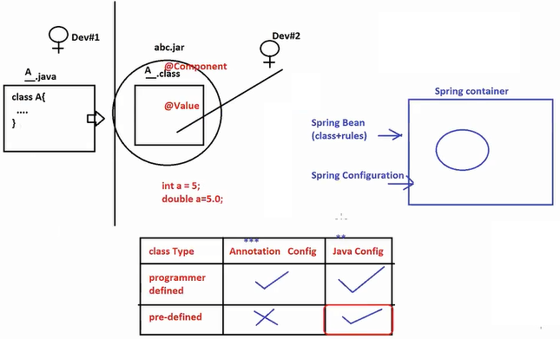

**Example: 1**

Step1: Creating Spring Starter Project

Name: SpringBootJavaConfig

Dependencies: Lombok

-- Bean / Models –

**package** com.SpringBootJavaConfig.export;

**import** lombok.Data;

@Data

**public** **class** ExcelExporter {

**private** String fileName;

}

----

**package** com.SpringBootJavaConfig.export;

**import** lombok.Data;

@Data

**public** **class** MyCustomEmpExp {

**private** ExcelExporter exp; //HAS-A

}

-----

**package** com.SpringBootJavaConfig.config;

**import** org.springframework.context.annotation.Bean;

**import** org.springframework.context.annotation.Configuration;

**import** com.SpringBootJavaConfig.export.ExcelExporter;

**import** com.SpringBootJavaConfig.export.MyCustomEmpExp;

@Configuration

**public** **class** AppConfig {

//1 object = 1 method

@Bean("eob")

**public** ExcelExporter exp() {

ExcelExporter exp=**new** ExcelExporter();

exp.setFileName("SAMPLE");

**return** exp;

}

@Bean

**public** MyCustomEmpExp cust() {

MyCustomEmpExp cust=**new** MyCustomEmpExp();

cust.setExp(exp());

**return** cust;

}

}

-------

**package** com.SpringBootJavaConfig.runner;

**import** org.springframework.beans.factory.annotation.Autowired;

**import** org.springframework.boot.CommandLineRunner;

**import** org.springframework.stereotype.Component;

**import** com.SpringBootJavaConfig.export.ExcelExporter;

**import** com.SpringBootJavaConfig.export.MyCustomEmpExp;

@Component

**public** **class** TestConfigRunner **implements** CommandLineRunner {

@Autowired

//private ExcelExporter exp;

**private** MyCustomEmpExp cust;

@Override

**public** **void** run(String... args) **throws** Exception {

System.***out***.println(cust);

}

}

------

package com.SpringBootJavaConfig;

import org.springframework.boot.SpringApplication;

import org.springframework.boot.autoconfigure.SpringBootApplication;

@SpringBootApplication

public class SpringBootJavaConfigTestApplication {

public static void main(String[] args) {

SpringApplication.run(SpringBootJavaConfigTestApplication.class, args);

}

}

**Example 2:**

**--** Pre-defined class ---

package org.springframework.jdbc.datasource;

public class DataManagerDataSource{

String driverClassName;

String url;

String username;

String password;

}

-- Java based configuration --

@Configuration

public class AppConfig{

//1 Object = 1 method

@Bean

public DiverManagerDataSource dsObj(){

DriverManagerDataSource ds=new DriverManagerDataSource();

ds.setDiverClassName(“oracle.jdbc.driver.OracleDriver”)

ds.setUrl(“jdbc:oracle:thin:@localhost:1521:xe”)

ds.setUserame(“system”)

ds.setPassword(“password”)

return ds;

}

}

**Passing inputs to Application**

1. application.properties
2. application.yml
3. *** Command Line Args [main method params]

* Used for Dynamic port number for server apps
* To give active profile details based on Environment
* To give Eureka server location.etc..,

1. VM/System args

* Sharing one value in key=val format to all apps running on same VM (JVM / One System JRE)
* Test Enviroment Variables, Dynamic Assert, Common Exporters.. etc

-- Java commands to compile and run with args--

* javac A.java
* java A V1 V2 V3

-- core java --

Step1: Create one java project

* File > New > java project > Enter name (Ex: ‘Test Args’) > Finish

Step2: Create one Main class

**package** com.vie;

**public** **class** Test {

**public** **static** **void** main(String[] args) {

// **TODO** Auto-generated method stub

System.***out***.println("Hai");

System.***out***.println(args[0]);

System.***out***.println(args[1]);

System.***out***.println(args[2]);

System.***out***.println(args[3]);

System.***out***.println("=========");

// -DdbExport=somedata

System.***out***.println(System.*getProperty*("dbExport"));

}

}

Step3: Pass Args

* Right click on code > Run as > Run Configuration > Click on Argument tab > pass data under program args with space and under vm args –Dkey=val

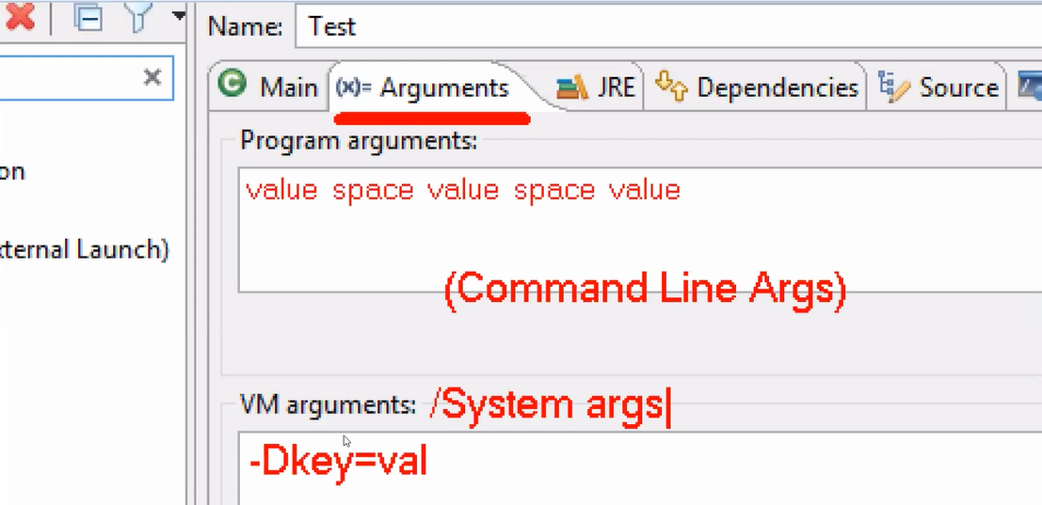

**Spring Boot Input (key=val) priority order is:**

1. Command Line Args(Option args)

--key=value

**Ex:**

--my.app.code=VIE-GLOBAL-DATA

1. VM/System Args

-Dkey=val

**Ex:**

-Dmy.app.code=VIE-GLOBAL-VM

1. application.properties

key=val

**Ex:**

my.app.code=VIE-GLOBAL-PROPS

1. application.yml

key: val

**Ex:**

my:

app:

code: VIE-GLOBAL-YML

**Runner class:**

**package** com.SpringBootArgsTest.runner;

**import** org.springframework.beans.factory.annotation.Value;

**import** org.springframework.boot.CommandLineRunner;

**import** org.springframework.stereotype.Component;

@Component

**public** **class** TestArgsRunner **implements** CommandLineRunner {

@Value("${my.app.code}")

**private** String code;

@Override

**public** **void** run(String... args) **throws** Exception {

System.***out***.println(code);

}

}

* Pass data using Command Line Args, VM args, properties and YMAL.
* If no key found, then @Value – throws execption. And @ConfigProps – gives default value.

**Q)** How can we convert our Spring Boot (Maven Project) into jar/war files?

**A)**

**Step1:** Setup Installed JRE

* Window > Preferences > Search using ‘Installed’ > Select Installed JRE > Click on Add button > Choose ‘Standard VM’ > Next > Click on Directory > select location of JDK

(Ex: C:\Program Files\Java\jdk-18.0.1.1) > Finish > Apply > Select checkbox > Apply and Close

**Step2:** Clean Project

* Right click on project > Run as > Maven Clean

**Step3:** Build/Install Project

* Right click on project > Run as > Maven Install

**Step4:** Refresh Project

Under target folder you can find jar : projectname-version.jar

Maven: <https://www.youtube.com/c/NareshIT/search>

* Run Docker Image

<https://www.youtube.com/c/NareshIT/search>

[“java”, “ –jar”, “SpringBootArgsTest-0.0.1-SNAPSHOT.jar”, “--my.app.code=VINEETH-IE”]

Q) How can we pass CommandLine Args to Spring boot at runtime?

A) > Execute Maven Goals for JAR/WAR creation.

> execute jar with --key=val

cmd >java -jar SpringBootArgsTest-0.0.1-SNAPSHOT.jar --my.app.code=VINEETH-IE

**Spring Based : Java Configuration HAS-A**

Association / HAS-A : Using child as DataType (class/interface) and creating variable, inside parent (class). Parent----<>Child

Coding order for @Bean: Child first, so we can use in parent next.

* Environment (I) [package: org.springframework.core.env]

It is an interface impl class: StandardEnvironment(C)

This is created inside Spring Container (by using Spring f/w only) that holds all key=vals given from different sources. Like Command Line Args, VM Args, Properties, YAML etc.,

* If we use @Value, @ConfigProps etc., data fetch from Environment only.
* In case of java config, we cannot use @Value. So, direct link created with Environment only. Use method env.getProperty(“key”) that return value from Environment memory.

**Example**

**Name:** SpringBootJavaConfigEnv

**Dependencies:** Lombok

1. Beans / Models

**package** com.SpringBootJavaConfig2.bean;

**import** lombok.Data;

@Data

**public** **class** Address {

**private** String hno;

**private** String loc;

}

----

**2.**

**package** com.SpringBootJavaConfig2.bean;

**import** lombok.Data;

@Data

**public** **class** Employee {

**private** String ename;

**private** String edept;

**private** Address addr; //HAS-A

}

1. *** Config File

**package** com.SpringBootJavaConfig2.config;

**import** org.springframework.beans.factory.annotation.Autowired;

**import** org.springframework.context.annotation.Bean;

**import** org.springframework.context.annotation.Configuration;

**import** org.springframework.core.env.Environment;

**import** com.SpringBootJavaConfig2.bean.Address;

**import** com.SpringBootJavaConfig2.bean.Employee;

@Configuration

**public** **class** AppConfig {

@Autowired

**private** Environment env;

//1 object = 1 method

@Bean("aobj")

**public** Address addr() {

Address a=**new** Address();

a.setHno(env.getProperty("my.data.hno"));

a.setLoc(env.getProperty("my.data.loc"));

**return** a;

}

//1 object = 1 method

@Bean

**public** Employee emp() {

Employee e=**new** Employee();

e.setEname(env.getProperty("my.data.ename"));

e.setEdept(env.getProperty("my.data.edept"));

e.setAddr(addr());

**return** e;

}

}

1. Runner class

**package** com.SpringBootJavaConfig2.runner;

**import** org.springframework.beans.factory.annotation.Autowired;

**import** org.springframework.boot.CommandLineRunner;

**import** org.springframework.stereotype.Component;

**import** com.SpringBootJavaConfig2.bean.Employee;

@Component

**public** **class** TestJavaConfigRunner **implements** CommandLineRunner {

@Autowired

**private** Employee e;

@Override

**public** **void** run(String... args) **throws** Exception {

System.***out***.println(e);

}

}

---

1. application.properties

my.data.hno=180/299

my.data.loc=KRTL

my.data.ename=KATHERINE

my.data.edept=FLIM

1. Starter class

package com.SpringBootJavaConfig2;

import org.springframework.boot.SpringApplication;

import org.springframework.boot.autoconfigure.SpringBootApplication;

@SpringBootApplication

public class SpringBootJavaConfigEx2Application {

public static void main(String[] args) {

SpringApplication.run(SpringBootJavaConfigEx2Application.class, args);

}

}

**Spring Boot : Profile**

**[ properties/yml + @Profile]**

**Environment:**

A System/Runtime Setup for our Application is called Environment.

In general server + Application + Database + Tools …. etc.,

* Different Environments are:

Dev, QA, UAT(User Acceptance Test), Production (Actual server where end-user are used).

* In Spring Boot for every concept we get starters (Readymade code in JAR format given by parent project).

spring-boot-starter-jdbc [driver, url, username, password]

spring-boot-starter-email [host, port, username, password, jmp (java mail properties)]

etc..,

**Profiles:**

To handle Environment based properties loading code execution we use profiles.

1. Profiles using Inputs [properties/YAML]
2. Profiles using code [@Profile]

**Profiles using Inputs [properties/YAML]**

* Always one profile will kept active: default.
* default profile always loads: application.properties
* we can define environment based properties using profile with file name:

application-[profilename].properties

**Ex:**

application-abcd.properties Profile name : abcd

application-qa.properties Profile name : qa

application-uat.properties Profile name : uat

application-prod.properties Profile name : prod

Q) How can we activate one profile?

A) By using pre-defined key ‘spring.profiles.active’ we can activate profile name given.

--spring.profiles.active=<profileName>

--spring.profiles.active=uat

* If we do not pass above key, then default profile is active that loads application.properties

--spring.profiles.active=qa

> java –jar sampleapp.war --spring.profiles.active=qa

Docker and run

**Profile Fall back:** If we activate on profile (having properties) but one key is not found in current profile, then Spring Boot reads such key from default properties file i.e. called as Fall back.

**-- code –**

**1. Name:** SpringBootProfileTest

**Dependencies:** Lombok

1. **Runner class**

**package** com.SpringBootProfileTest.runner;

**import** org.springframework.boot.CommandLineRunner;

**import** org.springframework.boot.context.properties.ConfigurationProperties;

**import** org.springframework.stereotype.Component;

**import** lombok.Data;

@Component

@Data

@ConfigurationProperties(prefix = "my.app")

**public** **class** MyProfileRunner **implements** CommandLineRunner {

**private** String driver;

**private** String url;

@Override

**public** **void** run(String... args) **throws** Exception {

System.***out***.println("Done");

System.***out***.println(**this**);

}

}

1. **properties files**

**application.properties**

my.app.driver=Oracle-Default

my.app.url=JDBC-Oracle-Default

**application-qa.properties**

my.app.driver=Oracle-QA

my.app.url=JDBC-Oracle-QA

**application-uat.properties**

my.app.driver=Oracle-UAT

my.app.url=JDBC-Oracle-UAT

* Profiles also applicable for YAML Files too..

1. We can define profile based YAML File

Ex:

application.yml

my:

app:

driver: Oracle-DEF

application-qa.yml

my:

app:

driver: Oracle-QA

application-uat.yml

my:

app:

driver: Oracle-UAT

1. We can create single YAML file (one YAML file ) using symbol 3 dashes (---) which makes new profile area but must provide profile name using spring:profiles:__

Ex: application.yml

my:

app:

driver: Oracle-DEF

#default

---

my:

app:

driver: Oracle-QA

spring:

profiles: qa

---

my:

app:

driver: Oracle-QA

spring:

profiles: uat

* Right click on code > Run As > Run Configuration > Arguments tab > Under Program Args

--spring.profiles.active=qa

* Apply > Run

**Profiles:** Execute logic/load properties based on environment

**Properties files:**

application-[profile name].properties

**YAML:**

application-[profile name].yml

* Use 3 dash (---) create new profile using single YAML file.
* Profile can be activated using:

--spring.profiles.active=___

* **Chilld/Include Profile:**

In real-time applications, properties file contains more no. of keys instead of writing them in single properties file, we can just divide into multiple files and finally combine them. It is called as profile include concept.

* This is only for modularity, not the concept of performance.

Programmer: Why this concept??

* Requirement
* Performance (reduce lines of code, execution time/memory)
* Modularity (code readability)
* In case of child profiles, if same key found at multiple places then last loaded combination is considered.
* First main profile loaded then child’s is given order are loaded.
* In our example prod first then prodmail and proddb are loaded.
* Activation profile can be given in CLA(Cpmmand Line Args) or we can even provide in properties file[not recomanded].

-- code ---

a.

Name: SpringBootProfileInclude

Dependencies: Lombok

b. application-prod.properties

my.app.id=101

my.app.title=VIE

spring.profiles.include=proddb,prodmail

application-proddb.properties

my.db.driver=oracle.jdbc.driver.OracleDriver

my.db.url=jdbc:oracle:thin:@localhost:1521:xe

application-prodmail.properties

my.mail.host=GMAIL

my.mail.port=589

1. Runner class

**package** com.SpringBootProfilesInclude.runner;

**import** org.springframework.beans.factory.annotation.Value;

**import** org.springframework.boot.CommandLineRunner;

**import** org.springframework.stereotype.Component;

**import** lombok.Data;

@Component

@Data

**public** **class** DataReadRunner **implements** CommandLineRunner {

@Value("${my.app.id}")

**private** Integer id;

@Value("${my.app.title}")

**private** String title;

@Value("${my.app.driver}")

**private** String driver;

@Value("${my.app.url}")

**private** String url;

@Value("${my.app.host}")

**private** String host;

@Value("${my.app.port}")

**private** Integer port;

@Override

**public** **void** run(String... args) **throws** Exception {

System.***out***.println(**this**);

}

}

ctrl + alt + up/down arrows -- copy current line and paste above/below

alt + up/down arrows -- to move current/ selected lines

@Profile Annotation: Executing logic based on Environment selected.

Ex: Work only in dev Environment

@Profile(“dev”)

class sample{

//code sample

}

Ex: Work everywhere not in dev Environment

@Profile(“!dev”)

class sample{

//code sample

}

Ex: Work in dev,qa,prod Environments

@Profile({“dev”, “qa”, “prod”})

class sample{

//code sample

}

* @Profile says on what Environment logic must be executed. It will not activate profile. We must activate using

--spring.profile.active=__

--Dummy Example—

a) Name: SpringBootProfileCodeAnnotation

b) Runner with @Profile

**package** com.SpringBootProfileCodeAnnotation.runner;

**import** org.springframework.boot.CommandLineRunner;

**import** org.springframework.context.annotation.Profile;

**import** org.springframework.stereotype.Component;

@Component

@Profile("qa")

**public** **class** MessageARunner **implements** CommandLineRunner {

@Override

**public** **void** run(String... args) **throws** Exception {

System.***out***.println("FROM QA ENVIRONMENT");

}

}

---

**package** com.SpringBootProfileCodeAnnotation.runner;

**import** org.springframework.boot.CommandLineRunner;

**import** org.springframework.context.annotation.Profile;

**import** org.springframework.stereotype.Component;

@Component

@Profile({"default","prod"})

**public** **class** MessageBRunner **implements** CommandLineRunner {

@Override

**public** **void** run(String... args) **throws** Exception {

System.***out***.println("FROM DEV[default]/PROD ENVIRONMENTS");

}

}

----

package com.SpringBootProfileCodeAnnotation.runner;

import org.springframework.boot.CommandLineRunner;

import org.springframework.context.annotation.Profile;

import org.springframework.stereotype.Component;

@Component

@Profile("!prod")

public class MessageCRunner implements CommandLineRunner {

@Override

public void run(String... args) throws Exception {

System.out.println("FROM NON-PROD ENVIRONMENTS");

}

}

* Activating multiple profiles may give output (might not be valid one) or Execption.

--spring.profiles.active=qa,prod

Code annotated with @Profile(“qa”) and @Profile(“prod”) are executed. No issues. Problem comes with properties only.

@Profile(“qa”) : Execute code only in QA Environment.

@Profile({“default”, “prod”}) : Execute code only in Default/PROD Environment.

@Profile(“!prod”) : Do not execute code if current Environment is PROD.

Q) On what environment SampleA and SampleB are executed?

@Component

class SampleA{}

@Component

@Profile(“default”)

class SampleB{}

1. SampleA gets executed in every environment. (Ex: current profile qa/prod/or any, also works)

SampleB gets executed in default environment only. (Ex: current profile qa/prod not works)

Interface

* Impl1 @Component
* Impl2 @Component
* Impl3 @Component
* Even want to link with interface reference?

interface A{}

@Component

class B implements A{}

@Component

class C implements A{}

@Component

class D implements A{}

@Autowired

private A oa;

NoUniqueBeanDefFoundExecption: expected single matching but found 3

@Qualifier : recommended for pre-defined classes, at HAS-A level

@Primary : recommended for programmer-defined classes, at Implementation class

@Profile : recommended at production environment.

**Profiles (@Profile) in Spring Boot**

@Profile (applied on class) used to indicate ‘execute code when given profile is active’.

** @Profile will not activate any profile. It says just execute code when (--spring.profiles.active=Value) and @Profile(Value) is matching.

@Component

@Profile(“qa”)

class Sample{

}

* Now activate profile --spring.profiles.active=qa

Q) Profiles Fallback?

A) If current profile has no key then read data from default properties

Q) Can we inject two or more objects into one reference variable?

A)

ClassName ob=new ClassName(), new ClassName(), new ClassName();

@Qualifier... run in any environment 🡪Same output will come.

* Activating multiple profiles in single system/single run has no meaning. It may given wrong output or Execption.

In our code 2 beans are created and injection becomes problem.

One interface reference cannot hold two impl objects.

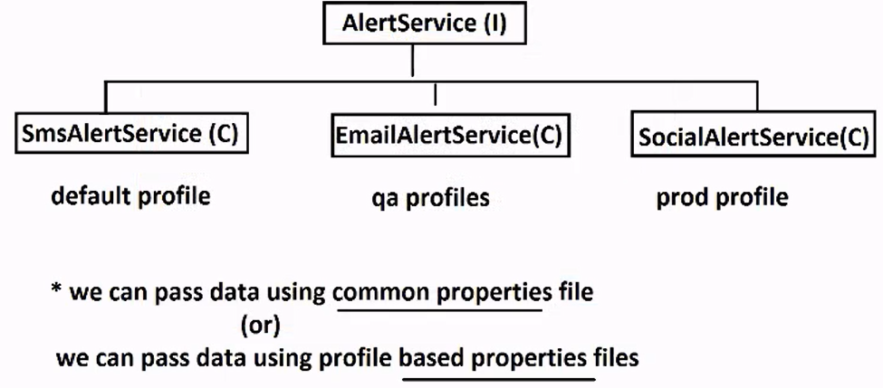

**Code**

**Name:** SpringBootProfileAnnotationEx2

**Dependencies:** Lombok

1. Service Interface

**package** com.SpringBootProfileCodeAnnotation.service;

**public** **interface** AlertService {

**void** send();

}

1. Impl classes

**package** com.SpringBootProfileCodeAnnotation.service.impl;

**import** org.springframework.beans.factory.annotation.Value;

**import** org.springframework.context.annotation.Profile;

**import** org.springframework.stereotype.Component;

**import** com.SpringBootProfileCodeAnnotation.service.AlertService;

@Component

@Profile("default")

**public** **class** SmsAlertService **implements** AlertService {

@Value("${my.app.code}")

**private** String code;

@Override

**public** **void** send() {

System.***out***.println("SMS ALERT-FROM DEFAULT PROFILE=>" +code);

}

}

----

**package** com.SpringBootProfileCodeAnnotation.service.impl;

**import** org.springframework.beans.factory.annotation.Value;

**import** org.springframework.context.annotation.Profile;

**import** org.springframework.stereotype.Component;

**import** com.SpringBootProfileCodeAnnotation.service.AlertService;

@Component

@Profile("qa")

**public** **class** EmailAlertService **implements** AlertService {

@Value("${my.app.code}")

**private** String code;

@Override

**public** **void** send() {

System.***out***.println("EMAIL ALERT-QA PROFILE=> "+code);

}

}

----

**package** com.SpringBootProfileCodeAnnotation.service.impl;

**import** org.springframework.beans.factory.annotation.Value;

**import** org.springframework.context.annotation.Profile;

**import** org.springframework.stereotype.Component;

**import** com.SpringBootProfileCodeAnnotation.service.AlertService;

@Component

@Profile("prod")

**public** **class** SocialAlettService **implements** AlertService {

@Value("${my.app.code}")

**private** String code;

@Override

**public** **void** send() {

System.***out***.println("SOCIAL-ALERT-FROM PROD ENVIRONMENT=> "+code);

}

}

1. **properties files**

**--**application.properties—

my.app.code=VIE-HYD

---

**--**application-qa.properties—

my.app.code=VIE-HYD-QA

---

**--**application-prod.properties—

my.app.code=VIE-HYD-PROD

1. Activate Profile while running starter

--spring.profiles.active=qa

1. Runner class

**package** com.SpringBootProfileCodeAnnotation.runner;

**import** org.springframework.beans.factory.annotation.Autowired;

**import** org.springframework.boot.CommandLineRunner;

**import** org.springframework.stereotype.Component;

**import** com.SpringBootProfileCodeAnnotation.service.AlertService;

@Component

**public** **class** TestAlertServiceRunner **implements** CommandLineRunner {

@Autowired

**private** AlertService service;

@Override

**public** **void** run(String... args) **throws** Exception {

service.send();

}

}

**Spring : Autowired Example**

**Case1:** One object found for @Autowired injected

**Case2:** @Autowired found zero objects inject then it gives execption: NoSuchBeanDefFound (expected one object)

**Spring Boot Core Concepts**

1. Interface as child in HAS-A

A ---<> B

^

| IS-A

C

B ob=new C();

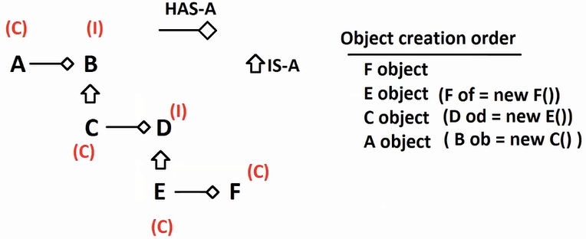

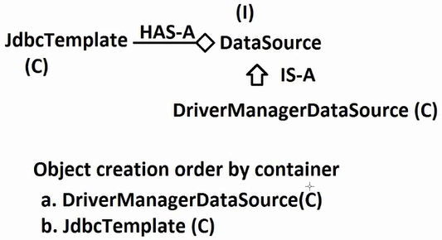

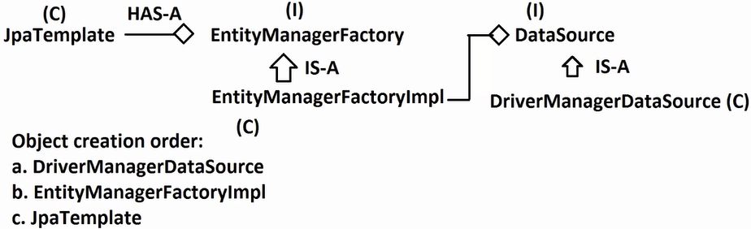

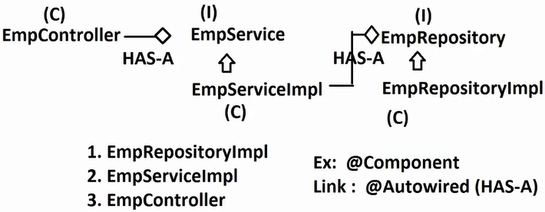

* In Association mapping (HAS-A) always child object is created first. Parent ---<> Child
* In Association mapping, if child is interface, then implementation class object is selected.
* IS-A : Inheritance (extends / implements)
* HAS-A : Association (Using child as DataType, create variable in parent)

Q) What is Dynamic Polymorphism?

A) Compile time connected to super type (interface/class) method and Runtime executing sub type method. [It can be implemented using interface-impl class with overriding concept]

Intrerface ob=new ImplClass();

ob.methodCall();

-- Spring Autowired ---

1.

**package** com.SpringBootAssociationTest.repo;

**public** **interface** EmpRepository {

**public** **void** saveEmp();

}

2.

**package** com.SpringBootAssociationTest.service;

**public** **interface** EmpService {

**public** **void** saveEmp();

}

3.

**package** com.SpringBootAssociationTest.repo.impl;

**import** org.springframework.stereotype.Component;

**import** com.SpringBootAssociationTest.repo.EmpRepository;

@Component

**public** **class** EmpRepositoryImpl **implements** EmpRepository{

**public** EmpRepositoryImpl() {

System.***out***.println("EmpRepository#Obj");

}

@Override

**public** **void** saveEmp() {

System.***out***.println("FROM Database Logics.");

}

}

4.

**package** com.SpringBootAssociationTest.service.impl;

**import** org.springframework.beans.factory.annotation.Autowired;

**import** org.springframework.stereotype.Component;

**import** com.SpringBootAssociationTest.repo.EmpRepository;

**import** com.SpringBootAssociationTest.service.EmpService;

@Component

**public** **class** EmpServiceImpl **implements** EmpService {

**public** EmpServiceImpl() {

System.***out***.println("EmpService#Object");

}

@Autowired

**private** EmpRepository repo;

@Override

**public** **void** saveEmp() {

repo.saveEmp();

System.***out***.println("FROM SERVICE");

}

}

5.

**package** com.SpringBootAssociationTest.controller;

**import** org.springframework.beans.factory.annotation.Autowired;

**import** org.springframework.stereotype.Component;

**import** com.SpringBootAssociationTest.service.EmpService;

@Component

**public** **class** EmpController {

**public** EmpController() {

System.***out***.println("EmpController#Object");

}

@Autowired

**private** EmpService service;

**public** **void** testSave() {

service.saveEmp();

System.***out***.println("FROM CONTROLLER");

}

}

6.

**package** com.SpringBootAssociationTest.runner;

**import** org.springframework.beans.factory.annotation.Autowired;

**import** org.springframework.boot.CommandLineRunner;

**import** org.springframework.stereotype.Component;

**import** com.SpringBootAssociationTest.controller.EmpController;

@Component

**public** **class** TestRelation **implements** CommandLineRunner {

@Autowired

**private** EmpController controller;

@Override

**public** **void** run(String... args) **throws** Exception {

// **TODO** Auto-generated method stub

controller.testSave();

}

}

-- Spring CDI (Constructor Dependency Injection) ---

1.

**package** com.SpringBootAssociationTest.repo;

**public** **interface** EmpRepository {

**public** **void** saveEmp();

}

2.

**package** com.SpringBootAssociationTest.repo.impl;

**import** org.springframework.stereotype.Component;

**import** com.SpringBootAssociationTest.repo.EmpRepository;

@Component

**public** **class** EmpRepositoryImpl **implements** EmpRepository{

**public** EmpRepositoryImpl() {

System.***out***.println("EmpRepository#Obj");

}

@Override

**public** **void** saveEmp() {

System.***out***.println("FROM Database Logics.");

}

}

3.

**package** com.SpringBootAssociationTest.service;

**public** **interface** EmpService {

**public** **void** saveEmp();

}

4.

**package** com.SpringBootAssociationTest.service.impl;

**import** org.springframework.beans.factory.annotation.Autowired;

**import** org.springframework.stereotype.Component;

**import** com.SpringBootAssociationTest.repo.EmpRepository;

**import** com.SpringBootAssociationTest.service.EmpService;

@Component

**public** **class** EmpServiceImpl **implements** EmpService {

**private** EmpRepository repo;

**public** EmpServiceImpl(EmpRepository repo) {

**this**.repo=repo;

System.***out***.println("EmpService#Object");

}

//@Autowired

//private EmpRepository repo;

@Override

**public** **void** saveEmp() {

repo.saveEmp();

System.***out***.println("FROM SERVICE");

}

}

5.

**package** com.SpringBootAssociationTest.controller;

**import** org.springframework.beans.factory.annotation.Autowired;

**import** org.springframework.stereotype.Component;

**import** com.SpringBootAssociationTest.service.EmpService;

@Component

**public** **class** EmpController {

**private** EmpService service;

**public** EmpController(EmpService service) {

**this**.service=service;

System.***out***.println("EmpController#Object");

}

//@Autowired

//private EmpService service;

**public** **void** testSave() {

service.saveEmp();

System.***out***.println("FROM CONTROLLER");

}

}

6.

**package** com.SpringBootAssociationTest.runner;

**import** org.springframework.beans.factory.annotation.Autowired;

**import** org.springframework.boot.CommandLineRunner;

**import** org.springframework.stereotype.Component;

**import** com.SpringBootAssociationTest.controller.EmpController;

@Component

**public** **class** TestRelation **implements** CommandLineRunner {

@Autowired

**private** EmpController controller;

@Override

**public** **void** run(String... args) **throws** Exception {

// **TODO** Auto-generated method stub

controller.testSave();

}

}

**Spring Boot Core: Scheduling**

**Scheduling:** Executing a task based on Period of Time/ Point of Time in a loop.

**Examples:**

1. Bank Account Statement
2. CC Billing/Invoice
3. Reports Generation
4. Payslip/Salary Processing
5. Birthday wishes... etc.,

Point of Time: (Exact Date/Time)

1st JAN – 9AM

6PM – DEC 14th

Point of Time: (Time gap)

4 hrs,

5 min,

5 months

* **Scheduling using Spring Boot**

1. fixedDelay
2. fixedRate
3. *** cron (cron expression)

-- Scheduling Coding Steps –

Step1: Create Spring Boot application

Step2: At main class / starter class, add : @EnableScheduling

Step3: Define one class with void method apply : @Scheduled on method

* @Scheduled can take any one of 3 options

1. fixedDelay=__
2. fixedRate=__
3. cron=__

Q) What is Demon Thread?

A) A Thread runs in background from application start to end, which will not affect your application usage from users.

* Schedulers are executed as Demon Thread which will not affect actual flow of application, it is started when application/server is starting and ended when we stop application/server.
* Goto console and click on Red colour button to stop application in STS/Eclipse.

Time Factor

* BASE FACTOR FOR TIME IS NANO SEC.

1 NANO_SCALE = 1L;

1 MICRO_SCALE = 1000L * NANO_SCALE;

1 MILLI_SCALE = 1000L * MICRO_SCALE;

1 SECOND_SCALE= 1000L * MILLI_SCALE;

1 MINUTE_SCALE = 60L * SECOND_SCALE;

1 HOUR_SCALE = 60L * MINUTE_SCALE;

1 DAY_SCALE = 24L * HOUR_SCALE;

* In java 1.5 (JDK 5) TimeUnit (enum) is added that supports time conversions by any java app/tech/fw etc.,

Ex:

**package** com.SpringBootSchedulingDemo;

**import** java.util.concurrent.TimeUnit;

**public** **class** Test {

**public** **static** **void** main(String[] args) {

**long** timea=TimeUnit.***HOURS***.toSeconds(4);

System.***out***.println(timea);

**long** timeb=TimeUnit.***DAYS***.toNanos(5);

System.***out***.println(timeb);

**long** timec=TimeUnit.***MILLISECONDS***.toSeconds(5000);

System.***out***.println(timec);

}

}

* **fixedDelay:** (input time in milli sec)

This is used to indicate time gap between two method calls for execution.

* Gap Call = last method call finish time to next method call start time.

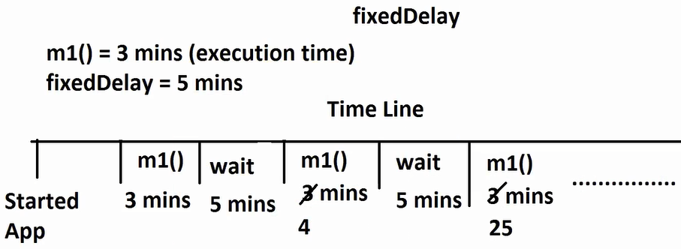

Q) Do we need to write @EnableScheduling at starter?

A) Yes, Else no schedulers are executed.

Q) Where did write loop in scheduling?

A) Along with @Scheduled, you provide time input, and then container calls this method loop.

Q) Can we apply @Scheduled on class?

A) No. only at method (TASK).

Q) Can we define multiple schedulers at same time?

A) YES, very simple define multiple classes/methods method with @Scheduled.

Ex:

**package** com.SpringBootSchedulingDemo.service;

**import** java.util.Date;

**import** org.springframework.scheduling.annotation.Scheduled;

**import** org.springframework.stereotype.Component;

@Component

**public** **class** EmpReportService {

@Scheduled(fixedDelay = 5000) //mili sec

**public** **void** executeReportA() {

System.***out***.println("ABC REPORT DATA..." + **new** Date());

}

@Scheduled(fixedDelay = 3000) //mili sec

**public** **void** executeReportB() {

System.***out***.println("IJK REPORT DATA..." + **new** Date());

}

}

Q) Any conditions on methods?

A) YES, must be void type and zero params, method called by container.

Q) How long scheduler is going to run?

A) Until we stop application.

Q) Can we define only @Scheduled annotation?

A) No. java.lang.IllegalStateException: Encountered invalid @Scheduled method 'executeReportA': One-time task only supported with specified initial delay.

* Even if we provide fixedDelay attribute with value zero or –ve then also same exception. It must be a +ve number.
* In case of time value is very big number (out of long range) then use fixedDelayString= “___”.

Ex:

@Scheduled(fixedDelayString = "5000")

**public** **void** executeReportA() {….}

* We can provide intialDelay= “” that indicates time gap between application start and first time method call.

Ex:

@Scheduled(initialDelay = 4000, fixedDelay = 5000)

**public** **void** executeReportA() {

System.***out***.println("ABC REPORT DATA..." + **new** Date());

}

* **fixedRate:** It gives max wait time (not exact wait time) between last method start time to next method start time.

Ex:

@Scheduled(fixedRate = 5000)

**public** **void** executeReportA() {

System.***out***.println("ABC REPORT DATA..." + **new** Date());

}

**Spring Boot Scheduling using cron**

* **cron** is expression used to indicate date time.
* It can be used both point of time (default) and even period of time.

**CRON EXPRESSION**

**SEC MIN HR DAY MONTH WEEKDAY**

0-59 0-59 0-23 1-31 1-12 SUN-SAT

**Symbols allowed in CRON:**

* = any/all

- = range

, = possible values

/ = period

? = any/all used for DAY and WEEKDAY when month is provided.

**Ex: 1**

0 0 9 * * *

Execute task, every day 9:00:00 AM

* 23th Dec 9:00:00 AM
* 24th Dec 9:00:00 AM
* 25th Dec 9:00:00 AM

Etc..,

**Ex: 2**

0 0 18 * * *

Execute task, every day 6:00:00 PM

* 23th Dec 6:00:00 PM
* 24th Dec 6:00:00 PM
* 25th Dec 6:00:00 PM

Etc..,

**Ex: 3**

0 0 6,18 * * *

Execute task, every day 2 times 6:00:00 AM and 6:00:00 PM

**Ex: 4**

0 0 9,14 * * *

Execute task, every day 2 times 9:00:00 AM and 2:00:00 PM

**Ex: 5**

0 0 * * * *

Execute task, every hour starting 0th min and 0th sec

* App started by 9:20:45 .
* 10:00:00 (first execution)
* 11:00:00
* ..etc

**Ex: 6**

0 30 * * * *

Execute task, every hour 30th min 0th sec (it is not 30 mis gap)

* App started by 9:20:45 .
* 9:30:00 (first execution will be at 9hr 30th min 0th sec.)
* 10:30:00
* 11:30:00
* ..etc

**Ex: 7**

10 * * * * *

Execute task, every minute 10th sec[it is not sec gap, it is 10th sec of a minute].

* 9:28:46 App started
* 9:29:10 (1st execution)
* 9:30:10
* 9:31:10
* ..etc

**Ex: 8**

45 20 * * * *

> Every hour 20th min 45th sec

> Application started: 8:35:00 PM

> 1st Execution

> 9:45:20

> 10:45:20

> 11:45:20

**Ex: 9**

65 * * * * *

> java.lang.IllegalStateException: Encountered invalid @Scheduled method 'executeReportA': Invalid value for SecondOfMinute (valid values 0 - 59): 65 '65' in cron expression "65 * * * * *

**Ex: 10**

0 25 * * *

> java.lang.IllegalStateException: Encountered invalid @Scheduled method 'executeReportA': Cron expression must consist of 6 fields (found 5 in "0 25 * * *")

**Ex: 11**

0 0 9-11 * *

> Every day, execute

> 9:00:00 AM

> 10:00:00 AM

> 11:00:00 AM

Symbol (-) indicates possible range.

**Ex: 12**

30 15, 25 * * * *

> Every hour 15th min 30th sec and 25th min 30th sec

> App started just now (13:02:00)

> 13:15:30 PM

> 13:25:30 PM

> 14:15:30 PM

> 14:25:30 PM

**Ex: 13**

10 25- 30 9,18 * * *

> Every day, 9AM , 6PM 25th min to 30th min (25,26,27,28,29,30) and 10th sec.

, comma - possible values

- dash - range

6,9 - only 6 and 9

6-9 - range

> App started just now (9:02:00)

> 9:25:10 AM

> 9:26:10 AM

> 9:27:10 AM

> 9:28:10 AM

> 9:29:10 AM

> 9:30:10 AM

> 6:25:10 PM

> 6:26:10 PM

> 6:27:10 PM

> 6:28:10 PM

> 6:29:10 PM

> 6:30:10 PM

**Ex: 14**

0 0 9 1 * *

> Every month, 1st (Day) , 9:00:00 Execute task.

> March 1st 9:00:00 AM (1st Execution)

> April 1st 9:00:00 AM (2st Execution)

> May 1st 9:00:00 AM (3st Execution)

**Ex: 15**

0 0 9 1 * MON-FRI

> Execute every month, 1st if not SAT or SUN.

> Execute every month, 1st if current day is in MON to FRI.

> March 1st 9:00:00 AM (1st Execution) Moday (execute)

> April 1st 9:00:00 AM (2st Execution) Thursday (execute)

> May 1st 9:00:00 AM (Not Executed) It is SATARDAY (dont).

> June 1st 9:00:00 AM (3rd Execution) Thursday (execute)

**Ex: 15**

0 0 9 10,15 * SUN

> Execute given task every month, 10th & 15th day if it is SUNDAY only at 9:00:00 AM

**Ex: 16**

0 0 9 10 3 MON-FRI

> Execute given task every year, 3rd month (March) 10th Day 9:00:00 AM if not SATARDAY/ SUNDAY.

**Ex: 17**

0 0 9 * 3 * (Invalid)

0 0 9 ? 3 ? (Valid)

Use symbol ? when month is provided and required every day/week day

**Ex: 18**

Use symbol / for any position (not for week days) to indicate period of time

*/10 * * * * * => For every 10 sec

* */15 * * * * => For every 15 mins

> In case of all stars: (execute task with gap of max 1 sec)

* * * * * *

**Ex:**

package com.SpringBootSchedulingDemo.service;

import java.util.Date;

import org.springframework.scheduling.annotation.Scheduled;

import org.springframework.stereotype.Component;

@Component

public class EmpReportService {

//@Scheduled(fixedDelay = 5000) //mili sec

//@Scheduled(fixedDelayString = "5000")

//@Scheduled(initialDelay = 4000, fixedDelay = 5000)

//@Scheduled(fixedRate = 5000)

//@Scheduled(cron = "10 * * * * *") //10th sec of a minute

@Scheduled(cron = "*/10 * * * * *") //10 sec gap

public void executeReportA() {

System.out.println("ABC REPORT DATA..." + new Date());

}

/*

@Scheduled(fixedDelay = 3000) //mili sec

public void executeReportB() {

System.out.println("IJK REPORT DATA..." + new Date());

}

*/

}

**Example patterns:**

"0 0 * * * *" = the top of every hour of every day.

"*/10 * * * * *" = every ten seconds.

"0 0 8-10 * * *" = 8, 9 and 10 o'clock of every day.

"0 0/30 8-10 * * *" = 8:00, 8:30, 9:00, 9:30 and 10 o'clock every day.

"0 0 9-17 * * MON-FRI" = on the hour nine-to-five weekdays

"0 0 0 25 12 ?" = every Christmas Day at midnight

**Req:**

1. 1 sec befor to New year

Midnight 1sec before to 12AM, 31st Dec.

59 59 23 31 12 ?

**2.** Every year August, 22nd 6AM and 6PM execute task if not MONDAY

0 0 6,18 22 ?8TUS-SUN

**3.** February, 14th – 1sec before day starting.

59 59 23 13 2 ?

**4.** Yours DOB, Happy B-Day (1sec before day starting)

59 59 23 1 4 ?

**Spring Boot – Internals**

* **Auto-Configuration:**

**Spring Framework:** Programmer is doing task (for setup).

**Spring Boot:** Pre-Defined code.

**Spring Java based configuration [ @Configuration, @Bean]**

1. public class with any name.
2. apply @Configuration over class.
3. define one method = one object

public className/InterfaceName methodName(){

//logic

}

1. Add @Bean (object) over methods.

**Spring code:**

1. Database connection

DataSource(I)

Impl class

DriverManagerDataSource(C)

driverClassName

Url

Username

Password

**-- Spring XML Configuration –**

<bean id= “ds” class= “org.springframework.jdbc.datasource.DriverManagerDataSource”>

<property name= “driverClassName” value= “oracle.jdbc.driver.OracleDriver”>

<property name= “url” value= “jdbc:oracle:thin:@localhost:1521:xe”>

<property name= “username” value= “system”>

<property name= “password” value= “root”>

</bean>

**-- Spring Java Configuration –**

@Configuration

public class AppConfig{

@Bean

public DataSource ds(){

DriverManagerDataSource d=new DriverManagerDataSource();

d.setDriverClassName(“oracle.jdbc.driver.OracleDriver”);

d.setUrl(“jdbc:oracle:thin:@localhost:1521:xe”);

d.setUsername(“system”);

d.setPassword(“root”);

return d;

}

}

1. ORM(Hibernate)

DataSource

Impl class

DriverManagerDataSource

SessionFactory

Impl class

LocalSessionFactoryBean

@Configuration

public class AppConfig{

@Bean

public DataSource ds(){

DriverManagerDataSource d=new DriverManagerDataSource();

d.setDriverClassName(“oracle.jdbc.driver.OracleDriver”);

d.setUrl(“jdbc:oracle:thin:@localhost:1521:xe”);

d.setUsername(“system”);

d.setPassword(“root”);

return d;

}

@Bean

public LocalSessionFactory sf(){

LocalSessionFactory s=new LocalSessionFactory();

s.setDtatSource(ds());

s.setAnnotatedPackages(“com.vie.model”);

s.setHibernateProperties(props());

}

}

**Spring Boot:**

* Jars, classes/interface(API), [objects]configuration code

spring-boot-starter-[___]

pom.xml

<dependency>

<groupId>org.springframework.boot </groupId>

<artifactId>spring-boot-starter-jdbc</artifactId>

</dependency>

build.gradle

implementation

group: ‘org.springframework.boot’

name: ‘spring-boot-starter-jdbc’

application.properties / application.yml

@Bean

@ConfigurationProperties(prefix = “spring.datasource.hikari”)

public HikariDataSource dataSource(DataSourceProperties properties)

{

HikariDataSource dataSource= createDataSource(properties, HikariDataSource.class);

return dataSource;

}

DMDS

Hikari

TomcatCP

JBoss

DBCP 2.x

**Note:**

1. Spring Boot provides pre-defined code using one jar

spring-boot-autoconfiguration (jar name)

1. It provides conditional beans setup

i.e., if properties provided, required jars added then only create beans.

c. To open any autoconfiguration

> Maven Dependenices

> spring-boot-autoconfigure (goto this jar)

> org.springframework.boot.autoconfigure.jdbc [folder/package name]

> DataSourceAutoConfiguration (open this code)

> @EnableConfigurationProperties (click on values )

Ref Link:

<https://spring.io/blog/2020/11/10/new-in-spring-5-3-improved-corn-expressions>

Pay Salary to employees: before starting 1st (last day in month 9M)

0 0 9 L * *

L = Last Day in month

**Spring Boot : Email (with AutoConfigure)**

* We have already registered one Mail Account ([www.gmail.com](http://www.gmail.com))

Step1: Goto Browser and Enter URL: [www.gmail.com](http://www.gmail.com)

Step2: Fill details username/password for Login

Step3: Click on compose button for new message creation

Step4: Fill details (to, cc, bcc, subject, text, attachments… etc.)

Step5: Click on Send Button

* Java Mail Sender API (Sun/Oracle) used by Spring Boot with AutoConfiguration for implementing Email Application.

in pom.xml

<dependency>

<groupId>org.springframework.boot</groupId>

<artifactId>spring-boot-starter-mail</artifactId>

</dependency>

* MimeMessage: [MIME – Multipurpose Internet Mail Extension]

It means, your email supports sending data like Image, Audio, Video, Pdf, Documents, Text etc..,

* Here, MIME indicates any MediaType.
* JavaMailSender (I) [org.springframework.mail.javamail]

JavaMailSenderImpl(C) is implementation class given by Spring Framework

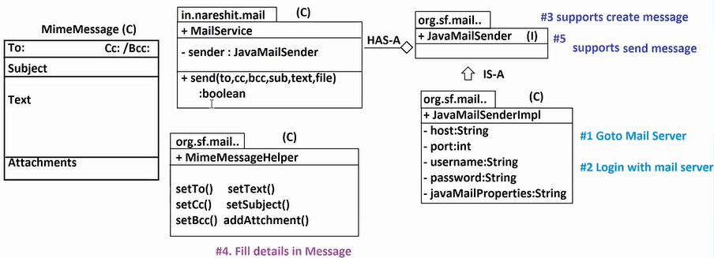

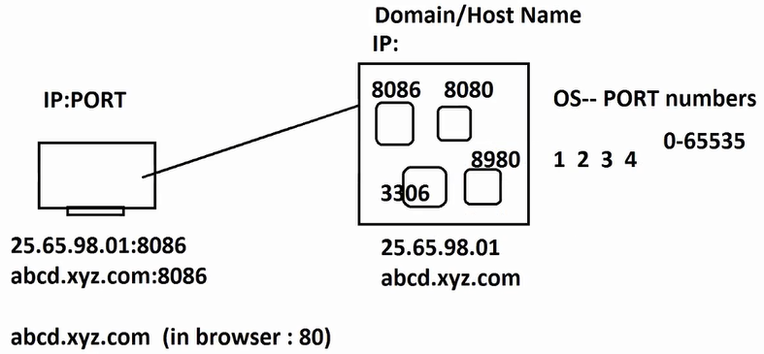

Google Search: google gmail server smtp details

Host: smtp.gmail.com

Port: 587 (TLS)

Username: [vineeth@gmail.com](mailto:vineeth@gmail.com)

Password: 9876543210

-- Spring Java Based Configuration –

@Configuration

public class AppConfig{

@Bean

public JavaMailSender jms(){

JavaMailSenderImpl jm=new JavaMailSenderImpl();

jm.setHost(“smtp.gmail.com”);

jm.setPort(587);

jm.setUsername(“[vineeth@gmail.com](mailto:vineeth@gmail.com)”);

jm.setPassword(“9876543210”);

jm.setJavaMailProperties(props()-> “tls->true”);

return jm;

}

}

* Above code is automated and given in jar ‘spring-boot-autoconfigure’

class name: MailSenderPropertiesConfiguration. (ctrl + shift + T)

* But Above code is activated on few conditions.

1. spring-boot-starter-mail added in pom.xml
2. you must provide keys using prefix “spring.mail”
3. you did not create this Bean manually like Spring code.

-- applicaton.properties –

spring.mail.host=smtp.gmail.com

spring.mail.port=587

spring.mail.username= [vineeth@gmail.com](mailto:vineeth@gmail.com)

spring.mail.password=9876543210

spring.mail.properties.mail.smtp.starttls.enable=true

-- application.yml –

spring:

mail:

host: smtp.gmail.com

password: 9876543210

port: 587

username: vineeth@gmail.com

properties:

mail:

smtp:

starttls:

enable: true

* By using JavaMailSender(I) we can create one empty Message
* By using MimeMessageHelper(C) [org.springframework.mail .javamail] we can fill data
* By using JavaMailSender(I) we can send message.

Q) What is IOS Network Layers model design?

Q) Which Protocol is used for Emails?

Q) How to add security to current protocol?

(or) What is difference between TLS, SSL?

Q) Are you going to send email every time with attachment or without attachment?

A) It may with attachment/ without attachment.

file!=null? then allocate attachment memory : else no.

* **MimeMessage:** MIME – Multipurpose Internet Mail Extension [Any type of data..]
* **MimeMessageHelper:** Supports filling data in message object (to, subject, text, attachments…)
* This object takes two inputs “message:MimeMessage, multipart:boolean”
* If you have attachments to pass using email then define multipart=true, else define multipart=false
* To create one empty message use JavaMailSender

MimeMessage message = sender.createMimeMessage();

* Even to submit/send message use JavaMailSender

sender.send(message)

* In Helper class we have setText() overload methods

setText(String text) ; //calling setText(text, false) interally.

setText(String text, boolean html);

* If first method is called then data is sent as plain text (Display what it is). Second method convert data into HTML Format and gives output in HTML (like browser output).

Q) What is Template Email?

A) Define one HTML Format commonly for multiple users. And replace their data at runtime and send to them using HTML Format.

-- Core Java Code –

**package** com.SpringBootEmailApp;

**import** java.io.FileInputStream;

**public** **class** MailTemplate {

**private** **static** String *template*=**null**;

**static** {

**try** {

FileInputStream fis=**new** FileInputStream("F:\\SpringBoot Videos\\Raghu Sir MS Video\\Notes\\mailtemplate.txt");

**byte**[] bytes=**new** **byte**[fis.available()];

fis.read(bytes);

*template*=**new** String(bytes);

} **catch** (Exception e) {

e.printStackTrace();

}

}

**public** **static** String getTemplate() {

**return** *template*;

}

**public** **static** **void** main(String...args) {

String template=*getTemplate*();

template=template.replace("{{user}}", "Vikarm")

.replace("{{Firstname}}", "Vineeth")

.replace("{{Lastname}}", "Armoori")

.replace("{{date}}", **new** java.util.Date().toString());

System.***out***.println(template);

}

}

-- mailtemplate.txt –

<html>

<body>

<h1>Welcome to {{user}}</h1>

This is sample mail to Mr/Mrs/Ms. {{Firstname}}-{{Lastname}}</br>

Thank you very much.

Date: {{data}}

</body>

</html>

Q) Read File Data into String variable?

FileInputStream fis=**new** FileInputStream("F:\\SpringBoot Videos\\Raghu Sir MS Video\\Notes\\mailtemplate.txt");

**byte**[] bytes=**new** **byte**[fis.available()];

fis.read(bytes);

*template*=**new** String(bytes);

Q) Replace String data with other String input?

template.replace(toBeReplaced, rePlaceText)

Q) What is method overloading?

Same method name with different parameters.

-- code ---

Name: SpringBootEmailApp

Dependencies: Java Mail Sender

1. application.yml:

spring:

mail:

host: smtp.gmail.com

password: Vineeth@2496

port: 587

properties:

mail:

smtp:

starttls:

enable: true

username: vineetharmoori2496@gmail.com

1. MailTemplate

**package** com.SpringBootEmailApp;

**import** java.io.FileInputStream;

**public** **class** MailTemplate {

**private** **static** String *template*=**null**;

**static** {

**try** {

FileInputStream fis=**new** FileInputStream("F:\\SpringBoot Videos\\Raghu Sir MS Video\\Notes\\mailtemplate.txt");

**byte**[] bytes=**new** **byte**[fis.available()];

fis.read(bytes);

*template*=**new** String(bytes);

} **catch** (Exception e) {

e.printStackTrace();

}

}

**private** **static** String getTemplate() {

**return** *template*;

}

**public** **static** String getTemplateData(String user, String fn, String ln) {

String template=*getTemplate*();

template=template.replace("{{user}}", "Vikarm")

.replace("{{Firstname}}", "Vineeth")

.replace("{{Lastname}}", "Armoori")

.replace("{{date}}", **new** java.util.Date().toString());

System.***out***.println(template);

**return** template;

}

}

1. MailService

package com.SpringBootEmailApp.service;

import org.springframework.beans.factory.annotation.Autowired;

import org.springframework.mail.javamail.JavaMailSender;

import org.springframework.mail.javamail.MimeMessageHelper;

import org.springframework.stereotype.Component;

import jakarta.annotation.Resource;

import jakarta.mail.internet.MimeMessage;

@Component

public class MailService {

@Autowired //Read new JavaMailSenderImpl() from container

private JavaMailSender sender;

public boolean sendEmail(

String to,

String cc[],

String bcc[],

String subject,

String text,

org.springframework.core.io.Resource file

) {

boolean isSent=false;

try {

// create new MimeMessage

MimeMessage message=sender.createMimeMessage();

// Use Helper class and fill details (to, cc, bcc.. )

//MimeMessageHelper helper=new MimeMessageHelper(message, file!=null?true:false);

MimeMessageHelper helper=new MimeMessageHelper(message, file!=null);

helper.setTo(to);

if(cc!=null) {

helper.setCc(cc);

}

if(bcc!=null) {

helper.setBcc(bcc);

}

helper.setSubject(subject);

//helper.setText(text);

helper.setText(text, true);

if(file!=null) {

//file name,file data

helper.addAttachment(file.getFilename(), file);

}

// send message

sender.send(message);

isSent=true;

}

catch (Exception e) {

isSent=false;

e.printStackTrace();

}

return isSent;

}

public boolean sendEmail(

String to,

String subject,

String text) {

return sendEmail(to, null, null, subject, text, null);

}

}

1. Test Runner

package com.SpringBootEmailApp.runner;

import org.springframework.beans.factory.annotation.Autowired;

import org.springframework.boot.CommandLineRunner;

import org.springframework.core.io.FileSystemResource;

import org.springframework.core.io.Resource;

import org.springframework.stereotype.Component;

import com.SpringBootEmailApp.MailTemplate;

import com.SpringBootEmailApp.service.MailService;

@Component

public class MailServiceRunner implements CommandLineRunner {

@Autowired

private MailService ms;

@Override

public void run(String... args) throws Exception {

Resource file=new FileSystemResource("F:\\SpringBoot Videos\\Practice\\SpringBootEmailApp\\src\\main\\java\\com\\SpringBootEmailApp\\margot_robbie.jpg");

/*

boolean sent=ms.sendEmail("vineetharmoori2496@gmail.com",

null, null,

"Welcome to Subject Email API",

"<html><body><h1>Hello Dude</h1><b><i></i></b></body></html>", file);

*/

boolean sent=ms.sendEmail("vineetharmoori2496@gmail.com",

"Welcome to Subject Email API",

MailTemplate.getTemplateData("Vikram", "Vineeth", "Armoori"));

if(sent) {

System.out.println("MAIL SENT");

}

else {

System.out.println("NOT SENT");

}

}

}

* **Note: Email Sending Failed**

1. Invalid Usename/Password (or with spaces in yml/properties files)
2. Purchased service from Google (or)

Else enable less secure apps

* Click on Top right corner on email account ( profile picture)
* Manage your Google account
* Security
* Less Secure Apps
* Turn on Less secure apps.

1. Disable Antivirus for few minutes.
2. 2 step verification must be disabled.
3. ***System JDK/JRE or OS is effected with virus.

* Google search: google email domain purchase

**Spring Boot JDBC**

**JDBC:** Java Data Base Connection

* Java Application wants to perform Database operations using SQL queries.
* SQL queries are two types mainly

1. SELECT queries
2. NON-SELECT (insert, update, delete)

* If we execute any non-select operation then we must either commit(save) / rollback (cancel). This is called as Transaction Management.

Pure JDBC: ()

* 1. Loading Driver class (Class.forName())
  2. Create Database Connection
  3. Define SQL query with input
  4. Create one Statement
  5. Execute Statement (query) and get Result.
  6. Print/use result
  7. Close connection

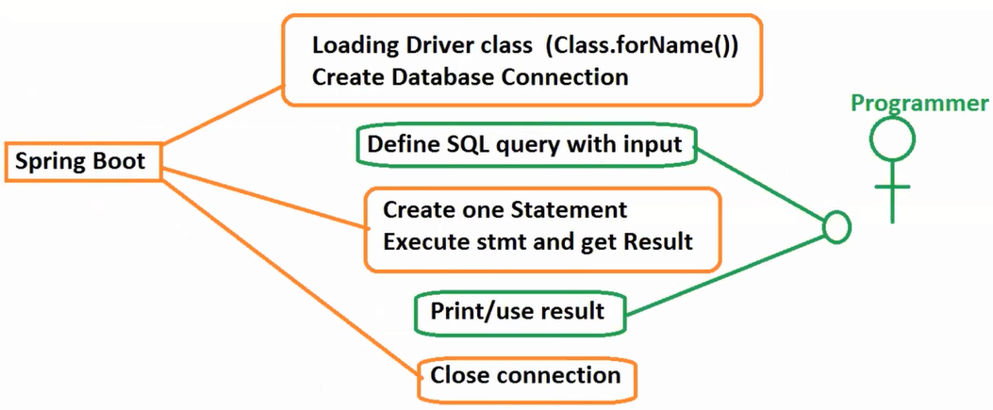

-- Spring Boot –

a) insert query

Class.forName(“”)

Connection con=DriverManager.getConneection(url, username, password)

SQL= “INSERT INTO TABLE VALUES(…)”

Statement st=con.createStatement();

st.executeUpdate()…

System.out.println(result is : saved);

con.close();

b) update code

Class.forName(“”)

Connection con=DriverManager.getConneection(url, username, password)

SQL= “UPDATE TABLE SET COLUMN…”

Statement st=con.createStatement();

st.executeUpdate()…

System.out.println(result is : update );

con.close();

* If we compare multiple Database operation using JDBC few lines are common and few are different (SQL, inputs and result).

**Template Design Pattern:**

In case of large set statements has common code for multiple usecase then use this design pattern.

* ** Duplicate code/boiler plate code is reduced by Template Design Pattern.

Technology : JDBC

Design Pattern: Template

Spring Boot = JDBC + Template => JdbcTemplate(C)

* JdbcTemplate(C) is a class that is used to perform DB operations in less lines of code.
* JdbcTempalte(C) makes HAS-A with DataSource(I) i.e., connection between database and application.
* DataSource(I) impl class used by Spring Boot default is HikariDataSource(C).
* All are pre-defined, so we can write only Java Based Configuration. That looks like

-- Spring Based Code ---

@Configuration

public class AppConfig{

@Bean

public DataSource ds(){

HikariDataSource ds=new HikariDataSource();

ds.setDriverClassName(“__”);

ds.setUrl(“__”);

ds.setUsername(“__”);

ds.setPassword(“__”);

return ds;

}

@Bean

public JdbcTemplate jt(){

JdbcTemplate jt=new JdbcTemplate();

jt.setDataSource(ds());

return jt;

}

}

Above code we are not going to write in Spring Boot we just add starter (read made code)

spring-boot-starter-jdbc

But we need to pass inputs properties/yml

spring.datasource.driver-class-name=__

spring.datasource.url=__

spring.datasource.username=__

spring.datasource.password=__

Download and Install Database

1. MySQL

MySQL 8:

<dependency>

<groupId>com.mysql</groupId>

<artifactId>mysql-connector-j</artifactId>

</dependency>

1. Oracle

Oracle 11g/21C

<dependency>

<groupId>com.oracle.database.jdbc</groupId>

<artifactId>ojdbc11</artifactId>

</dependency>

**MySQL (any version):**

**>** create database bootapp;

> use bootapp;

> create table books(bid int, bname varchar(20), bcost double);

> insert into books values(101, ‘Core Java’, 500.0);

> select * from book;

**Oracle (any version):**

**>** create user vie identified by vie;

**>** conn system/password

**>** create table books(bid number, bname varchar2(20), bcost number(13,3));

> insert into books values(101, ‘Core Java’, 500.0);

> select * from book;

**-- JdbcTemplate Operations---**

**a. update(String sql, Object…args) : int**

This method is predefined in JdbcTemplate(C).

This method is used to perform “INSERT, UPDATE, DELETE”.

Finally it results no. of rows effected in DB table.

Crtl + shift + T : open type (predefined code)

Ctrl + O : overview (to view all members of code)

Ctrl + L : Goto Line

**-- Full Code –**

**Step1:**

**Name:** SpringBootJdbcTemplate

**Dependencies:** JDBC API, MySQL/Oracle

**Step2:** application.properties

spring.datasource.driver-class-name=com.mysql.cj.jdbc.Driver

spring.datasource.url=jdbc:mysql://localhost:3306/bootapp

spring.datasource.username=root

spring.datasource.password=root

**or**

application.yml

spring:

datasource:

driver-class-name: com.mysql.cj.jdbc.Driver

password: vine96

url: jdbc:mysql://localhost:3306/bootapp

username: root

**Step3: Runner class**

**Insert Operation**

**package** com.SpringBootJdbcTemplate.runner;

**import** org.springframework.beans.factory.annotation.Autowired;

**import** org.springframework.boot.CommandLineRunner;

**import** org.springframework.jdbc.core.JdbcTemplate;

**import** org.springframework.stereotype.Component;

@Component

**public** **class** JdbcTestRunner **implements** CommandLineRunner {

@Autowired

**private** JdbcTemplate jt;

@Override

**public** **void** run(String... args) **throws** Exception {

//System.out.println(jt.getClass().getName());

//1. INSERT OPERATION

String sql="INSERT INTO BOOK VALUES(?,?,?)";

//2. Execute and get result

**int** count=jt.update(sql, 102, "JEE", 800.0);

//3. print result

System.***out***.println("NO OF ROWS INSERTED: "+count);

}

}

**Update operation:**

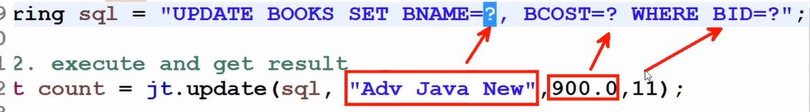

**package** com.SpringBootJdbcTemplate.runner;

**import** org.springframework.beans.factory.annotation.Autowired;

**import** org.springframework.boot.CommandLineRunner;

**import** org.springframework.jdbc.core.JdbcTemplate;

**import** org.springframework.stereotype.Component;

@Component

**public** **class** JdbcTestRunner **implements** CommandLineRunner {

@Autowired

**private** JdbcTemplate jt;

@Override

**public** **void** run(String... args) **throws** Exception {

//System.out.println(jt.getClass().getName());

//1. INSERT OPERATION

//String sql="INSERT INTO BOOK VALUES(?,?,?)";

//1. UPDATE OPERATION

String sql="UPDATE BOOK SET BNAME=?, BCOST=? WHERE BID=?";

//2. Execute and get result

//int count=jt.update(sql, 102, "JEE", 800.0);

**int** count=jt.update(sql, "Advanced Java", 900.0, 102);

//3. print result

System.***out***.println("NO OF ROWS UPDATED: "+count);

}

}

**Delete Operation:**

**package** com.SpringBootJdbcTemplate.runner;

**import** org.springframework.beans.factory.annotation.Autowired;

**import** org.springframework.boot.CommandLineRunner;

**import** org.springframework.jdbc.core.JdbcTemplate;

**import** org.springframework.stereotype.Component;

@Component

**public** **class** JdbcTestRunner **implements** CommandLineRunner {

@Autowired

**private** JdbcTemplate jt;

@Override

**public** **void** run(String... args) **throws** Exception {

//System.out.println(jt.getClass().getName());

//1. INSERT OPERATION

//String sql="INSERT INTO BOOK VALUES(?,?,?)";

//1. UPDATE OPERATION

//String sql="UPDATE BOOK SET BNAME=?, BCOST=? WHERE BID=?";

//1. DELETE OPERATION

String sql="DELETE FROM BOOK WHERE BID=?";

//2. Execute and get result

//int count=jt.update(sql, 102, "JEE", 800.0);

//int count=jt.update(sql, "Advanced Java", 900.0, 102);

**int** count=jt.update(sql, 102);

//3. print result

System.***out***.println("NO OF ROWS DELETED!!: "+count);

}

}

* **Note:**

1. If no.of ? symbols (parameters) and values passed count is not matching then

SQLException: No value specified for parameter __

1. If we pass more no.of parameters than expected,

SQLException: Parameter index out of range (4 > number of parameters, which is 3)

1. If order of passing data is invalid then

SQLException: Incorrect integer value:

1. If we did not specify valid connection details then

Failed to Configure a DataSource:

1. If we miss Database dependency (JAR) or invalid one given then

IllegalStateException: Cannot load driver class

1. In pure JDBC,there is one concept added i.e., AutoLoading of Driver Class (JDBC 4.0) It means no need of providing driver class name, just provide url, username, password.

Works for latest dependencies only.

(it is optional)

spring.datasource.driver-class-name=com.mysql.cj.jdbc.Driver

1. ? -> symbol indicate data come at runtime. It means data come from HTML Form in realtime

Ex: Register page, Movie Review post, Send Email (insert)

Q) What is var-args in java?

Q) What is volatile keyword in java?

**SELECT Operation – JdbcTemplate**

* JdbcTemplate(C) supports even select operation.

For those two types of methods given.

1. query() : Multiple rows output
2. queryForObject() : Single Value/row
3. method details

query(

String sql, //SQL Query

RowMapper<T> rowMapper, //RowMapper

Object…args) //inputs to query ?

:List<T> // Output

* This method executes given SQL query and gets data into ResultSet, uses RowMapper and convert Rows into Objects format create one new collection and stores all these objects.

1. method details

qureyForObject(

String sql, //SQL Query

RowMapper<T> rowMapper, //RowMapper

Object..args) //inputs to query

:T //Single Value/Object

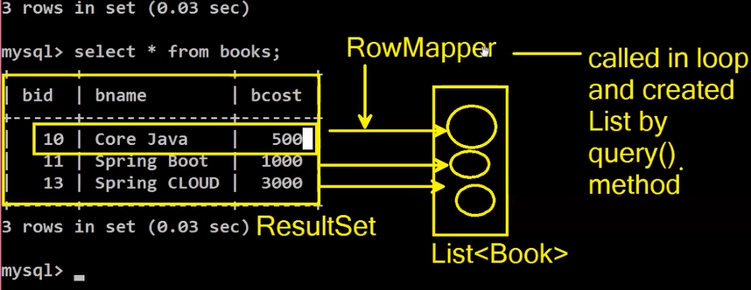

**-- Core Java –**

interface Sample{

int count(int a, int b);

}

1. **Implementation class + object**

class SampleImpl implements Sample{

public int count(int a, int b){

return (a*b) / (a-b);

}

}

Sample s=new SampleImpl();

1. **Anonymous class**

**Syntax:**

new interfaceName(){

//Override method

};

**Ex:**

new Sample(){

public int count(int a, int b){

return (a*b) / (a-b);

}

}

1. **Lambda Expression**

**Syntax:** (method param) -> { method body }

**Ex:**

(int a, int b) -> {

return (a*b) / (a-b)

}

Or in Short Format

Sample s=(a, b) -> (a*b) / (a-b);

* **RowMapper<T>:**

RowMapper<T> is a predefined functional interface. This is used to convert SQL Result (ResultSet) rows into Object Format.

* **Note:**

1. It is not used to SQL query execution
2. It is not used to data fetching into ResultSet
3. It is only used for Row -> Object conversion.

* **Entity/POJO (Same) --** A class that is mapped with Database table.
* **Model class:** A class that support object to store data which may get from DB/File/UI(Form)/ ..or any source.

**-- RowMapperImpl class –**

**package** com.SpringBootJdbcTemplate.mappper;

**import** java.sql.ResultSet;

**import** java.sql.SQLException;

**import** org.springframework.jdbc.core.RowMapper;

**import** com.SpringBootJdbcTemplate.model.Book;

**public** **class** BookRowMapper **implements** RowMapper<Book>{

@Override

**public** Book mapRow(ResultSet rs, **int** rowNum) **throws** SQLException

{

//Read from RS, set to object

//ob.set___(rs.get___("columname"));

/*

Book book=new Book();

book.setBookId(rs.getInt("bid"));

book.setBookName(rs.getString("bname"));

book.setBookCost(rs.getDouble("bcost"));

*/

Book book=**new** Book(rs.getInt("bid"), rs.getString("bname"),rs.getDouble("bcost"));

**return** book;

}

}

RowMapper<Book> rowMapper = new BookRowMapper();

**-- Lambda Expression –**

RowMapper<Book> rowMapper =

(rs, rowNum) ->  **new** Book(

rs.getInt("bid"),

rs.getString("bname"),

rs.getDouble("bcost")

);

* If Method Body has only one line then {} not required even do not write return keyword.
* If method param only 1 (not zero/ or more ) then symbol () optional.

**(Stream method)**

map( sourceType -> destinationType )

* This method is used to convert one datatype to another datatype.

Ex: Book obj -> String , String -> Employee etc..,

**-- Code --**

**1. Create Model Class**

package com.SpringBootJdbcTemplate.model;

import lombok.AllArgsConstructor;

import lombok.Data;

import lombok.NoArgsConstructor;

@Data

@NoArgsConstructor

@AllArgsConstructor

public class Book {

private Integer bookId;

private String bookName;

private Double bookCost;

}

1. Add Lombok dependency to pom.xml
2. **Runner class**

**Ex:1**

package com.SpringBootJdbcTemplate.runner;

import java.util.Iterator;

import java.util.List;

import java.util.stream.Collectors;

import org.springframework.beans.factory.annotation.Autowired;

import org.springframework.boot.CommandLineRunner;

import org.springframework.jdbc.core.JdbcTemplate;

import org.springframework.jdbc.core.RowMapper;

import org.springframework.stereotype.Component;

import com.SpringBootJdbcTemplate.mappper.BookRowMapper;

import com.SpringBootJdbcTemplate.model.Book;

@Component

public class JdbcSelectRunner implements CommandLineRunner {

@Autowired

private JdbcTemplate jt;

@Override

public void run(String... args) throws Exception {

String sql="SELECT * FROM BOOK";

RowMapper<Book> rowMapper=new BookRowMapper();

List<Book> list=jt.query(sql, rowMapper);

//JDK 1.5 - for each

// for(Book book : list) {

// System.out.println(book);

// }

//JDK 1.2 - Iterator

// Iterator<Book> itr=list.iterator();

// while(itr.hasNext()) {

// Book book= itr.next();

// System.out.println(book);

// }

//JDK 1.8 - forEach method + Lambda Expression

//list.forEach(book -> System.out.println(book));

//JDK 1.8 - forEach method + Method Reference

// list.forEach(System.out::println);

List<String> listStr=

list.stream()

.filter(ob->ob.getBookCost()>400.0)

.sorted((ob1,ob2)->ob1.getBookName().compareTo(ob2.getBookName()))

.map(ob->ob.getBookName()+", with id: "+ob.getBookId()+" having cost: "+ob.getBookCost())

.collect(Collectors.toList())

;

listStr.forEach(System.out::println);

}

}

**Ex:2**

String sql="SELECT * FROM BOOK WHERE BID>?";

List<Book> list=jt.query(

sql,

(rs, rowNum)->

new Book(

rs.getInt("bid"),

rs.getString("bname"),

rs.getDouble("bcost")

),

102

);

list.forEach(System.out::println);

-- **Short Format –**

jt.query(

"SELECT * FROM BOOK WHERE BID>?",

(rs, rowNum)->

**new** Book(

rs.getInt("bid"),

rs.getString("bname"),

rs.getDouble("bcost")

),

102

).forEach(System.***out***::println);

* Here value 102 is replaced in SQL ? symbol.

-- **Fetch only one row data—**

String sql="SELECT * FROM BOOK WHERE BID=?";

RowMapper<Book> rowMapper=**new** BookRowMapper();

Book book=jt.queryForObject(sql, rowMapper, 103);

System.***out***.println(book);

-- **Complex Structure –**

Book book=jt.queryForObject(

"SELECT * FROM BOOK WHERE BID=?",

(rs, rowNum) -> **new** Book(

rs.getInt("bid"),

rs.getString("bname"),

rs.getDouble("bcost")

),

104);

System.***out***.println(book);

**== FULL CODE==**

**Step1:**

**Name:** SpringBootJdbcTemplate

**Dependencies:** Lombok, JDBC API, MySQL

**Step2: yml file**

spring:

datasource:

driver-class-name: com.mysql.cj.jdbc.Driver

password: vine96

url: jdbc:mysql://localhost:3306/bootapp

username: root

**Step3: Model class**

package com.SpringBootJdbcTemplate.model;

import lombok.AllArgsConstructor;

import lombok.Data;

import lombok.NoArgsConstructor;

@Data

@NoArgsConstructor

@AllArgsConstructor

public class Book {

private Integer bookId;

private String bookName;

private Double bookCost;

}

**Step4: RowMapper class**

**package** com.SpringBootJdbcTemplate.mappper;

**import** java.sql.ResultSet;

**import** java.sql.SQLException;

**import** org.springframework.jdbc.core.RowMapper;

**import** com.SpringBootJdbcTemplate.model.Book;

**public** **class** BookRowMapper **implements** RowMapper<Book>{

@Override

**public** Book mapRow(ResultSet rs, **int** rowNum) **throws** SQLException

{

//Read from RS, set to object

//ob.set___(rs.get___("columname"));

/*

Book book=new Book();

book.setBookId(rs.getInt("bid"));

book.setBookName(rs.getString("bname"));

book.setBookCost(rs.getDouble("bcost"));

*/

Book book=**new** Book(rs.getInt("bid"), rs.getString("bname"),rs.getDouble("bcost"));

**return** book;

}

}

**Step5: Runner for insert/update/delete**

package com.SpringBootJdbcTemplate.runner;

import org.springframework.beans.factory.annotation.Autowired;

import org.springframework.boot.CommandLineRunner;

import org.springframework.jdbc.core.JdbcTemplate;

import org.springframework.stereotype.Component;

//@Component

public class JdbcTestRunner implements CommandLineRunner {

@Autowired

private JdbcTemplate jt;

@Override

public void run(String... args) throws Exception {

//System.out.println(jt.getClass().getName());

//1. INSERT OPERATION

String sql="INSERT INTO BOOK VALUES(?,?,?)";

//1. UPDATE OPERATION

//String sql="UPDATE BOOK SET BNAME=?, BCOST=? WHERE BID=?";

//1. DELETE OPERATION

//String sql="DELETE FROM BOOK WHERE BID=?";

//2. Execute and get result

int count=jt.update(sql, 104, "AI", 900.0);

//int count=jt.update(sql, "Advanced Java", 900.0, 102);

//int count=jt.update(sql, 102);

//3. print result

System.out.println("NO OF ROWS INSERTED!!: "+count);

}

}

**Step6: Runner for Select**

package com.SpringBootJdbcTemplate.runner;

import java.util.Iterator;

import java.util.List;

import java.util.stream.Collectors;

import org.springframework.beans.factory.annotation.Autowired;

import org.springframework.boot.CommandLineRunner;

import org.springframework.jdbc.core.JdbcTemplate;

import org.springframework.jdbc.core.RowMapper;

import org.springframework.stereotype.Component;

import com.SpringBootJdbcTemplate.mappper.BookRowMapper;

import com.SpringBootJdbcTemplate.model.Book;

@Component

public class JdbcSelectRunner implements CommandLineRunner {

@Autowired

private JdbcTemplate jt;

@Override

public void run(String... args) throws Exception {

/*

String sql="SELECT * FROM BOOK";

RowMapper<Book> rowMapper=new BookRowMapper();

List<Book> list=jt.query(sql, rowMapper);

//JDK 1.5 - for each

// for(Book book : list) {

// System.out.println(book);

// }

//JDK 1.2 - Iterator

// Iterator<Book> itr=list.iterator();

// while(itr.hasNext()) {

// Book book= itr.next();

// System.out.println(book);

// }

//JDK 1.8 - forEach method + Lambda Expression

//list.forEach(book -> System.out.println(book));

//JDK 1.8 - forEach method + Method Reference

// list.forEach(System.out::println);

List<String> listStr=

list.stream()

.filter(ob->ob.getBookCost()>400.0)

.sorted((ob1,ob2)->ob1.getBookName().compareTo(ob2.getBookName()))

.map(ob->ob.getBookName()+", with id: "+ob.getBookId()+" having cost: "+ob.getBookCost())

.collect(Collectors.toList())

;

listStr.forEach(System.out::println);

*/

/*

String sql="SELECT * FROM BOOK WHERE BID>?";

List<Book> list=jt.query(sql,

(rs, rowNum)->new Book(rs.getInt("bid"), rs.getString("bname"), rs.getDouble("bcost")),

102);

list.forEach(System.out::println);

*/

// OR

/*

jt.query("SELECT * FROM BOOK WHERE BID>?",

(rs, rowNum)->new Book(rs.getInt("bid"), rs.getString("bname"), rs.getDouble("bcost")),

102).forEach(System.out::println);

*/

//=================

/*

// Fetch only one row data

String sql="SELECT * FROM BOOK WHERE BID=?";

RowMapper<Book> rowMapper=new BookRowMapper();

Book book=jt.queryForObject(sql, rowMapper, 103);

System.out.println(book);

*/

// Complex Structure

Book book=jt.queryForObject(

"SELECT * FROM BOOK WHERE BID=?",

(rs, rowNum) -> new Book(

rs.getInt("bid"),

rs.getString("bname"),

rs.getDouble("bcost")

),

104);

System.out.println(book);

}

}

* If we use queryForObject() and trying to fetch data that returns zero result then

**EmptyResultDataAccessException:**

class A{

m1(){A}

}

class B : A{

m1(){B}

}

A oa=new B();

oa.m1() 🡪 “B”

A oa=new A();

oa.m1() 🡪 “A”

**Spring Boot JDBC**

* JdbcTemplate(C) is used to perform any DB Operation.
* Database initialization ! schema.sql and data.sql :-
* When we start application we want execute few SQL queries on startup, then we can go for Database initialization.
* If we want to execute any DDL Queries on start up use schema.sql (DDL - create/alter/drop).
* If we want to execute any DML queries on start up use data.sql (DML – insert/update/delete).

Requirement on StartUp Application, create UserTable with ADMIN details So, that they can login with default user details.

* File schema.sql and data.sql are optional. But if you want to use those files, add key:

Spring.datasource.initialization-mode: always

* You must place those files under src/main/resource folder (ie called as classpath)
* Execute some queries on app startup: Seed Data/Setup Data.

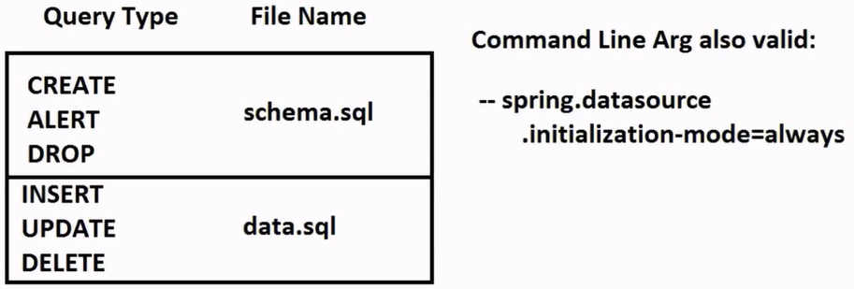

-- **FULL CODE –**

**Step1:**

**Name:** SpringBootJdbcSqlInit

**Dependencies:** JDBC API, MySQL, Lombok

**Step2:** Model

package com.SpringBootJdbcTemplateInit.model;

import lombok.AllArgsConstructor;

import lombok.Data;

import lombok.NoArgsConstructor;

@Data

@AllArgsConstructor

@NoArgsConstructor

public class Employee {

private Integer empId;

private String empName;

private Double empSal;

}

**Step3:** schema.sql

> Right click on src/main/resource folder > new > file > Enter file name > Finish

drop table if exists employee;

create table employee(eid int, ename varchar(20),esal double);

**Step4:** data.sql

insert into employee values(101, 'A', 500.00);

insert into employee values(102, 'B', 600.00);

insert into employee values(103, 'C', 700.00);

**Step5: Runner class**

package com.SpringBootJdbcTemplateInit.runner;

import org.springframework.beans.factory.annotation.Autowired;

import org.springframework.boot.CommandLineRunner;

import org.springframework.jdbc.core.JdbcTemplate;

import org.springframework.stereotype.Component;

import com.SpringBootJdbcTemplateInit.model.Employee;

@Component

public class EmployeeFetchDataRunner implements CommandLineRunner {

@Autowired

private JdbcTemplate jt;

@Override

public void run(String... args) throws Exception {

System.out.println("DATA OF EMPLOYEE TABLE IS:");

String sql="SELECT * FROM EMPLOYEE";

jt.query(sql, (r, count)-> new Employee(

r.getInt("eid"),

r.getString("ename"),

r.getDouble("esal")

)).forEach(System.out::println);

}

}

To develop one web application we need 3 layers minimum. They are.

PL = Presentation Layer (WEB MVC) [Display Data to End User].

SL = Service Layer (Calculation/logics).

DAL = Data Access Layer (DB Operations)

* This DAL can be implemented in Spring Boot using JDBC API, Data JPA, Data MongoDB.. etc
* DAL has other names Repository, Data Access Object, Persisted Layer.

Rules to write DAL:

1. Create one Model class that is going to read/write data with database table.
2. Define POJI (Plain Old Java Interface) using Operations as abstract method.
3. Define POJO (Plain Old Java Object) here implement all POJI operation using JdbcTemplate with HAS-A Relation.

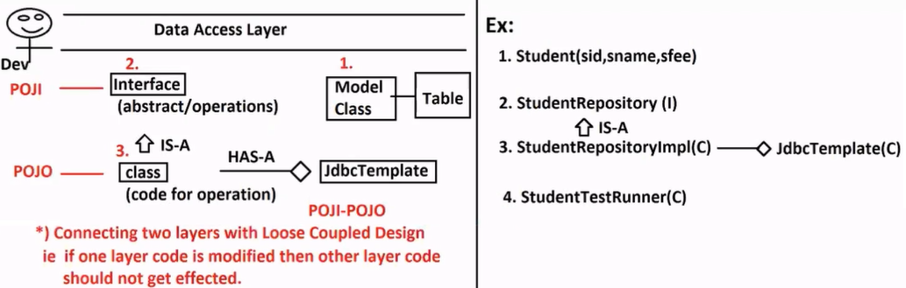

**Q)** What is Reflection API? Explain with examples

a) Object creation

b) calling methods

<https://www.oracle.com/technical-resources/articles/java/javareflection.html>

Q) What is Dynamic Proxy Pattern?

<https://docs.oracle.com/javase/8/docs/technotes/guides/reflection/proxy.html>

-- **FULL CODE –**

**Name:** SpringBootJdbcLayerApp

**Dependencies:** JDBC API, MySQL, Lombok

1. **application.properties**

spring.datasource.driver-class-name=com.mysql.cj.jdbc.Driver

spring.datasource.url=jdbc:mysql://localhost:3306/bootapp

spring.datasource.username=root

spring.datasource.password=vine96

spring.sql.init.mode=always

1. **schema.sql**

drop table if exists student;

create table student(sid int, sname varchar(20), sfee double);

1. **data.sql**

insert into student values(101, 'Vineeth', '50000.00')

insert into student values(102, 'Katherine', '500000.00')

1. **Model class**

**package** com.SpringBootJdbcLayerApp.model;

**import** lombok.AllArgsConstructor;

**import** lombok.Data;

**import** lombok.NoArgsConstructor;

@Data

@NoArgsConstructor

@AllArgsConstructor

**public** **class** Student {

**private** Integer stdId;

**private** String stdName;

**private** Double stdFee;

}

1. **Repository Interface**

**package** com.SpringBootJdbcLayerApp.repo;

**import** java.util.List;

**import** com.SpringBootJdbcLayerApp.model.Student;

**public** **interface** StudentRepository {

**int** saveStudent(Student s);

List<Student> getAllStudents();

Student getOneStudentById(Integer id);

**int** updateStudent(Student s);

**int** deleteStudent(Integer id);

}

1. **Repository Impl class**

**package** com.SpringBootJdbcLayerApp.repo.impl;

**import** java.util.List;

**import** org.springframework.beans.factory.annotation.Autowired;

**import** org.springframework.jdbc.core.JdbcTemplate;

**import** org.springframework.stereotype.Component;

**import** com.SpringBootJdbcLayerApp.model.Student;

**import** com.SpringBootJdbcLayerApp.repo.StudentRepository;

@Component

**public** **class** StudentRepositoryImpl **implements** StudentRepository {

@Autowired

**private** JdbcTemplate jt;

@Override

**public** **int** saveStudent(Student s) {

String sql="INSERT INTO STUDENT VALUES(?,?,?)";

**int** count=jt.update(sql, s.getStdId(), s.getStdName(), s.getStdFee());

**return** count;

}

@Override

**public** List<Student> getAllStudents() {

String sql="SELECT * FROM STUDENT";

List<Student> list=jt.query(sql, (r, count)-> **new** Student(

r.getInt("sid"),

r.getString("sname"),

r.getDouble("sfee")

));

**return** list;

}

@Override

**public** Student getOneStudentById(Integer id) {

String sql="SELECT * FROM STUDENT WHERE SID=?";

Student s=jt.queryForObject(sql, (r, count)-> **new** Student(

r.getInt("sid"),

r.getString("sname"),

r.getDouble("sfee")),

id );

**return** s;

}

@Override

**public** **int** updateStudent(Student s) {

String sql="UPDATE STUDENT SET SNAME=?, SFEE=? WHERE SID=?";

**int** count=jt.update(sql, s.getStdName(), s.getStdFee(), s.getStdId());

**return** count;

}

@Override

**public** **int** deleteStudent(Integer id) {

String sql="DELETE FROM STUDENT WHERE SID=?";

**int** count=jt.update(sql, id);

**return** count;

}

}

1. **Runner class for Testing**

**package** com.SpringBootJdbcLayerApp.runner;

**import** org.springframework.beans.factory.annotation.Autowired;

**import** org.springframework.boot.CommandLineRunner;

**import** org.springframework.stereotype.Component;

**import** com.SpringBootJdbcLayerApp.model.Student;

**import** com.SpringBootJdbcLayerApp.repo.StudentRepository;

@Component

**public** **class** StudentTestRunner **implements** CommandLineRunner {

@Autowired

**private** StudentRepository repo;

@Override

**public** **void** run(String... args) **throws** Exception {

System.***out***.println("============FROM RUNNER=============");

System.***out***.println("============INSERT RECORD==============");

**int** c1=repo.saveStudent(**new** Student(103, "Margot", 60000.00));

**int** c2=repo.saveStudent(**new** Student(104, "Angelina", 70000.00));

**int** c3=repo.saveStudent(**new** Student(105, "Gal Gadot", 80000.00));

System.***out***.println("RECORDS UPDATED: "+c1+" "+c2+" "+c3);

System.***out***.println("=====FETCH MULTIPLE RECORD======");

repo.getAllStudents().forEach(System.***out***::println);

System.***out***.println("=============UPDATE RECORD========");

**int** c4=repo.updateStudent(**new** Student(101, "VINEETH ARMOORI", 70000.00));

System.***out***.println("UPDATED ROWS: "+c4);

System.***out***.println("=============DELETE RECORD===============");

**int** c5=repo.deleteStudent(105);

System.***out***.println("DELETED ROWS: "+c5);

System.***out***.println("FETCH MULTIPLE RECORD AFTER UPDATE & DELETE");

repo.getAllStudents().forEach(System.***out***::println);

System.***out***.println("======FETCH ONE RECORD==========");

Student s=repo.getOneStudentById(104);

System.***out***.println(s);

}

}

**Spring Boot Concepts**

1. Stopwatch
2. Embeded Database
3. Log Support
4. **Stopwatch:** Claculate time taken for a task using java code

**Ex1:**

**package** com.SpringBootStopwatchApp.runner;

**import** java.util.Iterator;

**import** org.springframework.boot.CommandLineRunner;

**import** org.springframework.stereotype.Component;

**import** org.springframework.util.StopWatch;

@Component

**public** **class** TestStopwatchRunner **implements** CommandLineRunner {

@Override

**public** **void** run(String... args) **throws** Exception {

System.***out***.println("STARTED");

StopWatch st=**new** StopWatch();

st.start();

**for** (**int** i = 1; i < Integer.***MAX_VALUE***; i++) {

Math.*pow*(i*i*i, Math.*pow*(2*i+1, i*i));

}

st.stop();

**for** (**int** i = 1; i < Integer.***MAX_VALUE***; i++) {

Math.*pow*(i*i*i, Math.*pow*(2*i+1, i*i));

}

st.start();

**for** (**int** i = 1; i < Integer.***MAX_VALUE***; i++) {

Math.*pow*(i*i*i, Math.*pow*(2*i+1, i*i));

}

st.stop();

System.***out***.println("NANO SEC: "+st.getTotalTimeNanos());

System.***out***.println("MILLI SEC: "+st.getTotalTimeMillis());

System.***out***.println("SEC: "+st.getTotalTimeSeconds());

System.***out***.println("FINISHED");

}

}

* If we call start()/stop() in order more than 1 time then execption raised

Ex: st.stop();

st.stop()

* java.lang.IllegalStateException: Can't stop StopWatch: it's not running
* If we want to get block/method/logic based time calculation then use ID’s concept.i.e., while creation of “StopWatch” use string param even for calling a method start(String)

**Sample code:**

StopWatch st=**new** StopWatch("FULL TASK");

**-- Full code –**

**package** com.SpringBootStopwatchApp.runner;

**import** java.util.Iterator;

**import** org.springframework.boot.CommandLineRunner;

**import** org.springframework.stereotype.Component;

**import** org.springframework.util.StopWatch;

@Component

**public** **class** TestStopwatchRunner **implements** CommandLineRunner {

@Override

**public** **void** run(String... args) **throws** Exception {

System.***out***.println("STARTED");

StopWatch st=**new** StopWatch("FULL TASK");

st.start("LOOP#1");

**for** (**int** i = 1; i < 999999; i++) {

Math.*pow*(i*i*i, Math.*pow*(2*i+1, i*i));

}

st.stop();

st.start("LOOP#2");

**for** (**int** i = 1; i < 888888; i++) {

Math.*pow*(i*i*i, Math.*pow*(2*i+1, i*i));

}

st.stop();

st.start("LOOP#3");

**for** (**int** i = 1; i < 777777; i++) {

Math.*pow*(i*i*i, Math.*pow*(2*i+1, i*i));

}

st.stop();

String output=st.prettyPrint();

System.***out***.println(output);

System.***out***.println("FINISHED");

}

}

Output:

STARTED

StopWatch 'FULL TASK': 0.0108197 seconds

----------------------------------------

Seconds % Task name

----------------------------------------

0.0099315 92% LOOP#1

0.0004711 04% LOOP#2

0.0004171 04% LOOP#3

FINISHED

1. **Embeded Database:**

* A database which runs from Application start to stop. (or) A Temporary Database runs on RAM, no need to Download and Install.
* Once we restart application, Database data will be cleared.
* Embeded Database is Recommanded only for Development/Test Environment only. **Never** use for Production.
* Compared to normal/external DB these work faster. Less effect on CPU.
* Spring Boot has provided embedded Databases:

H2, Apache Derby, HyperSQL.

* Spring Boot web dependency we use for Embedded DB console support.

**pom.xml**

<dependency>

<groupId>org.springframework.boot</groupId>

<artifactId>spring-boot-starter-web</artifactId>

</dependency>

**-- FULL CODE—**

**Step1: Create One Project**

**Name:** SpringBootJbdcH2Ex

**Dependencies:** JDBC API, Lombok, H2, Spring web

**Step2: -- application.properties --**

server.port=8081

spring.h2.console.enabled=true

#spring.h2.console.path=/h2-console

spring.h2.console.path=/h2

spring.datasource.url=jdbc:h2:mem:testdb

#not required

#spring.sql.init.mode=embedded

**Step3: -- schema.sql –**

create table product(pid int, pname varchar(20), pcost double)

**Step4: -- data.sql –**

insert into product values(101, 'Product-A', 30.0);

insert into product values(102, 'Product-B', 40.0);

insert into product values(103, 'Product-C', 50.0);

* **Model class**

**package** com.SpringBootJDBCH2DB.model;

**import** lombok.AllArgsConstructor;

**import** lombok.Data;

**import** lombok.NoArgsConstructor;

@Data

@AllArgsConstructor

@NoArgsConstructor

**public** **class** Product {

**private** Integer prodId;

**private** String prodName;

**private** Double prodCost;

}

* **Runner class**

**package** com.SpringBootJDBCH2DB.runner;

**import** java.util.ArrayList;

**import** org.springframework.beans.factory.annotation.Autowired;

**import** org.springframework.boot.CommandLineRunner;

**import** org.springframework.jdbc.core.JdbcTemplate;

**import** org.springframework.stereotype.Component;

**import** com.SpringBootJDBCH2DB.model.Product;

@Component

**public** **class** TestH2Opr **implements** CommandLineRunner {

@Autowired

**private** JdbcTemplate jt;

@Override

**public** **void** run(String... args) **throws** Exception {

String sql="SELECT * FROM PRODUCT";

jt.query(sql, (rs,c)-> **new** Product(

rs.getInt("pid"),

rs.getString("pname"),

rs.getDouble("pcost")

)).forEach(System.***out***::println);

}

}

**Step5: Run Application**

**Step6:** Goto browser and enter URL

<http://localhost:8081/h2>

Modify JDBC URL: jdbc:h2:mem:testdb

And click on connect button.

Q. Why Spring Web Dependency?

A. H2 Run in RAM. So, we cannot see data by default. Here, Spring web support view data using browser only.

Q. What is the default port and default path we should enter in browser?

A. Default path is: /h2-console

We can modify using: spring.h2.console.path=/h2

Default port is: 8080

We can modify using: server.port=8081

Q. Do we need to provide Datasource URL for sure?

A. No Required, in that case, every time new data source URL is generated, that you need to copy from STS console and paste in browser before connect.

But we must enable console using key:

spring.h2.console.enabled=true

Q. How this is working without initializationMode?

A. This is set value with default EMBEDDED only

init.mode=EMBEDDED.

So, no need to add.

* No Username/ Password required

**Log4J Tool:**

**Environment:** System where application is running with all setup

**Type of Environments:**

1. DEV b. QA(Testing Env.) c. UAT (User Acceptence Test Env.) d. Production

* While Developing and Testing applications, message are printed on console in IDE(STS/Eclipse).
* Messages like Success, Warning, Errors/Execptions etc..,
* Console section will display last 100/200 messages only.

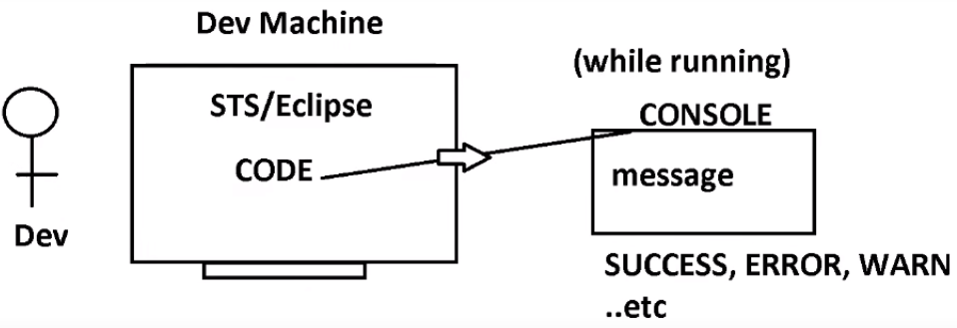

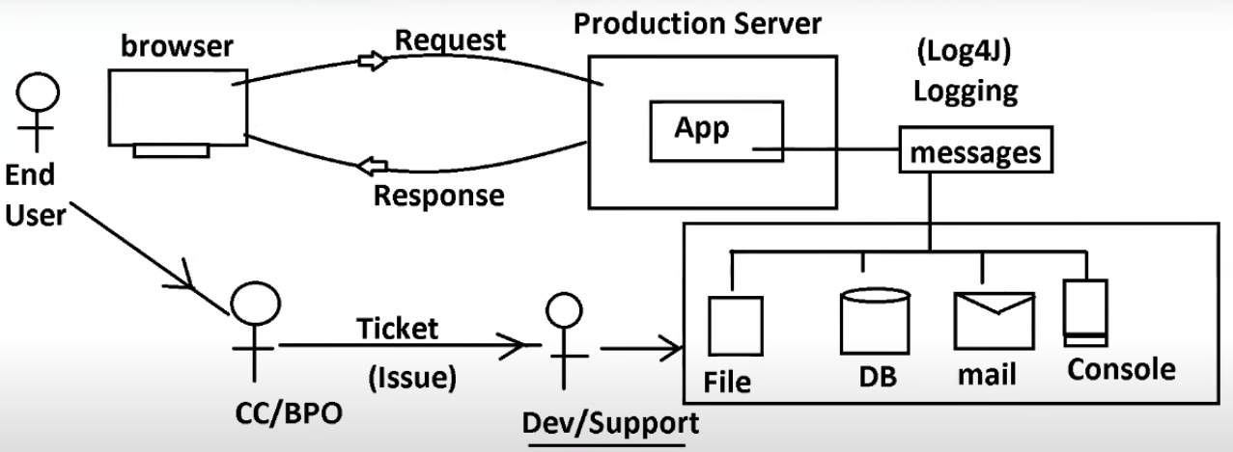

**Logging :** It is a process of getting / fectching Success, Warning, Errors/Execptions messages from server while it is running.

* **Log4J** is a Logging Tool.
* By using Log4J, we can get log messages and store in

File (Log File)*** [__.log]

Database

Email (send mail)

Console (Print on console – Dev Environment)

* By using Log Files, Dev/Support Team identifies the mistakes and Fix code.

**Log4J Compoents**

1. Logger (which class) b. Appender (where to print) c. Layout (How to print)
2. **Logger object**

* This object must be created inside class for which Log4J is required.

Ex: Controller, Services, Repository etc.., Needs Log4J Server if we get any execption/error inside these classes we can trace those into Log File.

* DO NOT CREATE logger object if we don’t want to Logging for class

Ex: Model/Entity

Ex: **private** **static** Logger *log*=Logger.*getLogger*(TestApp.**class**);

**private** **static** Logger *log*=Logger.*getLogger*(EmployeeRestController.**class**);

1. **Appender:**

Appender is used to specify where to store Log Message.

Types are:

1. ConsoleAppender : print log message on console.
2. FileAppender*** : Store log message in .log file
3. JdbcAppender : Store log messages in Database table.
4. Ftp/TelnetAppender : Send data from one server to another Server.
5. SMTP Appender : Send Log messages using email.
6. **Layout:** It indicates Message Format that should be printed on Appender.
7. Simple Layout : Print message as it is given by application
8. HTML Layout : Print message as HTML File.
9. XML Layout : Print message as XML Output.
10. ** Pattern Layout : Print message as Given pattern by Programmer.

**Priority Methods:**

These are pre-defined methods given inside Logger Object. By using these methods, we have to print messages at Appender.

**S.No Name Method**

1. DEBUG debug(msg)

2. INFO info(msg)

3. WARN warn(msg)

4. ERROR error(msg)

5. FATAL fatal(msg)

-NA- OFF -NA-

**DEBUG*:** This method is used to print a final/success message.

**Ex:** Employee created with ID-EMP-3652 Sucessfully.

**INFO*:** This method is used to print current status in execution

**Ex:** Request came to Controller method.

Object sent to Service layer.

Service Returned back to Controller.

Try block execution completed.

**WARN:** This method is used to print warning in application

**Ex:** File Object is created but never closed.

Variable is created, but not used.

**ERROR*:** This method is used to print any general exception

**Ex:** NullPointerException, ArrayIndexOutOf BoundException. Etc.,

Application Id is null can not be processed.

**FATAL:** This method is used to print any High level exception that makes STOPPING application usage.

**Ex:** Database connection is not working.

Network server/Middleware server is Down.

**Example1 Code:**

1. **Create Maven Application**
2. **Pom.xml**

<properties>

<maven.compiler.source>1.8</maven.compiler.source>

<maven.compiler.target>1.8</maven.compiler.target>

</properties>

<dependencies>

<!-- https://mvnrepository.com/artifact/log4j/log4j -->

<dependency>

<groupId>log4j</groupId>

<artifactId>log4j</artifactId>

<version>1.2.17</version>

</dependency>

</dependencies>

1. **TestClass**

**import** org.apache.log4j.Appender;

**import** org.apache.log4j.ConsoleAppender;

**import** org.apache.log4j.Layout;

**import** org.apache.log4j.Logger;

**import** org.apache.log4j.SimpleLayout;

**public** **class** TestApp {

//3. Create Logger object

**private** **static** Logger *log*=Logger.*getLogger*(TestApp.**class**);

**public** **static** **void** main(String[] args) {

//1. Create layout

Layout layout=**new** SimpleLayout();

//2. create appender + link layout

Appender app=**new** ConsoleAppender(layout);

//4. link appender with logger

*log*.addAppender(app);

//--- Print Message ---

*log*.info("FROM INFO");

*log*.debug("FROM DEBUG");

*log*.error("FROM ERROR");

*log*.warn("FROM WARN");

*log*.fatal("FROM FATAL");

}

}

**Example2 Code:**

**import** org.apache.log4j.Appender;

**import** org.apache.log4j.ConsoleAppender;

**import** org.apache.log4j.HTMLLayout;

**import** org.apache.log4j.Layout;

**import** org.apache.log4j.Logger;

**import** org.apache.log4j.PatternLayout;

**import** org.apache.log4j.SimpleLayout;

**import** org.apache.log4j.xml.XMLLayout;

**public** **class** TestApp {

//3. Create Logger object

**private** **static** Logger *log*=Logger.*getLogger*(TestApp.**class**);

**public** **static** **void** main(String[] args) {

//1. Create layout

//Layout layout=new SimpleLayout();

//Layout layout=new HTMLLayout();

//Layout layout=new XMLLayout();

Layout layout=**new** PatternLayout("%p %d %C %M %m %n");

//2. create appender + link layout

Appender app=**new** ConsoleAppender(layout);

//4. link appender with logger

*log*.addAppender(app);

//--- Print Message ---

*log*.info("FROM INFO");

*log*.debug("FROM DEBUG");

*log*.error("FROM ERROR");

*log*.warn("FROM WARN");

*log*.fatal("FROM FATAL");

}

}

**Example3 Code:**

**import** java.io.IOException;

**import** org.apache.log4j.Appender;

**import** org.apache.log4j.ConsoleAppender;

**import** org.apache.log4j.FileAppender;

**import** org.apache.log4j.HTMLLayout;

**import** org.apache.log4j.Layout;

**import** org.apache.log4j.Logger;

**import** org.apache.log4j.PatternLayout;

**import** org.apache.log4j.SimpleLayout;

**import** org.apache.log4j.xml.XMLLayout;

**public** **class** TestApp {

//3. Create Logger object

**private** **static** Logger *log*=Logger.*getLogger*(TestApp.**class**);

**public** **static** **void** main(String[] args) **throws** IOException {

//1. Create layout

//Layout layout=new SimpleLayout();

//Layout layout=new HTMLLayout();

//Layout layout=new XMLLayout();

Layout layout=**new** PatternLayout("%p %d %C %M %m %n");

//2. create appender + link layout

//Appender app=new ConsoleAppender(layout);

Appender app=**new** FileAppender(layout, "F:\\SpringBoot Videos\\Raghu Sir MS Video\\Notes\\data.log");

//4. link appender with logger

*log*.addAppender(app);

//--- Print Message ---

*log*.info("FROM INFO");

*log*.debug("FROM DEBUG");

*log*.error("FROM ERROR");

*log*.warn("FROM WARN");

*log*.fatal("FROM FATAL");

}

}

**ORM (Object Relational Mapping)**

* ORM Says perform Database Operations using Objects. Save(Object), Update(Object), Delete(Object) etc..,
* JDBC works on SQL Query that read primitive values from object and execute queries.
* Programmer has to follow Mapping rule to implement ORM concept.

Link class --with-- Table

Link variable --with-- column

Then

object <==> row by ORM

* Need not to define SQL query by programmers. Taken care by ORM

**Theory Programming/API**

OOPs Java

ORM JPA

DI IoC

Q) HttpServletRequest(I) then what is impl class?

servlet-api-jar (interfaces)

1. Tomat or any server will give impl class, not exist in servlet-api.jr

Q) What is the difference between ORM and JPA?

A) ORM is Standard (Theory)

JPA is coding /API given by SUN Microcsystem that follows ORM

* JPA has given rules and guidelines (Annotations/Interfaces)

Q) What is difference between JPA and Hibernate/EclipseLink/TopLinks?

A) Hiberanate/EclipseLink/TopLink etc.., are Vendors of JPA. (3rd Parties) they are providing Impl class for JPA Ineterfaces and Annotations processing classes.

Programmer follows JPA and writes code with any one vendor. Code Reamains same even if we move from one vendor to another vendor.

**JPA:** Java Persitancy API (JPA 2.X) is given by Sun Micro systems (now oracle).

* This is API for ORM Programming.
* JPA contains Annotations, Interfaces, classes etc., (But not full implementations).
* Developer has to follow API rules (annotations, interfaces) and write code.
* API Implementation (Impl classes, Annotation processing code) is given by 3rd parties (Vendors)

Ex: JBoss ‘Hibernate with JPA’, Eclipse Toplink, etc..,

* properties:

(Connection properties)

driver-class

url

username

password

(ORM Properties)

**dialect** = class + generate SQL queries when we perform operations.

Package: org.hibernate.dialect

OracleDialect, MySQL8Dialect, SysbaseDialect, DB2Dialect etc..,

<https://docs.jboss.org/hibernate/orm/3.5/api/org/hibernate/dialect/package-summary.html>

----

**show-sql** : boolean (false)

* To display generated SQLs on console/log file use this property as true.

----

**format-sql** : boolean(false)

* It will print query clause by clause.

format-sql=false

SQL: select eid, ename from emptab where esal>?

format-sql=true

select

eid, ename

from

emptab

where

esal>?

-----

**hbm2ddl.auto** – hibernate mapping - Automate DDL (create /alter/ drop)

To handle schema (DB Tables) creation we can use this key.

hbm2ddl.auto=create/update/validate/create-drop

1. create - Every time it create new table (if old table exist drop it)
2. update - Create new table if not exist, else use old same table
3. **validate - JPA/Hibernate will not create any table, programmer has to create manually
4. create-drop - Create table on app start and after operation drop table.

[default for embedded DB’s better in Dev/Test Environment]

* For Embeded Dbs default is create-drop i.e., create table on app startup and drop table while stopping
* For External Dbs ‘validate’ is the default value. i.e., Programmer has to take care of creating/droping/altering tables.
* annotations:
* Entity means Table. (In Realworld any thing can be entity).

@Entity: At class level

@Table: At class level (to prvide table name)

If we do not write this, then classname is taken as tablename

@Id: Every table must have Primary Key. That is indicated by this annotation.

@Column: To provide column name for variable

If we do not write this, then variable name is taken as column name

@Entity and @Id are must, @Table and @Column are optional.

**Example:**

@Entity

@Table(name= “emptab”)

class Employee{

@Id

@Column(name= “eid”)

Integer empid;

@Column(name= “ename”)

String empName;

@Column(name= “esal”)

Double empSal;

//set / get

//toString

//def const, param const

}

**-- Coding Files Required using JPA with ORM(Hibernate) vendor: –**

1. ***Model class/Entity class

2. XML Config File (Persistance file)

<https://examples.javacodegeeks.com/java-development/enterprise-java/jpa/java-persistence-xml-example/>

3. Test class

-- hibernate 3.x

SessionFactory

Session

Transcation

Operation

* hibernate.cfg.xml (legacy now) hibernate 3.x [still supported]
* META-INF/persistence.xml –hibernate 4.x onwards..

**-- code —**

1. **Create Simple Maven Project**
2. **pom.xml**

<properties>

<maven.compiler.source>1.8</maven.compiler.source>

<maven.compiler.target>1.8</maven.compiler.target>

</properties>

<dependencies>

<!-- https://mvnrepository.com/artifact/org.hibernate/hibernate-core -->

<dependency>

<groupId>org.hibernate</groupId>

<artifactId>hibernate-core</artifactId>

<version>5.5.2.Final</version>

<!-- <type>pom</type>-->

</dependency>

<!-- https://mvnrepository.com/artifact/com.mysql/mysql-connector-j -->

<dependency>

<groupId>com.mysql</groupId>

<artifactId>mysql-connector-j</artifactId>

<version>8.3.0</version>

</dependency>

<!-- https://mvnrepository.com/artifact/org.projectlombok/lombok-maven-plugin -->

<dependency>

<groupId>org.projectlombok</groupId>

<artifactId>lombok-maven-plugin</artifactId>

<version>1.18.20.0</version>

<scope>provided</scope>

</dependency>

</dependencies>

1. **Model class (src/main/java)**

**package** com.HibernateJPA.model;

**import** javax.persistence.Column;

**import** javax.persistence.Entity;

**import** javax.persistence.Id;

**import** javax.persistence.Table;

**import** lombok.AllArgsConstructor;

**import** lombok.Data;

**import** lombok.NoArgsConstructor;

@Entity

@Table(name = "emptab")

@Data

@AllArgsConstructor

@NoArgsConstructor

**public** **class** Employee {

@Id

@Column(name = "eid")

**private** Integer empId;

@Column(name = "ename")

**private** String empName;

@Column(name = "esal")

**private** Double empSal;

}

1. **Create folder META-INF under (src/main/resources)**
2. Create XML file **persistence.xml** under META-INF

<?xml version="1.0" encoding="UTF-8"?>

<persistence version="2.1"

xmlns="http://xmlns.jcp.org/xml/ns/persistence" xmlns:xsi="http://www.w3.org/2001/XMLSchema-instance"

xsi:schemaLocation="http://xmlns.jcp.org/xml/ns/persistence http://xmlns.jcp.org/xml/ns/persistence/persistence_2_1.xsd">

<persistence-unit name="sampleDB" ><!-- transaction-type="RESOURCE_LOCAL">-->

<!--<class> Entity Manager Class Name </class>-->

<properties>

<property name="javax.persistence.jdbc.driver" value="com.mysql.cj.jdbc.Driver" />

<property name="javax.persistence.jdbc.url" value="jdbc:mysql://localhost:3306/hibernate_db" />

<property name="javax.persistence.jdbc.user" value="root" />

<property name="javax.persistence.jdbc.password" value="vine96" />

<property name="hibernate.dialect" value="org.hibernate.dialect.MySQL8Dialect" />

<property name="hibernate.show_sql" value="true" />

<property name="hibernate.format_sql" value="true" />

<property name="hibernate.hbm2ddl.auto" value="create" />

</properties>

</persistence-unit>

</persistence>

1. **Test class for operation**

**package** com.HibernateJPA.model.test;

**import** javax.persistence.EntityManager;

**import** javax.persistence.EntityManagerFactory;

**import** javax.persistence.EntityTransaction;

**import** javax.persistence.Persistence;

**import** com.HibernateJPA.model.Employee;

**public** **class** Test {

**public** **static** **void** main(String[] args) {

**try** {

//1. Create EntityManagerFactory

EntityManagerFactory factory=Persistence.*createEntityManagerFactory*("sampleDB");

System.***out***.println(factory.getClass().getName());

//2. Create EntityManager

EntityManager em=factory.createEntityManager();

//3. Start Transaction

EntityTransaction tx=em.getTransaction();

tx.begin();

//4. Perform Operation

Employee emp=**new** Employee();

emp.setEmpId(101);

emp.setEmpName("KATHERINE LANGFORD");

emp.setEmpSal(50000.00);

em.persist(emp); // INSERT INTO EMPTAB...

//5. Commit Transaction

tx.commit();

//6. Close EntityManager

em.close();

//7. Close EntityManagerFactory

factory.close();

} **catch** (Exception e) {

e.printStackTrace();

}

}

}

* **EntityManagerFactory:**

Load Driver Class

Create Connection

Prepare Statement

* **EntityManager**

Define Operation based SQL

Use dialect to generate SQL

Execute Statement

Get Result

* **persist() :**  insert given object to database.
* In XML File URL, Username, Password must be provided, other details are optional (Dialect, Diver etc., )

**Spring Boot : Spring Data JPA**

* No need to define code for Oprerations (persist/ merge/ remove.. etc )

Just define one interface that extends JpaRepository<T, ID>

T = Model class name and

ID=PrimaryKey DataType

* We have to define Model/Entity class, provide properties in YAML/properties file

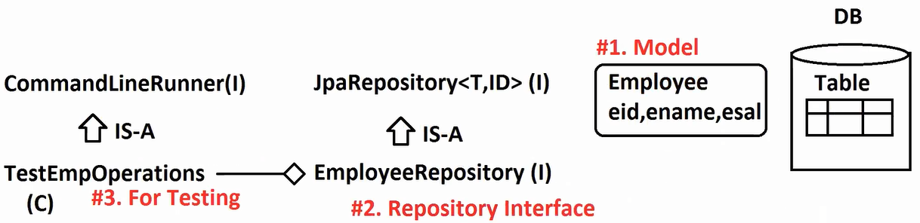

**Step1: Create Spring Boot Project**

**Name:** SpringBootDataJPAMySQLFirstEx

**Dependencies:** Sping Data JPA, MySQL, Lombok

**Step2: Model class**

**package** com.SpringBootJDataJPA.model;

**import** jakarta.persistence.Column;

**import** jakarta.persistence.Entity;

**import** jakarta.persistence.Id;

**import** jakarta.persistence.Table;

**import** lombok.AllArgsConstructor;

**import** lombok.Data;

**import** lombok.NoArgsConstructor;

@Entity

@Table(name = "emptab")

@Data

@AllArgsConstructor

@NoArgsConstructor

**public** **class** Employee {

@Id

@Column(name = "eid")

**private** Integer empId;

@Column(name = "ename")

**private** String empName;

@Column(name = "esal")

**private** Double empSal;

}

**Step3: properties file**

spring.datasource.driver-class-name=com.mysql.cj.jdbc.Driver #Optional

spring.datasource.url=jdbc:mysql://localhost:3306/bootapp

spring.datasource.username=root

spring.datasource.password=vine96

spring.jpa.database-platform=org.hibernate.dialect.MySQL8Dialect #Optional

spring.jpa.show-sql=true

spring.jpa.properties.hibernate.format_sql=true

spring.jpa.hibernate.ddl-auto=create

**Step4: interface extends to JpaRepository**

**package** com.SpringBootJDataJPA.repo;

**import** org.springframework.data.jpa.repository.JpaRepository;

**import** com.SpringBootJDataJPA.model.Employee;

**public** **interface** EmployeeRepository **extends** JpaRepository<Employee, Integer> {

}

**Step5: Test class**

**package** com.SpringBootJDataJPA.runner;

**import** org.springframework.beans.factory.annotation.Autowired;

**import** org.springframework.boot.CommandLineRunner;

**import** org.springframework.stereotype.Component;

**import** com.SpringBootJDataJPA.model.Employee;

**import** com.SpringBootJDataJPA.repo.EmployeeRepository;

@Component

**public** **class** TestEmployeeRunner **implements** CommandLineRunner {

@Autowired

**private** EmployeeRepository repo;

@Override

**public** **void** run(String... args) **throws** Exception {

repo.save(**new** Employee(102, "Margott Robbie", 60000.00));

}

}

* JpaRepository is pre-defined interface, for this impl class is given ‘SimpleJpaRepository(C)’

Ctrl+shift+T > Enter ‘SimpleJpaRepository’ > click on this

Ctrl+O (Enter method name)

Q) What is difference between Sun/Oracle JPA and Data JPA?

A) Sun JPA is a specification given to perform DB operation using ORM. But we should use on vendor (3rd party) Ex. Hibernate with JPA. Full code we should only write.

Data JPA reduces coding lines by using predefind code.

* Model class (we should write)
* Persistencty Configuration (give using properties files)
* Operation code (write interface only).

**Sun JPA Methods:**

persist (obj) : INSERT INTO TABLE..

merge (obj) : UPDATE TABLE SET COL..

remove (obj) : DELETE FROM…

find (obj) : SELECT ONE..

-- Operation Code Flow –

EntityManagerFactory

EntityManager

EntityTranscation

Operation

commit / rollback

close – EM

close – EMF

----------

CrudRepository<T, ID>

PagingAndSortingRepository<T, ID>

JpaRepository<T, ID>

SimpleJpaRepository<T, ID>

-- Generic (Java 1.5 ) –

**package** com.SpringBootJDataJPA;

**public** **class** Test<T> {

**public** **void** show(T input) {

System.***out***.println(input);

}

**public** **static** **void** main(String[] args) {

Test<String> t1=**new** Test<>();

t1.show("Dude");

Test<Integer> t2=**new** Test<>();

t2.show(20);

}

}

**Spring Data JPA : Operations**

**Step1: CreateApplication**

**Name:** SpringBootDataJPAOperations

**Dependencies:** Data JPA, MySQL, Lombok

**Step2: application.properties**

spring.datasource.driver-class-name=com.mysql.cj.jdbc.Driver

spring.datasource.url=jdbc:mysql://localhost:3306/bootapp

spring.datasource.username=root

spring.datasource.password=vine96

spring.jpa.show-sql=true

spring.jpa.database-platform=org.hibernate.dialect.MySQL8Dialect

spring.jpa.hibernate.ddl-auto=create

**application.yml**

spring:

datasource:

driver-class-name: com.mysql.cj.jdbc.Driver

password: vine96

url: jdbc:mysql://localhost:3306/bootapp

username: root

jpa:

database-platform: org.hibernate.dialect.MySQL8Dialect

hibernate:

ddl-auto: create

show-sql: true

**Step3: Model class with JPA Annotations**

**package** com.SpringBootJDataJPA.model;

**import** jakarta.persistence.Column;

**import** jakarta.persistence.Entity;

**import** jakarta.persistence.Id;

**import** jakarta.persistence.Table;

**import** lombok.Data;

@Data

@Entity

@Table(name = "stdtab")

**public** **class** Student {

@Id

@Column(name = "sid")

**private** Integer stdId;

@Column(name = "sname")

**private** String stdName;

@Column(name = "sfee")

**private** Double stdFee;

}

**Step4: Repository Interface**

**package** com.SpringBootJDataJPA.repo;

**import** org.springframework.data.repository.CrudRepository;

**import** com.SpringBootJDataJPA.model.Student;

**public** **interface** StudentRepository **extends** CrudRepository<Student, Integer> {

}

* **Note:** CrudRepository<T, ID> is a predefined interface.

[ Here, T = Model class name, ID = DataType of Primary Key Variable ]

It provides all basic database operations methods

Ex: insert, update, delete and select

* For all these operations, we need not to define code ( like Hibernate, JDBC Code..)
* Ctrl+shift+T and enter name: CrudRepository and press ctrl + O

**Step5: Test class**

**package** com.SpringBootJDataJPA.runner;

**import** java.util.Arrays;

**import** java.util.Iterator;

**import** java.util.List;

**import** java.util.Optional;

**import** org.springframework.beans.factory.annotation.Autowired;

**import** org.springframework.boot.CommandLineRunner;

**import** org.springframework.stereotype.Component;

**import** com.SpringBootJDataJPA.model.Student;

**import** com.SpringBootJDataJPA.repo.StudentRepository;

@Component

**public** **class** TestStudentOpr **implements** CommandLineRunner {

@Autowired

**private** StudentRepository repo;

@Override

**public** **void** run(String... args) **throws** Exception {

repo.save(**new** Student(101, "INNAYATH KHALIL", 340.00));

repo.save(**new** Student(102, "KHAlASH NIKOW", 450.00));

repo.save(**new** Student(103, "SNIPER", 560.00));

repo.save(**new** Student(104, "TARPIDO", 760.00));

System.***out***.println("£££££££££££££££££££££££££££");

repo.saveAll(List.*of*(

**new** Student(105, "BOW", 780.00),

**new** Student(106, "JAWAL", 890.00)));

System.***out***.println("##########################");

Iterable<Student> all=repo.findAll();

all.forEach(System.***out***::println);

System.***out***.println("---------------------------");

**boolean** exist1=repo.existsById(106);

**boolean** exist2=repo.existsById(107);

System.***out***.println("Data Exist: "+exist1+ " , "+exist2);

System.***out***.println("===========================");

Optional<Student> op=repo.findById(107);

**if**(op.isPresent()) {

Student st=op.get();

System.***out***.println("DATA FOUND => "+st);

}

**else** {

System.***out***.println("NO DATA");

}

System.***out***.println("**************************");

Iterable<Student> list=repo.findAllById(Arrays.*asList*(101,104,106,108, 111));

Iterator<Student> itr=list.iterator();

**while**(itr.hasNext()) {

Student st=itr.next();

System.***out***.println(st);

}

System.***out***.println("Total Rows: "+repo.count());

System.***out***.println("DONE");

}

}

1. **save(obj) : obj**

This method behaves like either INSERT … or UPDATE…

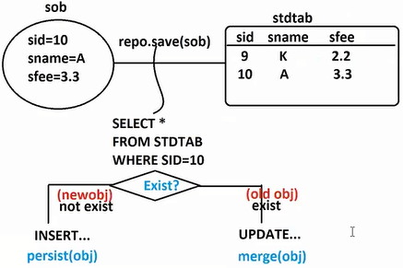

* First it will read ID given by object.
* If ID is not present in DB then save method behaves like INSERT QUERY (persist)

Else save method behaves like UPDATE QUERY (merge)

1. **saveAll(Iterable<S> entities)**

This method is used to perform bulk INSERT/UPDATE. i.e.., execute 50 objects INSERT at a time.

1. **findAll(): Iterable<T>**

This method is used to fetch all rows from DB table.

1. **existById(id): boolean**

This method is used to check given ID exist in DB or not? If exist then ‘true’ else then ‘false’

This method internally use count() concept.

1. **findById(id) : Optional<T>**

This method is used to get one row data from Database using ID (Primary key)

It returns data is Optional<T> format (JDK 1.8). It says check null condition and read, using method like isPresent(), isEmpty()

1. **findAllById(Iterable<ID> ids) : Iterable<T>**

This method internally uses ‘in’ operator.

It takes list of ids as input and return list of objects (rows matching) as output.

1. **count() : long**

This method is used to find total no.of rows in given db table.

SQL: select count(*) from tableName;

**-- Optional<T> --**

* Data in realtime applications may come from UI or Database.
* If no data exist then it is null.
* If data is null and we try to perform operations then JVM throws NullPointerException (NPE).
* To avoid NPE, use code standard

if( data!= null){

data.methodCall();

}

else{

System.out.println(“NO DATA”);

}

* But few developers may not follow above rule. So, java added a class name Optional<T> to make above standard as must written code.
* Now use methods isPresent() or isEmpty() before reading data

isPresent() -> Value!=null

isEmpty() -> Value==null

To read actual data method : get()

* **in operator in SQL:**

select * from stdtab where sid in (101,104, 105, 107);

Q) What is difference between List.of() and Arrays.asList()?

Q) Why should we use Optional<T> ?

Q) What is the super type for Collection?

Q) What is difference between forEach() method (in List) and enhanced for-each loop?

**Delete Operations:**

1. **\*\*\*deleteById(id) : void**

Delete one row/object by Id (Primary Key) then we can use this method

**SQL:** delete from stdtab where sid=?

-- code --

repo.deleteById(102);

1. **delete(obj) : void (legacy app)**

This method takes an object having Primary Key (ID) value and preforms one row delete.

**SQL:** delete from stdtab where sid=?

-- code --

Student st=**new** Student();

st.setStdId(105);

repo.delete(st);

1. **deleteAll(Iterable<T> entities): void (legacy app)**

This method is used to delete multiple rows based on id one by one. But we need to pass object having Primary Key value.

-- code --

repo.deleteAll(Arrays.*asList*(

**new** Student(101),

**new** Student(103),

**new** Student(107)));

1. **deleteAll() :**

This method is used to delete all rows based on id one by one.

-- code --

repo.deleteAll();

**-- Full code –**

* **Model**

**package** com.SpringBootJDataJPA.model;

**import** jakarta.persistence.Column;

**import** jakarta.persistence.Entity;

**import** jakarta.persistence.Id;

**import** jakarta.persistence.Table;

**import** lombok.AllArgsConstructor;

**import** lombok.Data;

**import** lombok.NoArgsConstructor;

**import** lombok.NonNull;

**import** lombok.RequiredArgsConstructor;

@Data

@AllArgsConstructor

@NoArgsConstructor

@RequiredArgsConstructor

@Entity

@Table(name = "stdtab")

**public** **class** Student {

@Id

@Column(name = "sid")

@NonNull

**private** Integer stdId;

@Column(name = "sname")

**private** String stdName;

@Column(name = "sfee")

**private** Double stdFee;

}

* **application.yml**

spring:

datasource:

driver-class-name: com.mysql.cj.jdbc.Driver

password: vine96

url: jdbc:mysql://localhost:3306/bootapp

username: root

jpa:

database-platform: org.hibernate.dialect.MySQL8Dialect

hibernate:

ddl-auto: update

show-sql: true

* **Repository**

**package** com.SpringBootJDataJPA.repo;

**import** org.springframework.data.repository.CrudRepository;

**import** com.SpringBootJDataJPA.model.Student;

**public** **interface** StudentRepository **extends** CrudRepository<Student, Integer> {

}

* **Runner class**

**package** com.SpringBootJDataJPA.runner;

**import** java.util.Arrays;

**import** org.springframework.beans.factory.annotation.Autowired;

**import** org.springframework.boot.CommandLineRunner;

**import** org.springframework.stereotype.Component;

**import** com.SpringBootJDataJPA.model.Student;

**import** com.SpringBootJDataJPA.repo.StudentRepository;

@Component

**public** **class** TestStdDelRunner **implements** CommandLineRunner {

@Autowired

**private** StudentRepository repo;

@Override

**public** **void** run(String... args) **throws** Exception {

repo.save(**new** Student(101, "INNAYATH KHALIL", 340.00));

repo.save(**new** Student(102, "KHAlASH NIKOW", 450.00));

repo.save(**new** Student(103, "SNIPER", 560.00));

repo.save(**new** Student(104, "TARPIDO", 760.00));

System.***out***.println("-------------Before DELEETE---------");

repo.findAll().forEach(System.***out***::println);

//repo.deleteById(102);

/*

Student st=new Student();

st.setStdId(105);

repo.delete(st);

*/

/*

repo.deleteAll(Arrays.asList(

new Student(101),

new Student(103),

new Student(107)));

*/

repo.deleteAll();

System.***out***.println("---------After DELETE------------");

repo.findAll().forEach(System.***out***::println);

}

}

**PagingAndSortingRepository(I)**

We can define our Repository Interface using ‘PagingAndSortingRepository’ also. It is sub type of ‘CurdRepository’.

**-- API code –**

**public** **interface** PagingAndSortingRepository<T, ID> **extends** CrudRepository<T, ID>

* **Additional Methods:**

1. findAll(Sort sort) : List<T>
2. findAll(Pageable pageable) : Page<T>

* Database support data sorting while fetching data from DB using order by clause with ASC default value and supports DESC.

**Ex SQLS:**

* select * from stdtab order by sname desc;
* select * from stdtab order by sname, sfee desc;
* select * from stdtab order by sname asc, sfee desc;

**SQL Code**

order by sname asc => Sort.by(“sname”) //default is ASC

Sort.by(Direction.ASC, “sname”);

order by sname desc => Sort.by(Direction.DESC, “sname”);

* Direction is a enum having two values ASC and DESC

public static enum Direction{

ASC, DESC;

//…

}

* Here default value is ASC.
* Sort class is having static method name by that returns same object

class Sort{

static Sort by(String property){…..}

static Sort by(Direction String property){…..}

static class Order{

static Order asc(String property){ }

static Order desc(String property) {}

}

static Sort by(Order ords…){____}

}

call:

Sort s=Sort.by(“sname”) ;

Sort s=Sort.by(“sname”, “sfee”) ; //both comes in ASC

Sort s=Sort.by(Direction.DESC , “sname”) ;

Sort s=Sort.by(Direction.DESC , “sname”, “sfee”) ; //both comes in DESC

Sort s=Sort.by(Order.asc(“sname”), Order.desc(“sfee”))

**___FULL CODE____**

1. **Model**

package com.SpringBootJDataJPA.model;

import jakarta.persistence.Column;

import jakarta.persistence.Entity;

import jakarta.persistence.Id;

import jakarta.persistence.Table;

import lombok.AllArgsConstructor;

import lombok.Data;

import lombok.NoArgsConstructor;

import lombok.NonNull;

import lombok.RequiredArgsConstructor;

@Data

@AllArgsConstructor

@NoArgsConstructor

@RequiredArgsConstructor

@Entity

@Table(name = "stdtab")

public class Student {

@Id

@Column(name = "sid")

@NonNull

private Integer stdId;

@Column(name = "sname")

private String stdName;

@Column(name = "sfee")

private Double stdFee;

}

1. **Repository**

package com.SpringBootJDataJPA.repo;

import org.springframework.data.repository.CrudRepository;

import org.springframework.data.repository.PagingAndSortingRepository;

import com.SpringBootJDataJPA.model.Student;

public interface StudentRepository extends

//CrudRepository<Student, Integer> {

PagingAndSortingRepository<Student, Integer>, CrudRepository<Student, Integer>{

}

1. **Runner class**

**package** com.SpringBootJDataJPA.runner;

**import** java.util.List;

**import** org.springframework.beans.factory.annotation.Autowired;

**import** org.springframework.boot.CommandLineRunner;

**import** org.springframework.data.domain.Sort;

**import** org.springframework.data.domain.Sort.Direction;

**import** org.springframework.stereotype.Component;

**import** org.springframework.data.domain.Sort.Order;

**import** com.SpringBootJDataJPA.model.Student;

**import** com.SpringBootJDataJPA.repo.StudentRepository;

@Component

**public** **class** TestStudentOprPageAndSort **implements** CommandLineRunner {

@Autowired

**private** StudentRepository repo;

@Override

**public** **void** run(String... args) **throws** Exception {

repo.save(**new** Student(101, "INNAYATH KHALIL", 340.00));

repo.save(**new** Student(102, "KHAlASH NIKOW", 450.00));

repo.save(**new** Student(103, "SNIPER", 560.00));

repo.save(**new** Student(104, "TARPIDO", 760.00));

System.***out***.println("£££££££££££££££££££££££££££");

repo.saveAll(List.*of*(

**new** Student(105, "BOW", 780.00),

**new** Student(106, "JAWAL", 890.00)));

repo.findAll().forEach(System.***out***::println);

System.***out***.println("##########################");

//Sort s1=Sort.by("stdName"); //ASC

//Sort s1=Sort.by(Direction.ASC,"stdName"); //ASC

//Sort s1=Sort.by(Direction.DESC,"stdName", "stdFee");

Sort s1=Sort.*by*(Order.*asc*("stdName"), Order.*desc*("stdFee"));

repo.findAll(s1).forEach(System.***out***::println);

}

}

* Directions are two types : ASC (A-Z), DESC (Z-A)
* If we do not specify any order default is ASC (A-Z)

Sort.by(“sname”); // order by sname ASC

Sort.by(Direction.DESC, “sname”); //order by sname DESC

Q) What are inner classes? how many types?

**Data JPA : Pagination**

* Loading all rows from DB table to UI screen may not be good some times i.e., using method: findAll(): List<T> Internally executes SQL: select * from <tableName>
* If table has few rows then it is good. If table has more no.of rows, loading data makes client device slow. Such process is handled using ‘Pagination’.
* Example for Pagination is Google Search

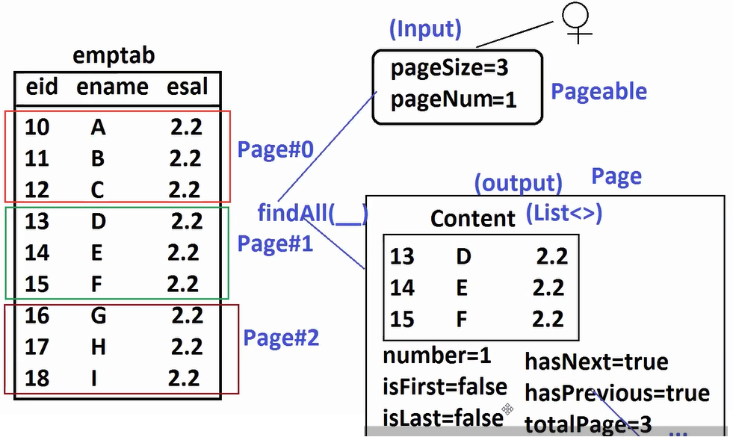

**findAll(Pageable) : Page<T>**

This method is used to get data page by page.

We need to pass Input ‘Pageable (Size, pageNumber)’

If we give above input then we get output ‘Page<T>’

Page<T> = Content + meta data (number, size, isFirst, isLast, hasNext…)

* Here Pageable is a Interface. Impl class is PageRequest having method of (number, size) return Pageable.

Pageable p = PageRequest.of(0, 10); //number, size

-- **code –**

1. **Model class**

package com.SpringBootJDataJPA.model;

import jakarta.persistence.Column;

import jakarta.persistence.Entity;

import jakarta.persistence.Id;

import jakarta.persistence.Table;

import lombok.AllArgsConstructor;

import lombok.Data;

import lombok.NoArgsConstructor;

import lombok.NonNull;

import lombok.RequiredArgsConstructor;

@Data

@AllArgsConstructor

@NoArgsConstructor

@RequiredArgsConstructor

@Entity

@Table(name = "stdtab")

public class Student {

@Id

@Column(name = "sid")

@NonNull

private Integer stdId;

@Column(name = "sname")

private String stdName;

@Column(name = "sfee")

private Double stdFee;

}

1. **Repository**

package com.SpringBootJDataJPA.repo;

import org.springframework.data.repository.CrudRepository;

import org.springframework.data.repository.PagingAndSortingRepository;

import com.SpringBootJDataJPA.model.Student;

public interface StudentRepository extends

//CrudRepository<Student, Integer> {

PagingAndSortingRepository<Student, Integer>, CrudRepository<Student, Integer>{

}

1. **Runner class**

**package** com.SpringBootJDataJPA.runner;

**import** java.util.List;

**import** org.springframework.beans.factory.annotation.Autowired;

**import** org.springframework.boot.CommandLineRunner;

**import** org.springframework.data.domain.Page;

**import** org.springframework.data.domain.PageRequest;

**import** org.springframework.data.domain.Pageable;

**import** org.springframework.stereotype.Component;

**import** com.SpringBootJDataJPA.model.Student;

**import** com.SpringBootJDataJPA.repo.StudentRepository;

@Component

**public** **class** TestStudentOprPageAndSortTwo **implements** CommandLineRunner {

@Autowired

**private** StudentRepository repo;

@Override

**public** **void** run(String... args) **throws** Exception {

repo.save(**new** Student(101, "INNAYATH KHALIL", 340.00));

repo.save(**new** Student(102, "KHAlASH NIKOW", 450.00));

repo.save(**new** Student(103, "SNIPER", 560.00));

repo.save(**new** Student(104, "TARPIDO", 760.00));

repo.save(**new** Student(105, "INNAYATH KHALIL", 340.00));

repo.save(**new** Student(106, "KHAlASH NIKOW", 450.00));

repo.save(**new** Student(107, "SNIPER", 560.00));

repo.save(**new** Student(108, "TARPIDO", 760.00));

repo.save(**new** Student(109, "SNIPER", 560.00));

repo.save(**new** Student(110, "TARPIDO", 760.00));

//Input (pageable)= number, size

Pageable pageable=PageRequest.*of*(222, 5);

//execute qurey

Page<Student> page=repo.findAll(pageable);

//print output

List<Student> data=page.getContent();

//System.out.println(data);

data.forEach(System.***out***::println);

//meta data

System.***out***.println("Is Empty Page? : "+page.isEmpty());

System.***out***.println("Is First Page? : "+page.isFirst());

System.***out***.println("Is Last Page? : "+page.isLast());

System.***out***.println("Next Page?: "+page.hasNext());

System.***out***.println("Previous Page?: "+page.hasPrevious());

System.***out***.println("Total Pages?: "+page.getTotalPages());

System.***out***.println("Current Page Number?: "+page.getNumber());

System.***out***.println("Page Size?: "+page.getSize());

}

}

1. **application.yml**

spring:

datasource:

driver-class-name: com.mysql.cj.jdbc.Driver

password: vine96

url: jdbc:mysql://localhost:3306/bootapp

username: root

jpa:

database-platform: org.hibernate.dialect.MySQL8Dialect

hibernate:

ddl-auto: update

show-sql: true

**Pagination:**

**Internal Formuals: (Hibernate Ex)**

**Inputs:**

pageNumber = pn

pageSize = ps

totalRows = tr

start Row = sr = (pn-1) * ps

end Row = current row to ps limit

**Ex:**

UI Index (pn=1 internally page=0), ps = 3

start row = (pn-1) * ps = (1-1) * 3 = 0 * 3 = 0

end row = 0th row to 3 rows = 3

totalPages = tr / ps + (tr%ps > 0 ? 1 : 0)

= 9 /3 + (9 % 3 > 0 ? 1: 0)

= 3 + (0 > 0 ? 1 : 0)

= 3 + 0

= 3

UI pn=2, ps=3

Start row = (pn-1) * ps = (2-1) * 3 = 1 * 3 = 3

105 rows, pagesize =50

1st page - 0-49

2nd page - 50-99

3rd page - 100-104

While implementing Pagination we can also send Sorting details by default Pagination output comes without Sorting (UnSorted)

Inside PageRequest class use method (3 param)

of(int page, int size, Sort(sort))

Pageable pageable=PageRequest.of(0, 5, Sort.by("stdName", "stdId"));

Pageable pageable=PageRequest.*of*(0, 5, Sort.*by*(Order.*asc*("stdName"), Order.*desc*("stdId")));

**JpaRepository<T, ID>**

findAll() : List<T> : Get All rows into List

SELECT * FROM TABLE;

findAll(Example<T> example) : List<T>

SELECT * FROM TABLE WHERE <DYNAMIC>;

This method is used to take one input Model class object that will be compared with every row data (only non-null values) matching records are selected.

Here, ‘Example’ is used to check and compare non-null variables, findAll just collecting data for Example.

where btype=?

where btype=? and bauthor=?

where bcost=300.0 and bauthor=? and btype=?

* If all variables holds null values then fetch all rows

-- **Example Internal** --

String sql= “SELECT * FROM BOOK WHERE”

if(booName!=null){

sql+= “bookName=?”

}

elseif(bookCost!=null){

sql+= “bookCost=?”

}

Example<T> is used to generate dynamic where condition in realtime used for Search Screen Implementation.

1. **Model class**

**package** com.SpringBootJDataJPA.model;

**import** jakarta.persistence.Column;

**import** jakarta.persistence.Entity;

**import** jakarta.persistence.Id;

**import** jakarta.persistence.Table;

**import** lombok.AllArgsConstructor;

**import** lombok.Data;

**import** lombok.NoArgsConstructor;

@Data

@AllArgsConstructor

@NoArgsConstructor

@Entity

@Table(name = "book_tab")

**public** **class** Book {

@Id

@Column(name = "bid")

**private** Integer bookId;

@Column(name = "bname")

**private** String bookName;

@Column(name = "bauthor")

**private** String author;

@Column(name = "bcost")

**private** Double bookCost;

@Column(name = "type")

**private** String bookType;

}

1. **application.properties**

#datasource

spring.datasource.driver-class-name=com.mysql.cj.jdbc.Driver

spring.datasource.url=jdbc:mysql://localhost:3306/bootapp

spring.datasource.username=root

spring.datasource.password=vine96

#JPA

spring.jpa.show-sql=true

spring.jpa.database-platform=org.hibernate.dialect.MySQLDialect

spring.jpa.hibernate.ddl-auto=update

1. **Repository**

**package** com.SpringBootJDataJPA.repo;

**import** org.springframework.data.jpa.repository.JpaRepository;

**import** com.SpringBootJDataJPA.model.Book;

**public** **interface** BookRepository **extends** JpaRepository<Book, Integer> {

}

1. **Runner class**

**package** com.SpringBootJDataJPA.runner;

**import** java.util.Arrays;

**import** java.util.List;

**import** org.springframework.beans.factory.annotation.Autowired;

**import** org.springframework.boot.CommandLineRunner;

**import** org.springframework.data.domain.Example;

**import** org.springframework.stereotype.Component;

**import** com.SpringBootJDataJPA.model.Book;

**import** com.SpringBootJDataJPA.repo.BookRepository;

@Component

**public** **class** BookRepoRunner **implements** CommandLineRunner {

@Autowired

**private** BookRepository repo;

@Override

**public** **void** run(String... args) **throws** Exception {

/*

repo.saveAll(Arrays.asList(

new Book(101, "Core Java", "SAM", 300.0, "Backend"),

new Book(102, "Advanced Java", "RAM", 400.0, "Backend"),

new Book(103, "Spring Boot", "SAM", 500.0, "Backend"),

new Book(104, "Angular", "SAM", 600.0, "UI"),

new Book(105, "HTML", "RAM", 700.0, "UI"),

new Book(106, "SQL/PLSQL", "SAM", 800.0, "DATABASE")

));

*/

Book b=**new** Book();

b.setAuthor("SAM");

b.setBookType("Backend");

//Convert this into Example object

Example<Book> example=Example.*of*(b);

//fetch data

List<Book> list=repo.findAll(example);

list.forEach(System.***out***::println);

System.***out***.println("DONE");

}

}

**Collections**

* Boyce codd normalization in database with example

ORM internally implements all rules of “Boyce codd normalization”, In case of JDBC we should implement them manually.

* As per ORM concept all primitive variables are mapped with one table (Parent table) and for every collection variable one child table is created with Foreian Key column.

**Ex:**

class A{

id:int

cod:String

cost:Double

data:List

models:Set

format:Map

}

id, cod, cost 🡪 1 parent table

data 🡪1 child table

models 🡪1child table

format 🡪 1 child table

**Index Based Collection Non-Indexed Based Collection**

**List Set**

**Map**

* For Every child table at minimum 2 columns at maximum 3 columns are given by ORM.

3 columns – key column, index column, element column

(FK column) (Position) (data of Collection)

i.e.., if we use List/Map then child table is created with 3 columns

if we use Set then child table is created with 2 columns

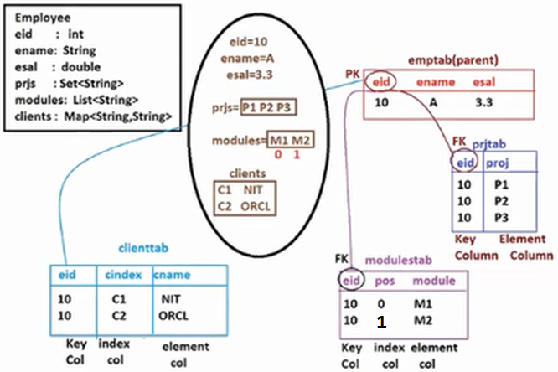

* We need to add @ElementCollection annotation at collection variable level in model class (Must)

@ElementCollection – creates child table with reference links (i.e.., FK columns linked to parent table PK column)

**Data JPA : Collections Mapping**

* For every collection one child table is created
* This child table contains at max 3 columns

Key column - Foreain Key Column

Index column - Position (only for List/Map)

Element - Data

* **@ElementCollection** should be provided over collection variable.
* To provide child table details created for collection variable like table name, FK (Join column) … etc

@ElementCollection

@CollectionTable(

name = "<child_tableName>",

joinColumns = @JoinColumn(name="<KeyColumn>")

)

* **Element Column name:** @Column(name= “<columnName>”)
* For List Collection we should add : @OrderColumn(name = “<indexColumnName>”)
* For Map Collection we should add : @MapKeyColumn(name = "<indexColumnName>")

Map – Key behaves like index

-- **code** --

**Name:** SpringBootDataJpaCollectionsEx

**Dependencies:** Data Jpa, MySQL, Lombok

1. **Model class**

**package** com.SpringBootJDataJPA.model;

**import** java.util.List;

**import** java.util.Map;

**import** java.util.Set;

**import** jakarta.persistence.CollectionTable;

**import** jakarta.persistence.Column;

**import** jakarta.persistence.ElementCollection;

**import** jakarta.persistence.Entity;

**import** jakarta.persistence.Id;

**import** jakarta.persistence.JoinColumn;

**import** jakarta.persistence.MapKeyColumn;

**import** jakarta.persistence.OrderColumn;

**import** jakarta.persistence.Table;

**import** lombok.AllArgsConstructor;

**import** lombok.Data;

**import** lombok.NoArgsConstructor;

@Data

@AllArgsConstructor

@NoArgsConstructor

@Entity

@Table(name = "emp_tab")

**public** **class** Employee {

@Id

@Column(name = "eid")

**private** Integer empId;

@Column(name = "ename")

**private** String empName;

@Column(name = "esal")

**private** Double empSal;

//collection variables

@ElementCollection

@CollectionTable(

name = "emp_prjs",

joinColumns = @JoinColumn(name="eid")

)

@Column(name = "proj")

**private** Set<String> empPrjs;

@ElementCollection

@CollectionTable(

name="emp_modules",

joinColumns = @JoinColumn(name="eid")

)

@OrderColumn(name = "epos")

@Column(name = "module")

**private** List<String> empModules;

@ElementCollection

@CollectionTable(

name = "emp_clients_tab",

joinColumns = @JoinColumn(name="eid")

)

@MapKeyColumn(name = "cindex")

@Column(name = "cname")

**private** Map<String, String> empClients;

}

1. **Repository**

**package** com.SpringBootJDataJPA.repo;

**import** org.springframework.data.jpa.repository.JpaRepository;

**import** com.SpringBootJDataJPA.model.Employee;

**public** **interface** EmployeeRepository **extends** JpaRepository<Employee, Integer> {

}

1. **Runner class**

**package** com.SpringBootJDataJPA.runner;

**import** java.util.List;

**import** java.util.Map;

**import** java.util.Set;

**import** org.springframework.beans.factory.annotation.Autowired;

**import** org.springframework.boot.CommandLineRunner;

**import** org.springframework.stereotype.Component;

**import** com.SpringBootJDataJPA.model.Employee;

**import** com.SpringBootJDataJPA.repo.EmployeeRepository;

@Component

**public** **class** TestRunner **implements** CommandLineRunner {

@Autowired

**private** EmployeeRepository repo;

@Override

**public** **void** run(String... args) **throws** Exception {

repo.save(

**new** Employee(11, "A", 3.3,

Set.*of*("P1", "P2", "P3"),

List.*of*("M1", "M2"),

Map.*of*("C1","VIE", "C2","ORCL")

)

);

System.***out***.println("DONE");

}

}

@ElementCollection (must)

-- child table --

table name : @CollectionTable(name = “”)

KeyColumn - @JoinColumn(name = “”)

IndexColumn

List - @OrderColumn(name = “”)

Map - @MapKeyColumn(name = “”)

Element Column - @Column(name = “”)

-----

Task:

Student

sid

sname

sfee

marks: List<Integer>

subnames: Set<String>

grades: Map<String, String>

-- **code** --

**Name:** SpringBootDataJpaCollectionEx2

**Dependencies:** Data Jpa, MySQL, Lombok

1. **Model class**

**package** com.SpringBootJDataJPA.model;

**import** java.util.List;

**import** java.util.Map;

**import** java.util.Set;

**import** jakarta.persistence.CollectionTable;

**import** jakarta.persistence.Column;

**import** jakarta.persistence.ElementCollection;

**import** jakarta.persistence.Entity;

**import** jakarta.persistence.Id;

**import** jakarta.persistence.JoinColumn;

**import** jakarta.persistence.OrderColumn;

**import** jakarta.persistence.Table;

**import** lombok.AllArgsConstructor;

**import** lombok.Data;

**import** lombok.NoArgsConstructor;

@Data

@AllArgsConstructor

@NoArgsConstructor

@Entity

@Table(name = "student_tab")

**public** **class** Student {

/*

sid

sname

sfee

marks: List<Integer>

subnames: Set<String>

grades: Map<String, String>

*/

@Id

@Column(name = "sid")

**private** Integer stdId;

@Column(name = "sname")

**private** String stdName;

@Column(name = "sfee")

**private** Double stdFee;

//Collection variables

@ElementCollection

@CollectionTable(

name = "std_marks",

joinColumns = @JoinColumn(name="sid")

)

@OrderColumn(name = "stdM")

@Column(name = "smarks")

**private** List<Integer> stdMarks;

@ElementCollection

@CollectionTable(

name = "sub_name",

joinColumns = @JoinColumn(name="sid")

)

@Column(name = "submarks")

**private** Set<String> subjNames;

@ElementCollection

@CollectionTable(

name = "std_grade",

joinColumns = @JoinColumn(name="sid")

)

@OrderColumn(name = "stdg")

@Column(name = "sgrades")

**private** Map<String, String> grades;

}

1. **Repository**

**package** com.SpringBootJDataJPA.repo;

**import** org.springframework.data.jpa.repository.JpaRepository;

**import** com.SpringBootJDataJPA.model.Student;

**public** **interface** StudentRepository **extends** JpaRepository<Student, Integer> {

}

1. **application.properties**

#datasource

spring.datasource.driver-class-name=com.mysql.cj.jdbc.Driver

spring.datasource.url=jdbc:mysql://localhost:3306/bootapp

spring.datasource.username=root

spring.datasource.password=vine96

#JPA

spring.jpa.show-sql=true

spring.jpa.database-platform=org.hibernate.dialect.MySQLDialect

spring.jpa.hibernate.ddl-auto=update

1. **Runner class**

**package** com.SpringBootJDataJPA.runner;

**import** java.util.List;

**import** java.util.Map;

**import** java.util.Set;

**import** org.springframework.beans.factory.annotation.Autowired;

**import** org.springframework.boot.CommandLineRunner;

**import** org.springframework.stereotype.Component;

**import** com.SpringBootJDataJPA.model.Student;

**import** com.SpringBootJDataJPA.repo.StudentRepository;

@Component

**public** **class** TestRunner **implements** CommandLineRunner {

@Autowired

**private** StudentRepository repo;

@Override

**public** **void** run(String... args) **throws** Exception {

repo.save(

**new** Student(101, "Vikram", 3000.00,

List.*of*(79, 89, 36, 45),

Set.*of*("Math", "English", "Physics", "Chemistry"),

Map.*of*("12","B", "11","A", "10", "B", "9", "C")

)

);

System.***out***.println("DONE");

}

}

* Child table created for collection never contains extra columns this is not association mapping.
* If we don’t provide Collectiontable and JoinColumn then

table name is = classsName_variableName

Join Column Name is = className_pkColumnName

i.e.., Providing

@CollectionTable( name = “____”,

joinColumns = @JoinColumn( name = “__”))

are optional.

@JoinColumn(name = “” ) – FK column created for linking other table PK

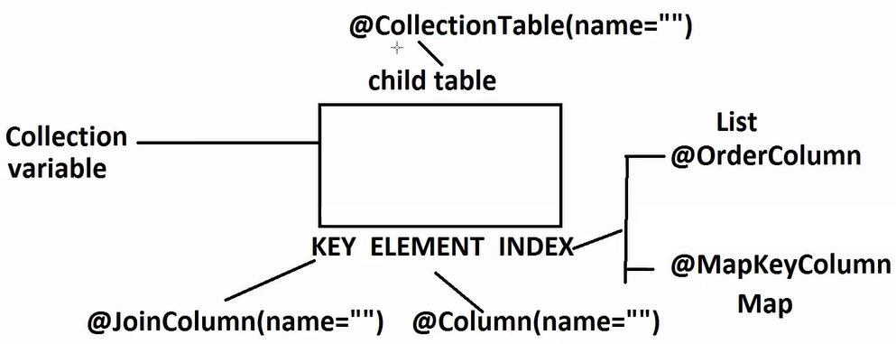

**Custom Query : Data JPA**

1. **@Query Annotation**

* This annotation supports both SELECT and NON-SELECT (update/delete)
* It supports both SQL and HQL/JPQL Query.
* Supports Data Projections (specific column select)
* We can even pass parameters (data at runtime)
* We can implement JOINs (INNER JOIN, LEFT JOIN… etc)
* We can use procedure calls.

1. **findBy methods**

* It supports only SELECT operation
* No need of writing any query, just define abstract method (i.e., converted by Query internally)
* This is better for simple queries.

**@Query**

**SQL :** Structured Query Language

**HQL/JPQL :** Hibernate Query Language/ Java Persistance Query Language

**SQL:** Database dependent. i.e.., If we define one SQL query for DB#1 (Working fine), may or may not work for DB#2. (DataTypes, Syntaxes … etc)

**SQL Query:** tableNames and columnNames

It is case-insensitive

select * from emptab

select * FROM EMPTAB

select * From EmpTab

(all are same)

**HQL/JPQL:** It is Database Independent (we use internally Dialect). Dialect will convert HQL/JPQL to SQL at runtime. So, if we goto to different DB, just modify dialect.

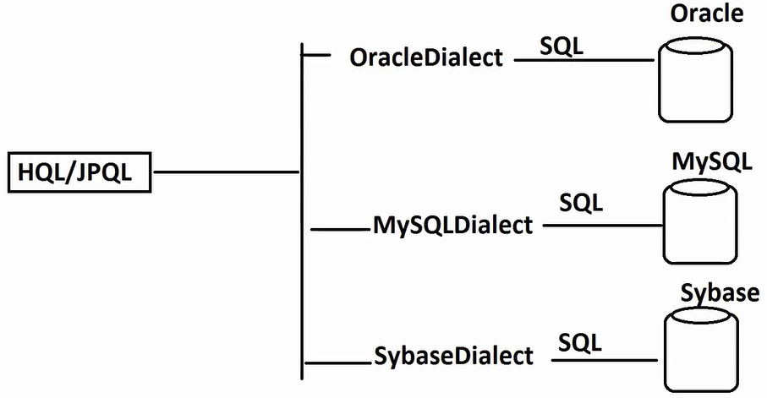

Partially case-sensitive.

i.e.., Java related words (className, variableName are case sensitive)

and SQL related words (SELECT, FROM, WHERE are case-insensitive)

**SQL => HQL/JPQL :** tableName – Replace with – className

columnName – Repalce with – VarableName

**Examples**

**1.**

**SQL:**

select eid, ename from emptab where esal>100;

**HQL/JPQL:**

select empId, empName from com.vie.model.Employee where empSal>100;

**2.**

**SQL:**

select * from emptab;

**HQL/JPQL:**

select * from com.vie.model.Employee: //(Invalid)

Note: In java * - multiply

**Sol#1:**

from com.vie.model.Employee

**Sol#2:**

select e from com.vie.model.Employee e

* FullyQualified name is optional, we can even directly write className i.e., valid

**HQL/JPQL:**

select empId,empName from com.vie.model.Employee (valid – recommended )

select empId,empName Employee (valid)

* select variables/columns using aliasing

select e.empId, e.empName from com.vie.model.Employee e

**SELECT QUERY**

1. SELECT ALL COLUMN DATA : List<T>
2. SELECT ONE COLUMN DATA : List<DataType>
3. SELECT MULTIPLE (NOT ALL) COLUMN DATA : List<Object[]>

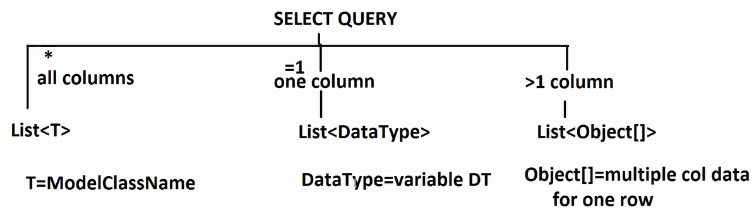

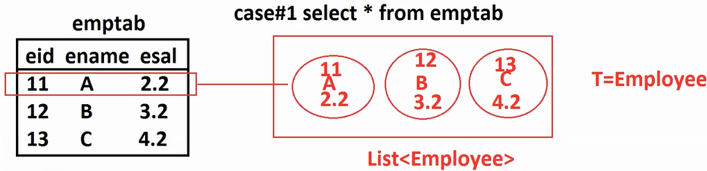

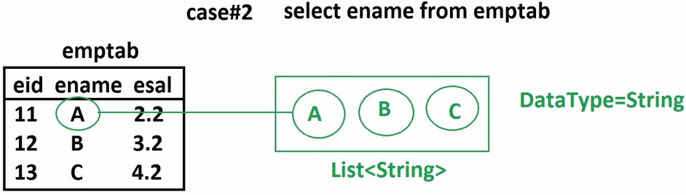

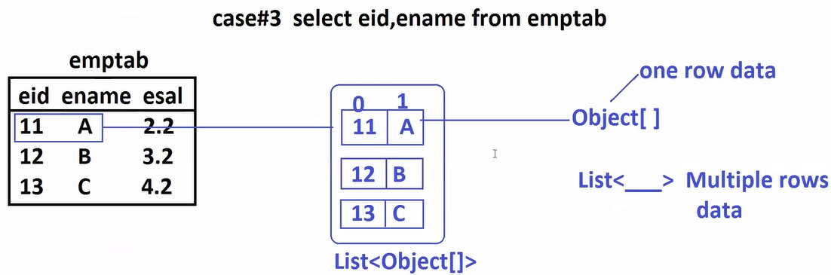

-- **code** --

**1. Model class**

**package** com.SpringBootJDataJPA.model;

**import** jakarta.persistence.Column;

**import** jakarta.persistence.Entity;

**import** jakarta.persistence.Id;

**import** jakarta.persistence.Table;

**import** lombok.AllArgsConstructor;

**import** lombok.Data;

**import** lombok.NoArgsConstructor;

@Data

@AllArgsConstructor

@NoArgsConstructor

@Entity

@Table(name = "emptab")

**public** **class** Employee {

@Id

@Column(name = "eid")

**private** Integer empId;

@Column(name = "ename")

**private** String empName;

@Column(name = "esal")

**private** Double empSal;

}

1. **Repository**

package com.SpringBootJDataJPA.repo;

import java.util.List;

import org.springframework.data.jpa.repository.JpaRepository;

import org.springframework.data.jpa.repository.Query;

import com.SpringBootJDataJPA.model.Employee;

public interface EmployeeRepository extends JpaRepository<Employee, Integer> {

//@Query("FROM Employee e")

@Query("SELECT e FROM Employee e")

List<Employee> getAllEmps();

@Query("SELECT e.empName FROM Employee e")

List<String> getEmpNames();

@Query("SELECT e.empName, e.empSal FROM Employee e")

List<Object[]> getEmpNameAndSals();

}

1. **application.properties**

#datasource

spring.datasource.driver-class-name=com.mysql.cj.jdbc.Driver

spring.datasource.url=jdbc:mysql://localhost:3306/bootapp

spring.datasource.username=root

spring.datasource.password=vine96

#JPA

spring.jpa.show-sql=true

spring.jpa.database-platform=org.hibernate.dialect.MySQLDialect

spring.jpa.hibernate.ddl-auto=update

1. **Runner class for Testing**

**package** com.SpringBootJDataJPA.runner;

**import** java.util.Arrays;

**import** java.util.List;

**import** org.springframework.beans.factory.annotation.Autowired;

**import** org.springframework.boot.CommandLineRunner;

**import** org.springframework.stereotype.Component;

**import** com.SpringBootJDataJPA.model.Employee;

**import** com.SpringBootJDataJPA.repo.EmployeeRepository;

@Component

**public** **class** TestEmpRunner **implements** CommandLineRunner {

@Autowired

**private** EmployeeRepository repo;

@Override

**public** **void** run(String... args) **throws** Exception {

repo.saveAll(Arrays.*asList*( **new** Employee(101, "Vikram", 2.2),

**new** Employee(101, "Vijay", 3.3),

**new** Employee(101, "Bantii", 4.4)));

repo.getAllEmps().forEach(System.***out***::println);

System.***out***.println("-------------------------");

repo.getEmpNames().forEach(System.***out***::println);

System.***out***.println("**************************");

/*

repo.getEmpNameAndSals()

.stream()

.map(ob->ob[0]+","+ob[1])

.forEach(System.out::println);

*/

List<Object[]> list=repo.getEmpNameAndSals();

**for**(Object[] ob: list) {

System.***out***.println(ob[0]+" - "+ob[1]);

}

}

}

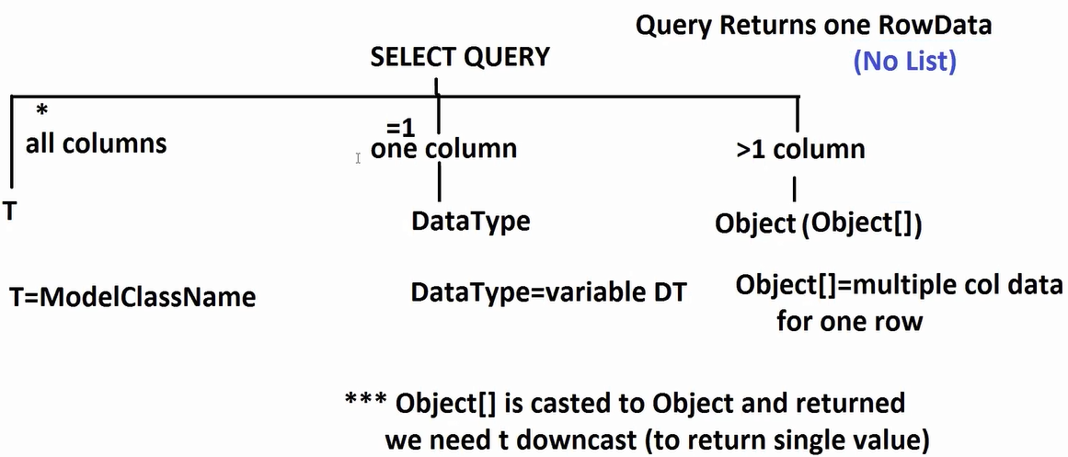

* If Query returns only one row data (not multiple rows) then return type can be given without List.

**Ex:**  SELECT * FROM EMPTAB EID=10

This query returns only one row data. So, return type is Employee.

* If method ReturnType is non-List for SELECT Operation and query returns more than one row data then Exception “NonUniqueResultException: query did not return unquie result: 3”

**Ex:** @Query("SELECT e FROM Employee e WHERE e.empId>=101")

Employee getEmpById();

**Repository**

package com.SpringBootJDataJPA.repo;

import java.util.List;

import org.springframework.data.jpa.repository.JpaRepository;

import org.springframework.data.jpa.repository.Query;

import com.SpringBootJDataJPA.model.Employee;

public interface EmployeeRepository extends JpaRepository<Employee, Integer> {

//@Query("FROM Employee e")

@Query("SELECT e FROM Employee e WHERE e.empId>=101")

Employee getEmpById();

@Query("SELECT e.empName FROM Employee e WHERE e.empId=101")

List<String> getEmpNameById();

@Query("SELECT e.empName, e.empSal FROM Employee e WHERE e.empId=101")

Object getEmpNameAndSalsById();

}

**Runner class**

**package** com.SpringBootJDataJPA.runner;

**import** java.util.Arrays;

**import** java.util.List;

**import** org.springframework.beans.factory.annotation.Autowired;

**import** org.springframework.boot.CommandLineRunner;

**import** org.springframework.stereotype.Component;

**import** com.SpringBootJDataJPA.model.Employee;

**import** com.SpringBootJDataJPA.repo.EmployeeRepository;

@Component

**public** **class** TestEmpRunner **implements** CommandLineRunner {

@Autowired

**private** EmployeeRepository repo;

@Override

**public** **void** run(String... args) **throws** Exception {

repo.saveAll(Arrays.*asList*( **new** Employee(101, "Vikram", 2.2),

**new** Employee(101, "Vijay", 3.3),

**new** Employee(101, "Bantii", 4.4)));

System.***out***.println(repo.getEmpById());

System.***out***.println(repo.getEmpNameById());

System.***out***.println(Arrays.*asList*((Object[]) repo.getEmpNameAndSalsById()));

/*

repo.getAllEmps().forEach(System.out::println);

System.out.println("-------------------------");

repo.getEmpNames().forEach(System.out::println);

System.out.println("**************************");

// repo.getEmpNameAndSals()

// .stream()

// .map(ob->ob[0]+","+ob[1])

// .forEach(System.out::println);

List<Object[]> list=repo.getEmpNameAndSals();

for(Object[] ob: list) {

System.out.println(ob[0]+" - "+ob[1]);

}

*/

}

}

**Parameters:** Passing input to Query at runtime is called as Parameters

1. **Positional Parameters:** ?1, ?2, ?3 (names can be different for parameter, but dataType must be matching)

**Ex:**

@Query("SELECT e FROM Employee e WHERE e.empId=?1")

Employee getEmpById(Integer id);

@Query("SELECT e.empName FROM Employee e WHERE e.empName=?1")

List<String> getEmpNameByName(String name);

@Query("SELECT e.empName, e.empSal FROM Employee e WHERE e.empSal=?1")

Object getEmpNameAndSalsBySal(Double sal);

1. **Named Parameters: “ :name(column name)”**

* Name of Parameter and namedParam must be matching. Even DataType too…

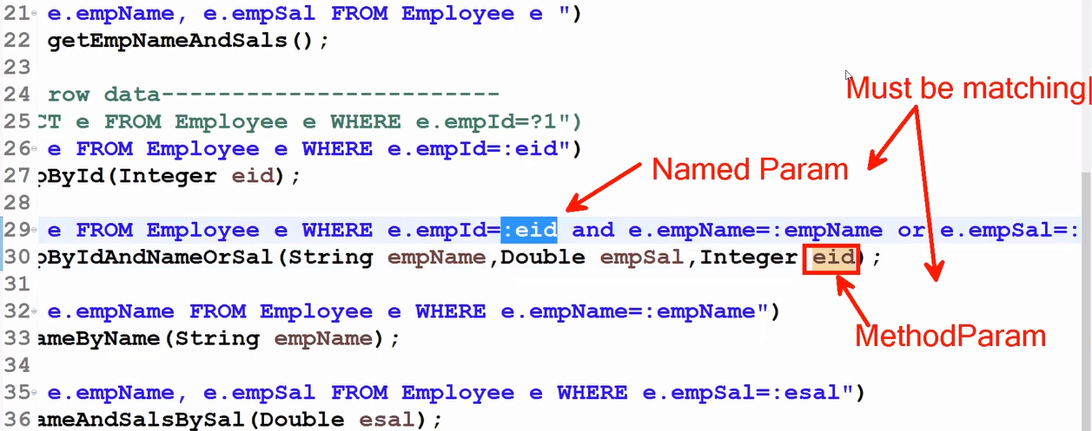

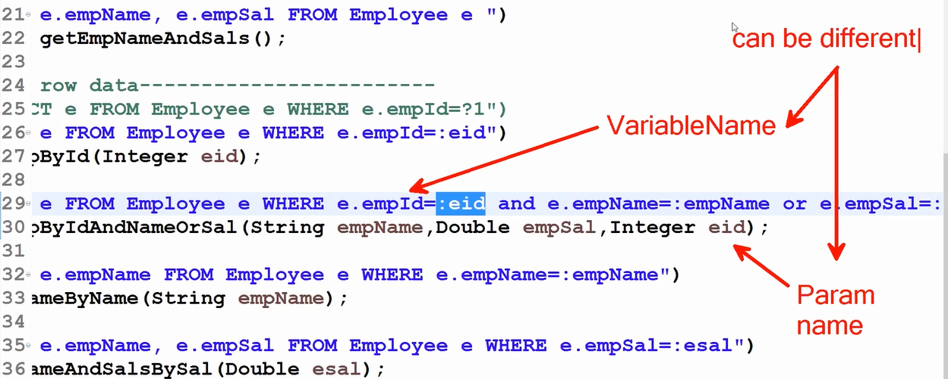

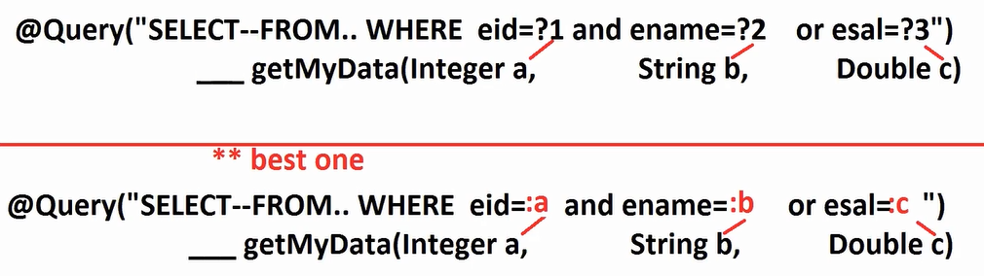

1. **in operator**

**SQL:** select * from emptab where eid=10 or eid=14 or eid =34 or eid=65

**SQL:** select * from emptab where eid in (10, 14,34,65)

**HQL/JPQL :** We need to pass input data using List of values.

1. **between (from __to___)**

**SQL:** SELECT * FROM TAB WHERE COL BETWEEN A AND B;

Even supported Group By, order by etc…

@Qurey supports executing pure SQL query (ie.., NativeSQL )

* To use this we need to provide additional param to @Query as “nativeQuery = true”

Ex: (Use table and column names, not class and variabele names)

@Query(value ="select ename from emptab", nativeQuery = **true**)

List<Employee> getAllEmployeesBySql();

* These are not recommended, they are executed without dialect Once you migrate from one DB to another DB it may not work properly.
* MultiDatabase also may not work properly.

**NON-SELECT:**

**@Query :** by default indicates as it is SELECT SQL

**@Query** -- SELECT

**@Query + @Modifying + @Transcational** -- NON-SELECT (UPDATE / DELETE)

**Ex 1**:

@Query("UPDATE Employee SET empName=:a WHERE empSal=:b")

@Modifying

@Transactional

Integer updateEmployeeNameBySal(String a, Double b);

**Ex 2:**

@Query("DELETE FROM Employee WHERE empSal>=:b")

@Modifying

@Transactional

Integer deleteEmployeeBySal(Double b);

-- **Full code** --

**1. Model class**

package com.SpringBootJDataJPA.model;

import jakarta.persistence.Column;

import jakarta.persistence.Entity;

import jakarta.persistence.Id;

import jakarta.persistence.Table;

import lombok.AllArgsConstructor;

import lombok.Data;

import lombok.NoArgsConstructor;

@Data

@AllArgsConstructor

@NoArgsConstructor

@Entity

@Table(name = "emptab")

public class Employee {

@Id

@Column(name = "eid")

private Integer empId;

@Column(name = "ename")

private String empName;

@Column(name = "esal")

private Double empSal;

}

**2. Repository**

package com.SpringBootJDataJPA.repo;

import java.util.List;

import org.springframework.data.jpa.repository.JpaRepository;

import org.springframework.data.jpa.repository.Modifying;

import org.springframework.data.jpa.repository.Query;

import org.springframework.transaction.annotation.Transactional;

import com.SpringBootJDataJPA.model.Employee;

public interface EmployeeRepository extends JpaRepository<Employee, Integer> {

//---where conditions-----

@Query("SELECT e FROM Employee e WHERE e.empId in (:data)")

List<Employee> getEmpsByIdIn(List<Integer> data);

@Query("SELECT e FROM Employee e WHERE e.empId between :start and :end")

List<Employee> getEmpsByIdBetween(Integer start, Integer end);

//---- Native SQL -----

@Query(value ="select ename from emptab", nativeQuery = true)

List<Employee> getAllEmployeesBySql();

@Query(value ="select * from emptab", nativeQuery = true)

List<Employee> getAllEmployeesBySql2();

@Query("UPDATE Employee SET empName=:a WHERE empSal=:b")

@Modifying

@Transactional

Integer updateEmployeeNameBySal(String a, Double b);

@Query("DELETE FROM Employee WHERE empSal>=:b")

@Modifying

@Transactional

Integer deleteEmployeeBySal(Double b);

}

**3. Runner class**

**package** com.SpringBootJDataJPA.runner;

**import** java.util.Arrays;

**import** org.springframework.beans.factory.annotation.Autowired;

**import** org.springframework.boot.CommandLineRunner;

**import** org.springframework.stereotype.Component;

**import** com.SpringBootJDataJPA.repo.EmployeeRepository;

@Component

**public** **class** TestEmpTwoRunner **implements** CommandLineRunner {

@Autowired

**private** EmployeeRepository repo;

@Override

**public** **void** run(String... args) **throws** Exception {

//repo.getEmpsByIdIn(Arrays.asList(101,104,108,120)).forEach(System.out::println);

//repo.getEmpsByIdBetween(101,109).forEach(System.out::println);

//repo.getAllEmployeesBySql().forEach(System.out::println);;

//repo.getAllEmployeesBySql2().forEach(System.out::println);;

//int count=repo.updateEmployeeNameBySal("KATHERINE LANGFORD", 6.5);

//System.out.println(count);

**int** count=repo.deleteEmployeeBySal(6.0);

System.***out***.println(count);

}

}

**4. application.properties**

#datasource

spring.datasource.driver-class-name=com.mysql.cj.jdbc.Driver

spring.datasource.url=jdbc:mysql://localhost:3306/bootapp

spring.datasource.username=root

spring.datasource.password=vine96

#JPA

spring.jpa.show-sql=true

spring.jpa.database-platform=org.hibernate.dialect.MySQLDialect

spring.jpa.hibernate.ddl-auto=update

------------

**@Transcational** : Annotation is required for non-select operations , If our method call is executed without any problem (Spring AOP – afterReturning Advice) then it will do commit. If any exeception occurred (Spring AOP-afterThrowing Advice) then it will do rollback.

**#Spring AOP#**

* For Pre-defined methods like save(), delete() given by CurdRepository already added @Transcational

**Association Mapping**

**non-collection collection-type**

1…1 1…*

*…1 *…*

**1…\***

**Dept** ---**<> Employee**

**1…1**

**Person** ---<> **Aadhar**

**\*…1**

**Project** ---<> **Client**

**\*…\***

**Student** ---<> **Course**

* Two classes are mapped to two tables.
* Both tables contains PK
* One Table PK is taken as another table FK.

**Hint: many**(*) side table FK is added. (1 side PK is taken as * side FK)

**1…\***

**College** ---<> **Branch**

**\*…\***

**Course** ---<> **Subject**

**Employee** ---<> **Address**

**1…1**

**1…* (present, permanent)**

**Odred**  --<> **Item**

**\*…1**

**Student** ---<> **Class room**

**\*…1**

**Data JPA : Association Mapping**

**(Hibernate with JPA)**

**Step1:** Define Two model classes with HAS-A

**Step2:** Check for Collection Type (1…*/ *…1) or not (1…1/ *…1)

**Step3:** Apply Multiplicity Annotation

1…1 @ManyToOne + FK Column Unique

*…1 @ManyToOne

1…* @OneToMany

*…* @ManyToMany

**Step4:** Provide FK Column (@JoinColumn), for many-to-many one extra table (@JoinTable – 2 FK Column)

**Step5:** Define Repository Interfaces

**Step6:** Execute Insert Operation

**Step7:** Cross Verify table designs.

**Note:**

1. A Foreian Key Column always links with another table Primary Key column
2. Values allowed in Foreain Key

null, values exist in PK column, duplicate values, But PK holds always unique data.

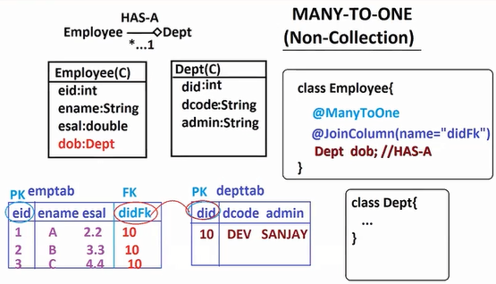

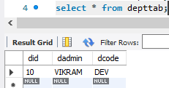 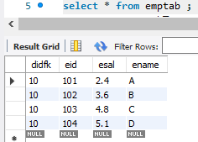

-- **Full code For ManyToOne**–

**Name:** com.SpringBootDataJpaManyToOneEx

**Dependencies:** Lombok, Data JPA, MySQL

1. **Model class**
2. **Dept class**

**package** com.SpringBootJDataJPA.model;

**import** jakarta.persistence.Column;

**import** jakarta.persistence.Entity;

**import** jakarta.persistence.Id;

**import** jakarta.persistence.Table;

**import** lombok.AllArgsConstructor;

**import** lombok.Data;

**import** lombok.NoArgsConstructor;

@Data

@NoArgsConstructor

@AllArgsConstructor

@Entity

@Table(name = "depttab")

**public** **class** Dept {

@Id

@Column(name = "did")

**private** Integer deptId;

@Column(name = "dcode")

**private** String deptCode;

@Column(name = "dadmin")

**private** String deptAdmin;

}

1. **Employee class**

**package** com.SpringBootJDataJPA.model;

**import** org.hibernate.annotations.ManyToAny;

**import** jakarta.persistence.Column;

**import** jakarta.persistence.Entity;

**import** jakarta.persistence.Id;

**import** jakarta.persistence.JoinColumn;

**import** jakarta.persistence.ManyToOne;

**import** jakarta.persistence.Table;

**import** lombok.AllArgsConstructor;

**import** lombok.Data;

**import** lombok.NoArgsConstructor;

@Data

@NoArgsConstructor

@AllArgsConstructor

@Entity

@Table(name = "emptab")

**public** **class** Employee {

@Id

@Column(name = "eid")

**private** Integer empId;

@Column(name = "ename")

**private** String empName;

@Column(name = "esal")

**private** Double empSal;

@ManyToOne

@JoinColumn(name = "didFK")

**private** Dept dob;

}

1. **Repository**
2. **DeptRepository**

**package** com.SpringBootJDataJPA.repo;

**import** org.springframework.data.jpa.repository.JpaRepository;

**import** com.SpringBootJDataJPA.model.Dept;

**public** **interface** DeptRepository **extends** JpaRepository<Dept, Integer> {

}

1. **EmployeeRepository**

package com.SpringBootJDataJPA.repo;

import org.springframework.data.jpa.repository.JpaRepository;

import com.SpringBootJDataJPA.model.Dept;

import com.SpringBootJDataJPA.model.Employee;

public interface EmployeeRepository extends JpaRepository<Employee, Integer> {

}

1. **application.properties**

#datasource

spring.datasource.driver-class-name=com.mysql.cj.jdbc.Driver

spring.datasource.url=jdbc:mysql://localhost:3306/bootapp

spring.datasource.username=root

spring.datasource.password=vine96

#JPA

spring.jpa.show-sql=true

spring.jpa.database-platform=org.hibernate.dialect.MySQLDialect

spring.jpa.hibernate.ddl-auto=create

1. **Runner class**

**package** com.SpringBootJDataJPA.runner;

**import** org.springframework.beans.factory.annotation.Autowired;

**import** org.springframework.boot.CommandLineRunner;

**import** org.springframework.stereotype.Component;

**import** com.SpringBootJDataJPA.model.Dept;

**import** com.SpringBootJDataJPA.model.Employee;

**import** com.SpringBootJDataJPA.repo.DeptRepository;

**import** com.SpringBootJDataJPA.repo.EmployeeRepository;

@Component

**public** **class** DataInsertRunner **implements** CommandLineRunner {

@Autowired

**private** DeptRepository drepo;

@Autowired

**private** EmployeeRepository erepo;

@Override

**public** **void** run(String... args) **throws** Exception {

Dept d1=**new** Dept(10, "DEV", "VIKRAM");

drepo.save(d1);

Employee e1=**new** Employee(101, "A", 2.4, d1);

Employee e2=**new** Employee(102, "B", 3.6, d1);

Employee e3=**new** Employee(103, "C", 4.8, d1);

Employee e4=**new** Employee(104, "D", 5.1, d1);

erepo.save(e1);

erepo.save(e2);

erepo.save(e3);

erepo.save(e4);

}

}

Q) When should we use @ElementCollection and @OneToMany / @ManyToMany?

A)

For Collection of Primitive Types

@ElementCollection

Set<String>

For Collection of ClassType.

@___ToMany

Set<Type>

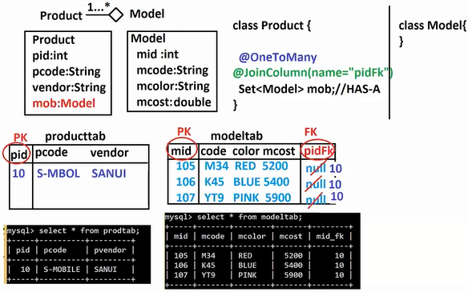

-- **Full Code For OneToMany** --

**Name:** SpringBootDataJpaOneToManyEx

**Dependencies:** Data JPA, MySQL, Lombok

**1. Model class**

**a. Model**

**package** com.SpringBootJDataJPA.model;

**import** jakarta.persistence.Column;

**import** jakarta.persistence.Entity;

**import** jakarta.persistence.Id;

**import** jakarta.persistence.Table;

**import** lombok.AllArgsConstructor;

**import** lombok.Data;

**import** lombok.NoArgsConstructor;

@Data

@NoArgsConstructor

@AllArgsConstructor

@Entity

@Table(name = "modeltab")

**public** **class** Model {

@Id

@Column(name = "mid")

**private** Integer modId;

@Column(name = "mcode")

**private** String modCode;

@Column(name = "mcolor")

**private** String modColor;

@Column(name = "mcost")

**private** Double modCost;

}

**b. Product class**

**package** com.SpringBootJDataJPA.model;

**import** java.util.Set;

**import** jakarta.persistence.Column;

**import** jakarta.persistence.Entity;

**import** jakarta.persistence.Id;

**import** jakarta.persistence.JoinColumn;

**import** jakarta.persistence.OneToMany;

**import** jakarta.persistence.Table;

**import** lombok.AllArgsConstructor;

**import** lombok.Data;

**import** lombok.NoArgsConstructor;

@Data

@NoArgsConstructor

@AllArgsConstructor

@Entity

@Table(name = "prodtab")

**public** **class** Product {

@Id

@Column(name = "pid")

**private** Integer prodId;

@Column(name = "pcode")

**private** String prodCode;

@Column(name = "pvendor")

**private** String Vendor;

@OneToMany

@JoinColumn(name = "midFK")

**private** Set<Model> mobs; //HAS-A

}

**2. Repository**

**a. Model Repository**

**package** com.SpringBootJDataJPA.repo;

**import** org.springframework.data.jpa.repository.JpaRepository;

**import** com.SpringBootJDataJPA.model.Model;

**public** **interface** ModelRepository **extends** JpaRepository<Model, Integer> {

}

**b. Product Repository**

package com.SpringBootJDataJPA.repo;

import org.springframework.data.jpa.repository.JpaRepository;

import com.SpringBootJDataJPA.model.Model;

import com.SpringBootJDataJPA.model.Product;

public interface ProductRepository extends JpaRepository<Product, Integer> {

}

**3. Runner class**

**package** com.SpringBootJDataJPA.runner;

**import** java.util.Set;

**import** org.springframework.beans.factory.annotation.Autowired;

**import** org.springframework.boot.CommandLineRunner;

**import** org.springframework.stereotype.Component;

**import** com.SpringBootJDataJPA.model.Model;

**import** com.SpringBootJDataJPA.model.Product;

**import** com.SpringBootJDataJPA.repo.ModelRepository;

**import** com.SpringBootJDataJPA.repo.ProductRepository;

@Component

**public** **class** TestDataInsertRunner **implements** CommandLineRunner {

@Autowired

**private** ModelRepository mrepo;

@Autowired

**private** ProductRepository prepo;

@Override

**public** **void** run(String... args) **throws** Exception {

Model m1=**new** Model(105, "M34", "RED", 5200.00);

Model m2=**new** Model(106, "K45", "BLUE", 5400.00);

Model m3=**new** Model(107, "YT9", "PINK", 5900.00);

mrepo.save(m1);

mrepo.save(m2);

mrepo.save(m3);

Product p1=**new** Product(10, "S-MOBILE", "SANUI", Set.*of*(m1, m2, m3));

prepo.save(p1);

}

}

**4. application.properties**

#datasource

spring.datasource.driver-class-name=com.mysql.cj.jdbc.Driver

spring.datasource.url=jdbc:mysql://localhost:3306/bootapp

spring.datasource.username=root

spring.datasource.password=vine96

#JPA

spring.jpa.show-sql=true

spring.jpa.database-platform=org.hibernate.dialect.MySQLDialect

spring.jpa.hibernate.ddl-auto=create

**Spring Data JPA : Many-To-Many Example**

**(Hibernate with JPA)**

* If both sides relation exist as 1…* the use *…*

**Ex:**  *…*

Student ----<> Course

i.e.., 1 Student can learn many courses, many student can learn on course.

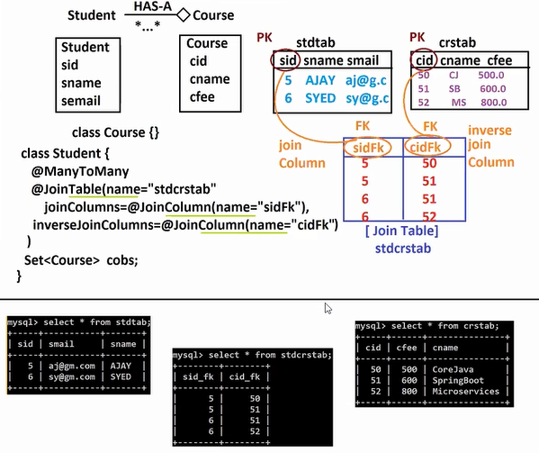

* **Note:**

1. For *…* relation one additional table is created i.e.., called as 3rd Table **@JoinTable**.
2. In this case two FK column are created.

1st one is called as “joinColumn”. i.e.., A FK column connected to Parent table PK column

2nd one is called as “inverseJoinColumn”. i.e.., A FK column connected to Child table PK column

**Q)** What is database key constraints? Explain then with rules and examples?

**A)**

-- **Full code Data JPA Many-To-Many** --

**Name:** SpringBootDatJpaManyToManyEx

**Dependencies:** Data JPA, MySQL, Lombok

1. **Models**
2. **Course class**

**package** com.SpringBootJDataJPA.model;

**import** jakarta.persistence.Column;

**import** jakarta.persistence.Entity;

**import** jakarta.persistence.Id;

**import** jakarta.persistence.Table;

**import** lombok.AllArgsConstructor;

**import** lombok.Data;

**import** lombok.NoArgsConstructor;

@Data

@NoArgsConstructor

@AllArgsConstructor

@Entity

@Table(name = "crstab")

**public** **class** Course {

@Id

@Column(name = "cid")

**private** Integer crsId;

@Column(name = "cname")

**private** String crsName;

@Column(name = "cfee")

**private** Double crsFee;

}

1. **Student class**

**package** com.SpringBootJDataJPA.model;

**import** java.util.Set;

**import** jakarta.persistence.Column;

**import** jakarta.persistence.Entity;

**import** jakarta.persistence.Id;

**import** jakarta.persistence.JoinColumn;

**import** jakarta.persistence.JoinTable;

**import** jakarta.persistence.ManyToMany;

**import** jakarta.persistence.Table;

**import** lombok.AllArgsConstructor;

**import** lombok.Data;

**import** lombok.NoArgsConstructor;

@Data

@NoArgsConstructor

@AllArgsConstructor

@Entity

@Table(name = "stdtab")

**public** **class** Student {

@Id

@Column(name = "sid")

**private** Integer stdId;

@Column(name = "sname")

**private** String stdName;

@Column(name = "smail")

**private** String stdEmail;

@ManyToMany

@JoinTable(

name = "stdcrstab",

joinColumns = @JoinColumn(name="sidFK"),

inverseJoinColumns = @JoinColumn(name="cidFK")

)

**private** Set<Course> cob; //HAS-A

}

1. **Repository**
2. **StudentRepository**

**package** com.SpringBootJDataJPA.repo;

**import** org.springframework.data.jpa.repository.JpaRepository;

**import** com.SpringBootJDataJPA.model.Student;

**public** **interface** StudentrRepository **extends** JpaRepository<Student, Integer> {

}

1. **CourseRepository**

**package** com.SpringBootJDataJPA.repo;

**import** org.springframework.data.jpa.repository.JpaRepository;

**import** com.SpringBootJDataJPA.model.Course;

**public** **interface** CourseRepository **extends** JpaRepository<Course, Integer> {

}

1. **Runner class**

**package** com.SpringBootJDataJPA.runner;

**import** java.util.Set;

**import** org.springframework.beans.factory.annotation.Autowired;

**import** org.springframework.boot.CommandLineRunner;

**import** org.springframework.stereotype.Component;

**import** com.SpringBootJDataJPA.model.Course;

**import** com.SpringBootJDataJPA.model.Student;

**import** com.SpringBootJDataJPA.repo.CourseRepository;

**import** com.SpringBootJDataJPA.repo.StudentrRepository;

@Component

**public** **class** DataInsertRunner **implements** CommandLineRunner {

@Autowired

**private** StudentrRepository srepo;

@Autowired

**private** CourseRepository crepo;

@Override

**public** **void** run(String... args) **throws** Exception {

Course c1=**new** Course(50, "Core Java", 500.00);

Course c2=**new** Course(51, "Spring Boot", 600.00);

Course c3=**new** Course(52, "Micro Services", 800.00);

crepo.save(c1);

crepo.save(c2);

crepo.save(c3);

Student s1=**new** Student(5, "AJAY", "ajay@gmail.com", Set.*of*(c1, c2));

Student s2=**new** Student(6, "SYED", "syed@gmail.com", Set.*of*(c2, c3));

srepo.save(s1);

srepo.save(s2);

}

}

1. **application.properties**

#datasource

spring.datasource.driver-class-name=com.mysql.cj.jdbc.Driver

spring.datasource.url=jdbc:mysql://localhost:3306/bootapp

spring.datasource.username=root

spring.datasource.password=vine96

#JPA

spring.jpa.show-sql=true

spring.jpa.database-platform=org.hibernate.dialect.MySQLDialect

spring.jpa.hibernate.ddl-auto=create

**Data JPA : One-To-One**

**1…1 = *(unique)…1**

Q) Why can’t we use directly OneToOne annotation?

A) @OneToOne is used only in bi-directional mapping. It will not create any FK column.

In the place of @OneToOne we can use @ManyToOne + @JoinColumn(unique=true). unique=true means do not accept duplicates, one PK value as one time FK value.

Q) Why can’t we use @OneToMany + @JoinColumn(unique=true) for OneToOne?

A) Yes, possible, we can use this also. But @ManyToOne + @JoinColumn(unique=true) only recomanded.

If we use OneToMany then variable is created as Collection. But Collection variable hold single value.

So, it is not recomanded.

Q) What is @ManyToAny in Hibernate(JPA) Explain with example?

A)

**FetchType**

* It is a enum, having 2 possible values.

EAGER: While fetching(selecting) parent data we can get child data

LAZY: While fetching(selecting) parent data we don’t get child data

call getChild() method for data.

**Cascading**

**BiDirectional**

**Consider:**

Employee --<> Profile

Employee e= repo.findById(1);

//EAGER Ex: Employee with Profile object

//LAZY Ex: Employee object only

Non-Collection Type Collection Type

EAGER is default LAZY is default

Trying to fetch employee data: (EAGAR LOADING/ EARLY LOADING)

It is fetching Employee data and its child data

select eid, edesg, ename, prid, prcode, prexp, prpack

from emptab e

left join

profiletab p

on p.prid=e.pidfk

where e.eid=?

Trying to fetch employee data: (LAZY LOADING/ LATE LOADING)

It is fetching Employee data not its child data

select eid, edesg, ename, pidfk

from emptab where eid=?

Ex: @ManyToOne(fetch = FetchType.***LAZY***)

Q) What is default fetch type for Many-To-Many

A) LAZY

* When child is Many -- default is LAZY
* When child is One -- default is EAGER

**Ex:**

@Entity

@Table(name= “prodtab”)

public class Product{

@OneToMany(cascade = CascadeType.ALL)

@JoinColumn(name = “midFK”)

private Set<Model> mobs; //HAS-A

}

* For Collections cascading is good approach.

@OneToMany(cascade = CascadeType.PERSIST) //Only for save

@OneToMany(cascade = CascadeType.REMOVE) //Only for delete

* There is no default value for cascading, if we do not write any cascade type.

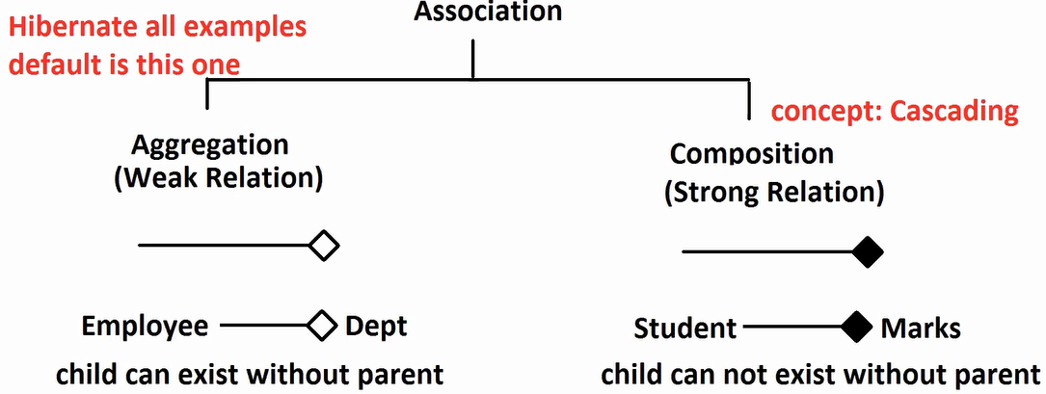

**Data JPA : JOINS (HQL/JPQL)**

**Joins:**  Fetch Data from multiple tables using Single Query

**Types of SQL Joins**

1. Equal Join
2. Self Join
3. Cross Join
4. Inner Join or Join (Word Inner is Optional)

Fetching only connected rows of two tables (using PK-FK)

1. Outer Join
   1. Left Outer Join or Left Join (word outer is optional)

Left side (Parent) table all rows and their connected right side(child) table rows

* 1. Right Outer Joing or Right Join

Right side (Parent) table all rows and their connected left side (Parent) table rows

* 1. Full Outer Join or Full Join

All rows from both tables with connected and non-connected.

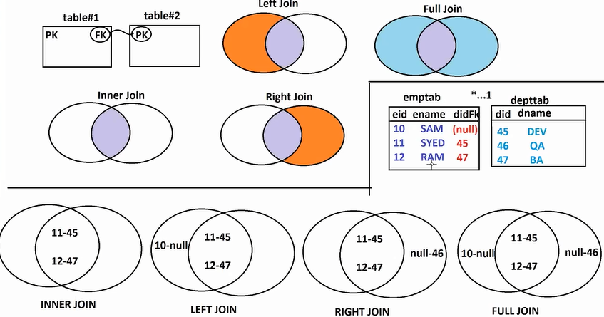

**SQL Joins Syntax:**

SELECT P.<columname>, C.<columnname>

FROM ParentTable P

[Join Type]

ChildTable P

ON P.PK = C.FK (or) P.FK = C.PK (any one)

WHERE [conditions]

**Ex1:**

Employe----<>Department

emptab deptab

eid ename didFK did dname

**1: Inner Join**

SELECT e.ename, d.dname

FROM emptab e

JOIN

depttab d

ON e.didFK = d.did

**2: Left Join**

SELECT e.ename, d.dname

FROM emptab e

LEFT JOIN

depttab d

ON e.didFK = d.did

-------

**Ex2:**

1…*

Product-----<>Model

prodtab modeltab

pid pname pcost mid mcode pidFK

SQL: Write inner join and display product name and model code

SELECT p.pname, m.mcode

FROM prodtab p

JOIN (or) INNER JOIN

modeltab m

ON p.pid=m.pidFK

**Ex3:**

1…*

Book-----<>Author

booktab authortab

bid bname bcost discount aid aname email bidFK

SQL: Print All books rows and their connected authors if exist [book name, cost and author name]

SELECT b.bname, b.cost, a.aname

FROM booktab b

LEFT JOIN (or) LEFT OUTER JOIN

authortab a

ON b.bid=a.bidFK

----------

**HQL/JPQL Syntax For Joins: (class and variable names)**

SELECT P.<variableName>, C.<variableName>

FROM ParentClass P

JOIN TYPE

P.HasAVariable AS C

WHERE [CONDITION];

**Ex1:** Employee---<>Department

empId deptId

empName deptName

empSal admiName

dob:Department

class Department{}

class Employee{

Department dob; //HAS-A (link of PK-FK)

}

SELECT e.empName, e.empSal, d.deptName

FROM Employee e

INNER JOIN

e.dob AS d

* We should not write ON clause in HQL/JPQL Joins, HAS-A Variable behaves like Link of PK-FK with ON.
* Finally HQL/JPQL Join is converted into SQL Joins by Dialect.

-- **Full Example Code** --

**1. Model classes**

**Employee class**

package com.SpringBootJDataJPA.model;

import org.hibernate.annotations.ManyToAny;

import jakarta.persistence.Column;

import jakarta.persistence.Entity;

import jakarta.persistence.Id;

import jakarta.persistence.JoinColumn;

import jakarta.persistence.ManyToOne;

import jakarta.persistence.Table;

import lombok.AllArgsConstructor;

import lombok.Data;

import lombok.NoArgsConstructor;

@Data

@NoArgsConstructor

@AllArgsConstructor

@Entity

@Table(name = "emptab")

public class Employee {

@Id

@Column(name = "eid")

private Integer empId;

@Column(name = "ename")

private String empName;

@Column(name = "esal")

private Double empSal;

@ManyToOne

@JoinColumn(name = "didFK")

private Dept dob;

}

**Deptment class**

package com.SpringBootJDataJPA.model;

import jakarta.persistence.Column;

import jakarta.persistence.Entity;

import jakarta.persistence.Id;

import jakarta.persistence.Table;

import lombok.AllArgsConstructor;

import lombok.Data;

import lombok.NoArgsConstructor;

@Data

@NoArgsConstructor

@AllArgsConstructor

@Entity

@Table(name = "depttab")

public class Dept {

@Id

@Column(name = "did")

private Integer deptId;

@Column(name = "dcode")

private String deptCode;

@Column(name = "dadmin")

private String deptAdmin;

}

**2. Repository**

package com.SpringBootJDataJPA.repo;

import java.util.List;

import org.springframework.data.jpa.repository.JpaRepository;

import org.springframework.data.jpa.repository.Query;

import com.SpringBootJDataJPA.model.Dept;

import com.SpringBootJDataJPA.model.Employee;

public interface EmployeeRepository extends JpaRepository<Employee, Integer> {

//INNER JOIN or JOIN

//@Query("SELECT e.empName ,d.deptCode FROM Employee e INNER JOIN e.dob AS d")

//LEFT OUTER JOIN or LEFT JOIN

//@Query("SELECT e.empName ,d.deptCode FROM Employee e LEFT JOIN e.dob AS d")

//List<Object[]> getEmpDeptInnerJoinData();

//INNER JOIN or JOIN WHERE CONDITION

//@Query("SELECT e.empName ,d.deptCode FROM Employee e INNER JOIN e.dob AS d WHERE e.empSal>=:esal")

//List<Object[]> getEmpDeptInnerJoinDataInput(Double esal);

//RIGHT OUTER JOIN or RIGHT JOIN

//@Query("SELECT e.empName ,d.deptCode FROM Employee e RIGHT JOIN e.dob AS d")

//List<Object[]> getEmpDeptRightJoinData();

//ONLY LEFT TABLE or ONLY RIGHT TABLE (Not connected data)

//@Query("SELECT e.empName ,d.deptCode FROM Employee e LEFT JOIN e.dob AS d WHERE d IS NULL")

//@Query("SELECT e.empName ,d.deptCode FROM Employee e RIGHT JOIN e.dob AS d WHERE d IS NULL")

@Query("SELECT e.empName ,d.deptCode FROM Employee e FULL OUTER JOIN e.dob AS d WHERE d IS NULL")

List<Object[]> getEmpDeptFullJoinData();

}

**3. DataInsertRunner**

package com.SpringBootJDataJPA.runner;

import org.springframework.beans.factory.annotation.Autowired;

import org.springframework.boot.CommandLineRunner;

import org.springframework.stereotype.Component;

import com.SpringBootJDataJPA.model.Dept;

import com.SpringBootJDataJPA.model.Employee;

import com.SpringBootJDataJPA.repo.DeptRepository;

import com.SpringBootJDataJPA.repo.EmployeeRepository;

@Component

public class DataInsertRunner implements CommandLineRunner {

@Autowired

private DeptRepository drepo;

@Autowired

private EmployeeRepository erepo;

@Override

public void run(String... args) throws Exception {

Dept d1=new Dept(10, "DEV", "VIKRAM");

Dept d2=new Dept(11, "QA", "BANTI");

Dept d3=new Dept(12, "BA", "VINEETH");

drepo.save(d1);

drepo.save(d2);

drepo.save(d3);

Employee e1=new Employee(101, "A", 2.4, null);

Employee e2=new Employee(102, "B", 3.6, d1);

Employee e3=new Employee(103, "C", 4.8, d3);

Employee e4=new Employee(104, "D", 5.1, d1);

erepo.save(e1);

erepo.save(e2);

erepo.save(e3);

erepo.save(e4);

}

}

**4. TestJoinsRunner**

**package** com.SpringBootJDataJPA.runner;

**import** java.util.Iterator;

**import** java.util.List;

**import** org.springframework.beans.factory.annotation.Autowired;

**import** org.springframework.boot.CommandLineRunner;

**import** org.springframework.stereotype.Component;

**import** com.SpringBootJDataJPA.repo.EmployeeRepository;

@Component

**public** **class** TestJoinsRunner **implements** CommandLineRunner {

@Autowired

**private** EmployeeRepository erepo;

@Override

**public** **void** run(String... args) **throws** Exception {

//List<Object[]> list=erepo.getEmpDeptInnerJoinData();

//List<Object[]> list=erepo.getEmpDeptInnerJoinDataInput(5.00);

//List<Object[]> list=erepo.getEmpDeptRightJoinData();

List<Object[]> list=erepo.getEmpDeptFullJoinData();

**for**(Object[] ob: list) {

System.***out***.println(ob[0] +"--"+ob[1]);

}

}

}

**5. application.properties**

#datasource

spring.datasource.driver-class-name=com.mysql.cj.jdbc.Driver

spring.datasource.url=jdbc:mysql://localhost:3306/bootapp

spring.datasource.username=root

spring.datasource.password=vine96

#JPA

spring.jpa.show-sql=true

spring.jpa.database-platform=org.hibernate.dialect.MySQLDialect

spring.jpa.hibernate.ddl-auto=update

**findBy Methods : Data JPA**

* **@**Query(“hql/jpql”) : By using this we can execute our custom query. Similer to this we have findBy methods.
* findBy methods are abstract methods, These are converted to SQL query at runtime No need of writing any query.

**abstractMethod(findBy____()) 🡺 SQL Query**

* It supports only SELECT operations.
* It supports even Projections.
* *** If we compare with JDBC concept they are PerparedStatements.
* We should follows some rules to write this findBy methods.

**Syntax:** (Define inside Repository Interface)

ReturnType findBy<VariablesAndConditions>(<DataType> <paramName>)

**Ex1:**

class Employee{

int empId;

String empName;

Double empSal;

}

#**1**

Method:

//findByVariableName(DataType paramName)

List<Employee> findByempName(String ename); //both are valid

List<Employee> findByEmpName(String ename); //recommanded

Generated SQL:

SELECT * FROM Employee WHERE empName=:ename

**#2**

Method:

//findByVariableName(DataType paramName)

List<Employee> findByempId(int eid);

Equal SQL(Generated):

SELECT * FROM Employee WHERE empId=:eid

#**3**

Method: List<Employee> findByEmpSal(Double esal);

Generated SQL: SELECT * FROM Employee WHERE empSal=:esal

#**4**

Method: List<Student> findByStdFee(Double sfee)

Generated SQL: SELECT * FROM STUDENT WHERE STDFEE=:sfee

Q) Find Student where names not having size 3 characters?

A) SELECT * FROM STDNAME WHERE SNAME NOT LIKE ‘___’;

One _(Underscoure) indicates on char.

-- **Full Code** --

**1. Model class**

**package** com.SpringBootJDataJPA.model;

**import** jakarta.persistence.Column;

**import** jakarta.persistence.Entity;

**import** jakarta.persistence.Id;

**import** jakarta.persistence.Table;

**import** lombok.AllArgsConstructor;

**import** lombok.Data;

**import** lombok.NoArgsConstructor;

@Data

@NoArgsConstructor

@AllArgsConstructor

@Entity

@Table(name = "stdtab")

**public** **class** Student {

@Id

@Column(name = "sid")

**private** Integer stdId;

@Column(name = "sname")

**private** String stdName;

@Column(name = "sfee")

**private** Double stdFee;

@Column(name = "scourse")

**private** String stdCourse;

}

**2. Repository**

**package** com.SpringBootJDataJPA.repo;

**import** java.util.List;

**import** org.springframework.data.jpa.repository.JpaRepository;

**import** com.SpringBootJDataJPA.model.Student;

**public** **interface** StudentRepository **extends** JpaRepository<Student, Integer> {

//SQL: select * from stdtab where scourse=:course

//findBy<VariableName>(DataType paramName)

//List<Student> findBystdCourse(String scourse);

//SQL: select * from stdtab where sfee=:fee

//List<Student> findBystdFee(Double sfee);

//SQL: select * from stdtab where stdId>=?

//findBy<VariableNameKeyword>(DataType paramName)

//List<Student> findByStdId(Integer sid);

List<Student> findByStdIdGreaterThanEqual(Integer sid);

}

**3. DataInsertRunner**

**package** com.SpringBootJDataJPA.runner;

**import** java.util.Arrays;

**import** org.springframework.beans.factory.annotation.Autowired;

**import** org.springframework.boot.CommandLineRunner;

**import** org.springframework.stereotype.Component;

**import** com.SpringBootJDataJPA.model.Student;

**import** com.SpringBootJDataJPA.repo.StudentRepository;

//@Component

**public** **class** StudentDataInsertRunner **implements** CommandLineRunner {

@Autowired

**private** StudentRepository srepo;

@Override

**public** **void** run(String... args) **throws** Exception {

srepo.saveAll(Arrays.*asList*(

**new** Student(10, "SHYAM", 300.00, "Core Java"),

**new** Student(11, "RAM", 300.00, "Core Java"),

**new** Student(12, "SYED", 450.00, "Advanced Java"),

**new** Student(13, "AJAY", 450.00, "Advanced Java"),

**new** Student(14, "JAI", 500.00, "Micro Service"),

**new** Student(15, "KUMAR", 600.00, "Boot"),

**new** Student(16, "SANJU", 500.00, "Spring")

));

srepo.findAll().forEach(System.***out***::println);

}

}

**4. Test Runner**

**package** com.SpringBootJDataJPA.runner;

**import** org.springframework.beans.factory.annotation.Autowired;

**import** org.springframework.boot.CommandLineRunner;

**import** org.springframework.stereotype.Component;

**import** com.SpringBootJDataJPA.repo.StudentRepository;

@Component

**public** **class** TestFindByRunner **implements** CommandLineRunner {

@Autowired

**private** StudentRepository srepo;

@Override

**public** **void** run(String... args) **throws** Exception {

//srepo.findBystdCourse("Core Java").forEach(System.out::println);

//srepo.findBystdFee(300.00).forEach(System.out::println);

//srepo.findByStdId(20).forEach(System.out::println);

srepo.findByStdIdGreaterThanEqual(10).forEach(System.***out***::println);

}

}

**5. application.properties**

#datasource

spring.datasource.driver-class-name=com.mysql.cj.jdbc.Driver

spring.datasource.url=jdbc:mysql://localhost:3306/bootapp

spring.datasource.username=root

spring.datasource.password=vine96

#JPA

spring.jpa.show-sql=true

spring.jpa.database-platform=org.hibernate.dialect.MySQLDialect

spring.jpa.hibernate.ddl-auto=update

**Data JPA : Hibernate Concepts**

* @Lob Annotation ( BLOB and CLOB – Oracle DB Datatypes)

**BLOB** – Binary Large OBject

Storing Images, Audio, Video, word docs, Excel files etc..,

**CLOB** – Character Large OBject

Stroing Large text data (varchar – limit 255 char)

* BLOB = byte[] + @Lob (JPA)
* CLOB = char[] + @Lob
* BLOB and CLOB are given by Oracle, if we goto any other DB names might be slight different.
* But annotation @Lob is given by JPA.

Q) How can we convert String to char[] ?

A) using string methods toCharArrray()

Q) How to convert byte[] to File? Hint:FOS

Q) How can we convert char[] to String? : hint String(char[])

-- **Code** --

**1.**

**Name:** SpringBootJpaLOBs

**Dpendencies:** MySQL, Lombok, Data JPA

**2. Model class**

package com.SpringBootJDataJPA.model;

import jakarta.persistence.Column;

import jakarta.persistence.Entity;

import jakarta.persistence.Id;

import jakarta.persistence.Lob;

import jakarta.persistence.Table;

import lombok.AllArgsConstructor;

import lombok.Data;

import lombok.NoArgsConstructor;

@Data

@AllArgsConstructor

@NoArgsConstructor

@Entity

@Table(name = "prodtab")

public class Product {

@Id

@Column(name = "pid")

private Integer prodId;

@Column(name = "pcode")

private String prodCode;

@Column(name = "pcost")

private Double prodCost;

@Lob // byte[] + @Lob = BLOB

@Column(name = "pimage")

private byte[] prodImg;

@Lob // char[] + @Lob = CLOB

@Column(name = "pnote")

private char[] prodDesc;

}

**3. Repository**

package com.SpringBootJDataJPA.repo;

import org.springframework.data.jpa.repository.JpaRepository;

import com.SpringBootJDataJPA.model.Product;

public interface ProductRepositroy extends JpaRepository<Product, Integer>{

}

**4. Runner class**

**package** com.SpringBootJDataJPA.runner;

**import** java.io.FileInputStream;

**import** org.springframework.beans.factory.annotation.Autowired;

**import** org.springframework.boot.CommandLineRunner;

**import** org.springframework.stereotype.Component;

**import** com.SpringBootJDataJPA.model.Product;

**import** com.SpringBootJDataJPA.repo.ProductRepositroy;

@Component

**public** **class** DataInsertRunner **implements** CommandLineRunner {

@Autowired

**private** ProductRepositroy repo;

@Override

**public** **void** run(String... args) **throws** Exception {

//Loading file data

FileInputStream fis=**new** FileInputStream("F:\\SpringBoot Videos\\Notes\\margot_robbie.jpg");

//create byte array with size equal to file size

**byte**[] prodImg=**new** **byte**[fis.available()];

//load file data into byte[]

fis.read(prodImg);

//create length string

String description="HELLO DUDE, welcome to all, sample data, Spring Boot and MS";

**char**[] prodDesc=description.toCharArray();

repo.save(**new** Product(101, "BOOK", 500.00, prodImg, prodDesc));

fis.close();

}

}

**5. application.properties**

#datasource

spring.datasource.driver-class-name=com.mysql.cj.jdbc.Driver

spring.datasource.url=jdbc:mysql://localhost:3306/bootapp

spring.datasource.username=root

spring.datasource.password=vine96

#JPA

spring.jpa.show-sql=true

spring.jpa.database-platform=org.hibernate.dialect.MySQL8Dialect

spring.jpa.hibernate.ddl-auto=create

* CLOB supports only text type data, BLOB supports only binary data

---

**Stored Procedures:-**

CODE BLOCKED DEFINED AND EXECUTED AT DATABASE WHICH CAN BE CALLED MULTIPLE TIMES.

* In simple, these are like methods in java. i.e., Method inside database.
* By using Hiberanate, we are calling procedure from our app.
* Not recommended in latest apps. Why?

1. Data migration becomes complex to manage Procedures.
2. Additional burden and network call data process over database.
3. All DBs may not support this concept (Ex: NoSQL DBs)

* Replace strored Procedure with java code (method at java)

-- **Mysql Syntax to create Stored Procedure** --

USE `bootapp`;

DROP procedure IF EXISTS `getAllEmps`;

DELIMITER $$

USE `bootapp`$$

CREATE PROCEDURE `getAllEmps` ()

BEGIN

END$$

DELIMITER ;

-------

DELIMITER $$

PL/SQL BLOCK

DELIMITER ;

**Example1: (Procedure with no IN/OUT Parameter)**

DELIMITER$$

CREATE PROCEDURE GETALLEMPS()

BEGIN

SELECT * FROM emptabs ;

END$

DELIMITER;

**Example2: (Procedure with IN Parameter)**

DELIMITER$$

CREATE PROCEDURE GETEMPBYDEPT(IN emp_dept VARCHAR(20))

BEGIN

SELECT * FROM emptabs e WHERE e.edept = emp_dept

END$

DELIMITER;

**Example3: (Procedure with IN and OUT Parameter)**

DELIMITER$$

CREATE PROCEDURE GETEMPBYDEPTCOUNT(IN emp_dept VARCHAR(20), OUT dept_count int)

BEGIN

SELECT count(*) INTO dept_count FROM emptabs e WHERE e.edept = emp_dept;

END$

DELIMITER;

* Hibernate converts our call to JDBC Callable Statement

Ex: {call GETALLEMPS()} and executes it.

-- **Code** --

**1. Model class**

package com.SpringBootJDataJPA.model;

import jakarta.persistence.Column;

import jakarta.persistence.Entity;

import jakarta.persistence.Id;

import jakarta.persistence.Table;

import lombok.AllArgsConstructor;

import lombok.Data;

import lombok.NoArgsConstructor;

@Data

@AllArgsConstructor

@NoArgsConstructor

@Entity

@Table(name = "emptabs")

public class Employee {

@Id

@Column(name = "eid")

private Integer empId;

@Column(name = "ename")

private String empName;

@Column(name = "esal")

private Double empSal;

@Column(name = "edesg")

private String empDesg;

@Column(name = "edept")

private String empDept;

}

**2. Repository**

package com.SpringBootJDataJPA.repo;

import org.springframework.data.jpa.repository.JpaRepository;

import com.SpringBootJDataJPA.model.Employee;

public interface EmployeeRepository extends JpaRepository<Employee, Integer> {

}

**3. Data Insert Runner**

package com.SpringBootJDataJPA.runner;

import java.util.Arrays;

import org.springframework.beans.factory.annotation.Autowired;

import org.springframework.boot.CommandLineRunner;

import org.springframework.stereotype.Component;

import com.SpringBootJDataJPA.model.Employee;

import com.SpringBootJDataJPA.repo.EmployeeRepository;

//@Component

public class EmployeeDataRunner implements CommandLineRunner {

@Autowired

private EmployeeRepository repo;

@Override

public void run(String... args) throws Exception {

repo.saveAll(Arrays.asList(

new Employee(10, "A", 2.2, "Lead", "DEV"),

new Employee(11, "B", 2.3, "MGR", "QA"),

new Employee(12, "C", 4.2, "Lead", "QA"),

new Employee(13, "D", 5.3, "MG", "DEV"),

new Employee(14, "E", 4.4, "SE", "DEV"),

new Employee(15, "F", 3.6, "SE", "DEV")

)

);

}

}

**4. Test Proc Runner**

package com.SpringBootJDataJPA.runner;

import java.util.List;

import org.springframework.beans.factory.annotation.Autowired;

import org.springframework.boot.CommandLineRunner;

import org.springframework.stereotype.Component;

import com.SpringBootJDataJPA.model.Employee;

import jakarta.persistence.EntityManager;

import jakarta.persistence.ParameterMode;

import jakarta.persistence.StoredProcedureQuery;

@Component

public class EmployeeStoredProcRunner implements CommandLineRunner {

@Autowired

private EntityManager em;

@Override

public void run(String... args) throws Exception {

/*

// Example 1

//1. create Query using proc-name and type for output

StoredProcedureQuery query=em.createStoredProcedureQuery("GETALLEMPS", Employee.class);

//2. execute / call query

List<Employee> emps=query.getResultList();

//3. Print data

emps.forEach(System.out::println);

*/

/*

// Example 2

// {call GETEMPBYDEPT(?)}

StoredProcedureQuery query=em.createStoredProcedureQuery("GETEMPBYDEPT", Employee.class);

// register parameter with name, data type, model(IN/OUT)

query.registerStoredProcedureParameter("emp_dept", String.class, ParameterMode.IN);

// pass input data

query.setParameter("emp_dept", "DEV");

List<Employee> emps=query.getResultList();

emps.forEach(System.out::println);

*/

// Example 3

//{call GETEMPBYDEPTCOUNT(?,?)}

StoredProcedureQuery query=em.createStoredProcedureQuery("GETEMPBYDEPTCOUNT", Employee.class);

// register parameter with name, data type, model(IN/OUT)

query.registerStoredProcedureParameter("emp_dept", String.class, ParameterMode.IN);

query.registerStoredProcedureParameter("dept_count", Integer.class, ParameterMode.OUT);

// pass input data

query.setParameter("emp_dept", "QA");

// execute (not list this time)

query.execute();

//read output

Integer count=(Integer)query.getOutputParameterValue("dept_count");

System.out.println(count);

}

}

**Spring Boot : Web MVC**

**Project = Layers (4)**

1. Persistance Layer (PL) => User Interface(UI) / Web Pages

HTML, CSS, JS, JSP, Thymeleaf… etc

1. Service Layer (SL) / Bussiness Layer (BL)

Calculations, Operations, Logics, Transcations… etc..,

1. Data Access Layer (DAL)

Database Operations (CURD)

1. Integration Layer (IL)

Webservices (link your app with other apps )

* Spring Boot Web MVC is used to design PL Layer only. It is used to develop web pages (mainly dynamic pages). i.e., Change of data in webpage occurs based on location, time, user.
* As per Java, to develop any dynamic webpage/ web app, must use servlets concept.
* Design pattern (Improve Performance) using MVC

M = Model (Data)

V = View (UI / Display)

C = Controller (Class/ Process request)

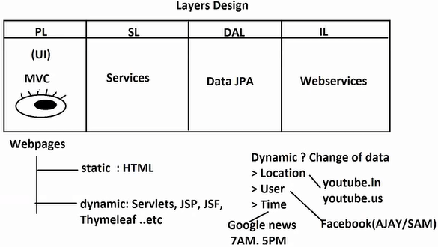

**Spring Boot WEB MVC Execution Flow**

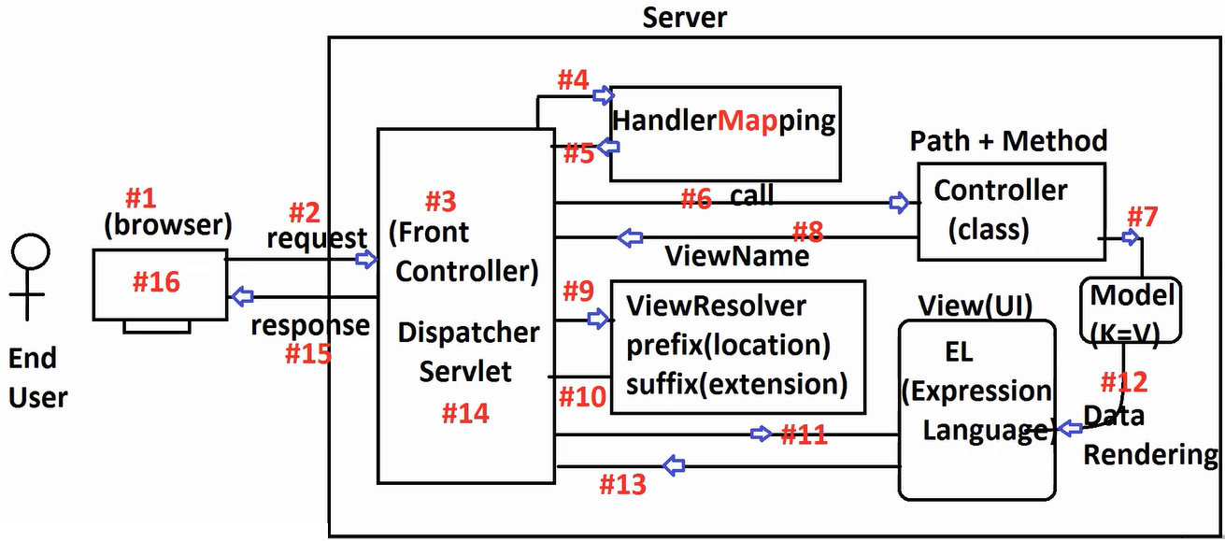

**1.** Client Machine is operated by Enduser which has one browser software.

**Ex:** YourLaptop, Mobile … etc..,

**2.** Browser makes request when user operates it.

**Q)** How many ways can browser makes request when user operates it.

**A)** 3 ways.

**a.** Enter URL in Addressbar [GET] (ex: <http://www.fackbook.com> )

**b.** Click on Links (HyperLink/<a>) [GET]

**c.** HTML Form Submit (Register Form, Comment Form, Login Form, Payment… etc..,) [GET*/POST]

**3.** Every request is received by FrontController which is a pre-defined servlet (named as : DispatcherServlet) given by Spring WEB MVC.

* In case of Spring Framework we should configure using web.xml, But Spring Boot comes with auto-configuration

<servlet>

<servlet-name>sample</servlet-name>

<servlet-class>org.springframework.web.servlet.DispatcherServlet</servlet-class>

</servlet>

<servlet-mapping>

<servlet-name>sample</servlet-name>

<url-pattern>/</url-pattern>

</servlet-mapping>

**4. HandlerMapping** is created by Spring Framework at runtime by using all details of our controller classes. It stores data as Map Format

Key (Path + HttpMethod) Value (Class # Method)

/emp/save + POST EmployeeController#save()

/prod/export + GET ProductController#export()

* For one MVC Project, there will be only one Front Controller (FC), HandlerMapper.

**5.** Fornt Controller (FC) gives path and Http methods details as input taken by Request and reads back Class and Method details(Controller)

**6.** Now, Fornt Controller (FC) will call/execute Controller method.

**7.** Contoller class contains request processing logics inside java methods linked with path and Http Methods (GET/POST)

* There will be multiple controller in a project, in general 1 - Module - 1 Controller

**Ex:** SearchController, CartController, PaymentController, InvoiceController, TrackController, ShippingController… etc..,

**Ex:**

@Controller

class PaymentController{

@PostMapping(“/pay”)

public String doPayment(){

//logics

}

}  
Fornt Controller (FC) calls like : paymentController.doPayment() for one request.

* Controller provide Model (Data) in key=val format which can shared with UI (view) to display finally.

**key value**

Message = “Payment SuccessFul”;

1. Controller class finally returns ViewName(String)

**Ex:** Home, Inbox, Search …et..,

* Controller returns Viewname without any extension (to be independent of UI technology). i.e., in future if we move from one UI technology to any other UI technology, controller code remains same.

**9.** Fornt Controller is taking help of **“ViewResolver”** to get full details of View Name.

**10.** ViewResolver gives viewPage details

ViewPage = prefix + viewName + suffix

/mypages/ Home .html

PageName = /mypage/Home.html is returned to ForntController (FC).

**11.** Now, ForntController(FC) will call that page (execute UI page)

**12.** UI Page reads data from Model(if exist) into page using EL (Expression Language) concept (Such process is called as data rendering).

**Ex:** Welcome to ${user}

**At Runtime:** Welcome to ‘SAM’

Model(user=SAM)

**13.** This page data is given back to ForntController (FC).

**14.** FrontController(FC) convert it into Response Format

**15.** Response is sent back to browser.

**16.** Browser will display output.

**Controller class**

Who is writing code ?? Programmer

Who is creating object ?? Spring Container

Who is calling method ?? FrontController,when request comes

* Spring Boot Provides 3 embedded Webservers. [no install/no download required].
  1. Apache Tomcat (default)
  2. JBoss Undertow
  3. Eclipse Jetty
* Even we can deploy on external server also.
* All objects (ViewResolver, HandlerMapping, Controller class, View … etc..,) are created inside Spring Container.
* FrontController(FC) read those objects from container.

**Q)** What is maven exclusions?

**A)**

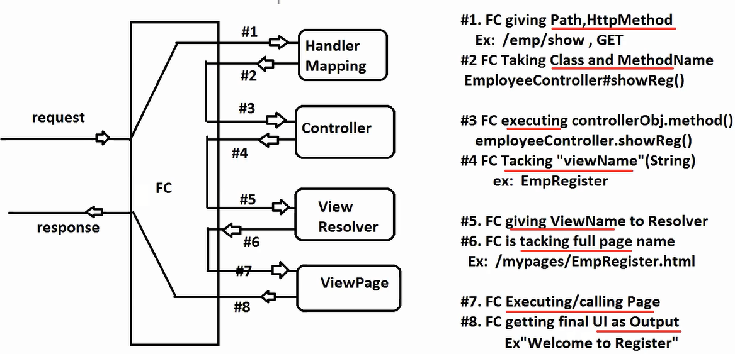

**1.** Sending data from controller to view Model Memory.

**2.** Sending Data from View (UI) to Controller HTML Form, Parameters

**1.** Sending data from controller to view Model Memory.

* Spring framework has provided Model(I).
* This is internally behaves like a Map (K-V).
* This memory is used to share data from Controller to UI (View).
* This memory is created/altered/removed by Spring Contianer only.
* You just take this as Controller #method param and call method : addAttribute(String key, Object val);
* By using this method we can send primitive data, Object data and Collection data too…

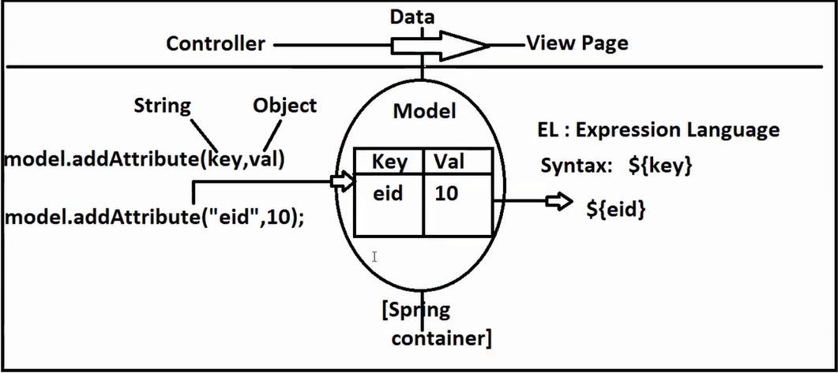

**Ex1:**

**Name:** SpringBootWebMVCModelEx

**Dependencies:** Spring web, lombok, tomcat-embedded-jasper

**1. Controller**

**package** com.SpringBootWebMVC.controller;

**import** org.springframework.stereotype.Controller;

**import** org.springframework.ui.Model;

**import** org.springframework.web.bind.annotation.GetMapping;

**import** org.springframework.web.bind.annotation.RequestMapping;

@Controller

@RequestMapping("/student")

**public** **class** StudentController {

@GetMapping("/show")

**public** String showData(Model model) {

System.***out***.println(model.getClass().getName());

model.addAttribute("stdId", 500);

model.addAttribute("stdName", "AJAY");

model.addAttribute("stdFee", 300.02);

**return** "StudentData";

}

}

**2. View :** StudentData.jsp

<!DOCTYPE.html>

<html>

<head>

<title>Student Data</title>

</head>

<body>

<h1>WELCOME TO STUDENT DATA PAGE</h1>

<h1>

Data is : ${stdId}, ${stdName}, ${stdFee}

</h1>

</body>

</html>

**3. application.properties**

server.port=9898

spring.mvc.view.prefix=/WEB-INF/pages/

spring.mvc.view.suffix=.jsp

**4.** Run App and enter URL:

<http://localhost:9898/student/show>

* **Note:** Here, Model(I) for this Spring container is creating object for its impl class i.e ‘BindingAwareModelMap(C)’. Once we read data at UI, it will delete it after response commited.

**Ex2: Object Data**

**Name:** SpringBootWebMVCModelEx

**Dependencies:** Spring web, lombok, tomcat-embedded-jasper

**1. Model**

**package** com.SpringBootWebMVC.model;

**import** lombok.Data;

@Data

**public** **class** Student {

**private** Integer stdId;

**private** String stdName;

**private** Double stdFee;

}

**2. Controller**

**package** com.SpringBootWebMVC.controller;

**import** org.springframework.stereotype.Controller;

**import** org.springframework.ui.Model;

**import** org.springframework.web.bind.annotation.GetMapping;

**import** org.springframework.web.bind.annotation.RequestMapping;

**import** com.SpringBootWebMVC.model.Student;

@Controller

@RequestMapping("/student")

**public** **class** StudentController {

@GetMapping("/show")

**public** String showData(Model model) {

System.***out***.println(model.getClass().getName());

/*

//--- primitive data---

model.addAttribute("stdId", 500);

model.addAttribute("stdName", "AJAY");

model.addAttribute("stdFee", 300.02);

*/

Student s=**new** Student();

s.setStdId(101);

s.setStdName("SAM");

s.setStdFee(8500.0);

// Key , val

model.addAttribute("sob", s);

**return** "StudentData";

}

}

**3. UI :** StudentData.jsp

<!DOCTYPE.html>

<html>

<head>

<title>Student Data</title>

</head>

<body>

<h1>WELCOME TO STUDENT DATA PAGE</h1>

<h1>

<%-- Data is : ${stdId}, ${stdName}, ${stdFee} --%>

Data is: ${sob} </br> ${sob.stdId}, ${sob.stdName}, ${sob.stdFee}

</h1>

</body>

</html>

* JSTL = JSP Standard Tag Library

To write java code at UI, some tags(pre-defined) are given by JSP, those are called as JSTL.

*** In Simple java code in TAGS format.Because UI is tag based

**Core java:**

for(Student s : list){

//print

}

**JSTL:**

<c:forEach items= “${list}” var= “s”>

//print

<c:forEach>

**Ex3: Collection Data**

**Name:** SpringBootWebMVCModelEx

**Dependencies:** Spring web, lombok, tomcat-embedded-jasper

**1. Controller**

package com.SpringBootWebMVC.controller;

import java.util.Arrays;

import java.util.List;

import org.springframework.stereotype.Controller;

import org.springframework.ui.Model;

import org.springframework.web.bind.annotation.GetMapping;

import org.springframework.web.bind.annotation.RequestMapping;

import com.SpringBootWebMVC.model.Student;

@Controller

@RequestMapping("/student")

public class StudentController {

@GetMapping("/show")

public String showData(Model model) {

System.out.println(model.getClass().getName());

/*

//--- primitive data---

model.addAttribute("stdId", 500);

model.addAttribute("stdName", "AJAY");

model.addAttribute("stdFee", 300.02);

*/

/*

//--- Object data---

Student s=new Student();

s.setStdId(101);

s.setStdName("SAM");

s.setStdFee(8500.0);

// Key , val

model.addAttribute("sob", s);

*/

List<Student> list=Arrays.asList(

new Student(101,"A", 200.00),

new Student(102,"B", 400.00),

new Student(103,"C", 800.00),

new Student(104,"D", 600.00)

);

//Key,

model.addAttribute("list", list);

return "StudentData";

}

}

**2. UI:** StudentData.jsp

<%-- <%@taglib prefix="c" uri="http://java.sun.com/jsp/jstl/core" %> --%>

<html>

<head>

<title>Student Data</title>

</head>

<body>

<h1>WELCOME TO STUDENT DATA PAGE</h1>

<%--

<h1>

<%-- Data is : ${stdId}, ${stdName}, ${stdFee} --%>

<%-- Data is: ${sob} </br> ${sob.stdId}, ${sob.stdName}, ${sob.stdFee} --%>

Data is: ${list}

</h1>

--%>

Data is: ${list}

<%--

<table border="1">

<tr>

<th>ID</th>

<th>NAME</th>

<th>FEE</th>

</tr>

<c:forEach items="${list}" var="ob">

<tr>

<td>${ob.stdId}</td>

<td>${ob.stdName}</td>

<td>${ob.stdFee}</td>

</tr>

</c:forEach>

</table>

--%>

</body>

</html>

**3. pom.xml**

<dependency>

<groupId>javax.servlet</groupId>

<artifactId>jstl</artifactId>

<version>1.2</version>

</dependency>

* **Note:** Do not forgot to add this line at JSP page

**Forms : Spring Boot WEB MVC**

1. **Input1:** create primitive/Wrapper type variable that holds single value.

Text, Radio, DropDown, TextArea

1. **Input2:** create a Collection variable that holds multiple values

Checkbox, Multi Select DropDown

* **HTML Form =>** Object (Model Attribute) **[**Spring Container**] =>** Controller (@ModelAttribute)

**1.** Spring Container is creating object in 4 steps

**a.** Creating object

**b.** Read Form Inputs

**c.** Parse Data If Required

**d.** set data to Object

**2.** Programming is following 4 steps

**a.** define a class with any name

**b.** Provide a default constructors

**c.** No.of Variables = No.of Form Inputs

**d.** Form Input name must match with variable name.

--- **Task** ---

* Define matching variables with datatypes in Model class

<!DOCTYPE html>

<html lang="en">

<head>

    <meta charset="UTF-8">

    <meta name="viewport" content="width=device-width, initial-scale=1.0">

    <title>Document</title>

</head>

<body>

    <pre>

    Color code      :   <input type="color" name=""/>

    Resume Upload   :   <input type="file" name=""/>

    Date            :   <input type="date" name=""/>

    Time            :   <input type="time" name=""/>

    Date & Time     :   <input type="datetime-local" name=""/>

    </pre>

</body>

</html>

-- **Code** --

**1. Model class**

**package** com.SpringBootWebMVC.model;

**import** java.util.List;

**import** java.util.Set;

**import** lombok.Data;

@Data

**public** **class** Employee {

**private** String empName;

**private** String empPassword;

**private** String empGender;

**private** String empProject;

**private** String empAddress;

**private** List<String> empLang;

**private** Set<String> empClient;

}

**2. Controller class**

**Ex: EmployeeController**

**package** com.SpringBootWebMVC.controller;

**import** org.springframework.stereotype.Controller;

**import** org.springframework.ui.Model;

**import** org.springframework.web.bind.annotation.GetMapping;

**import** org.springframework.web.bind.annotation.ModelAttribute;

**import** org.springframework.web.bind.annotation.PostMapping;

**import** com.SpringBootWebMVC.model.Employee;

@Controller

**public** **class** EmployeeController {

@GetMapping("/register")

**public** String showReg() {

**return** "EmployeeRegister";

}

@PostMapping("/save")

**public** String readForm(@ModelAttribute Employee employee, Model model) {

model.addAttribute("emp", employee);

**return** "EmployeeData";

}

}

**3. UI :** EmployeeRegister.jsp

<!DOCTYPE html>

<html>

<head>

    <title>Employee Register</title>

    <link rel='stylesheet' type='text/css' media='screen' href='main.css'>

    <script src='main.js'></script>

</head>

<body>

    <form action="save" method="POST">

        <pre>

            NAME        : <input type="text" name="empName"/>

            PASSWORD    : <input type="password" name="empPassword"/>

            GENDER      : <input type="radio" name="empGender" value="Male"> Male

                          <input type="radio" name="empGender" value="Female"> Female

            PROJCET     : <select name="empProject">

                            <option value="">-SELECT-</option>

                            <option value="HTC">HTC</option>

                            <option value="MNO">MNO</option>

                            <option value="XYZ">XYZ</option>

                          </select>

            ADDRESS     : <textarea name="empAddress"></textarea>

            LANGUAGE    : <input type="checkbox" name="empLang" value="ENGLISH"> ENGLISH

                          <input type="checkbox" name="empLang" value="HINDI"> HINDI

                          <input type="checkbox" name="empLang" value="TELUGU"> TELUGU

                          <input type="checkbox" name="empLang" value="TAMIL"> TAMIL

            CLIENTS     : <select name="empClient" multiple>

                            <option value="NIT">NIT</option>

                            <option value="ORACLE">ORACLE</option>

                            <option value="DELL">DELL</option>

                            <option value="HP">HP</option>

                          </select>

                            <input type="submit" value="Add Employee"/>

        </pre>

    </form>

</body>

</html>>

**4. UI:** EmployeeData

<!DOCTYPE html>

<html lang="en">

<head>

    <title>Employee Data</title>

</head>

<body>

    <h3>DATA is: ${emp}</h3>

</body>

</html>

**5. pom.xml**

<dependency>

<groupId>org.apache.tomcat.embed</groupId>

<artifactId>tomcat-embed-jasper</artifactId>

<!-- <version>10.1.13</version> -->

</dependency>

**In web MVC**

We need to define below syntax inside method parameter.

@RequestParam(“key”) DataType localVariable [mostly used]

(or)

@RequestParam DataType key

* This annotation supports data reading and parsing for given datatype.

**DevTool:**

* Used only in Developer Environment
* It avoid sever restart for small code changes.
* If we do code modifications and press ctrl+s then it will restart server with changes effected. [No need to start and stop manually]

<dependency>

<groupId>org.springframework.boot</groupId>

<artifactId>spring-boot-devtools</artifactId>

<scope>runtime</scope>

<optional>true</optional>

</dependency>

**optional:** true (default false) without this dependency application can work.

**scope:** runtime, while compiling app jar is not required only while starting/running application it is required.

**Q)** What is default HTTP port number?

**A)** 80. If we don’t enter any PORT number in URL, default is 80.

**Q)** What is default server port in Spring Boot?

**A)** 8080.

Tomcat, Undertow, Jetty … servers runs on port 8080.

**Note:**

1. Data is sent in key=val format using URL

URL?key=val&key=val&key=val

2. To Read data in Controller, follow syntax

@RequestParam(“key”)DataType localvariable.

3. It supports auto-parsing based on datatype used.

4. Keys(URL) are case-sensitive. emp and Emp are different.

5. Every Parameter by default required. i.e., must send data using URL, else 400-Bad Request is thrown by Front controller(FC) with sample message like: Required parameter 'ename' is not present.

URL: <http://localhost:80/emp/data>

Output:

MissingServletRequestParameterException:

Required request parameter 'ename' for method parameter type String is not present

1. We can convert required param is optional param by adding required=false attribute

@RequestParam(value = "key", required = **false**)DT localVar,

Ex: @RequestParam(value = "ename", required = **false**)String name,

* Now default value is null is taken if no data is sent.

1. We can modify default value for optional params.

**Syntax:**

@RequestParam(value= “key”, required =false, defaultValue= “<defaultValue>”)DataType localVar

1. In case of multiple parameters need not to follow order Data read is done based on key name matching.

Ex:

http:localhost:80/emp/data?eid=10&ename=SAM

http:localhost:80/emp/data?ename=SAM&eid=10

1. Optional + Primitive variables makes problem if no data is sent using URL.

(Internal Server Error, status=500).

URL: <http://localhost:80/emp/data>

Output:

Optional int parameter 'eid' is present but cannot be translated into a null value due to being declared as a primitive type.

Solution1: (Given by Programmer)

* Modify default value from null to any matching value.

@RequestParam(value = "eid",required = **false**, defaultValue = "-1")**int** id,

Output : -1

Solution2: (Given by Spring Web MVC)

* Convert Primitive type to equal wrapper class

@RequestParam(value = "eid",required = **false**, defaultValue = "-1")**Integer** id,

Output : null

1. Additional Params sent using URL will be ignored by FC [No Error and No Exception]

Ex: sending esal, edesg which are not present in code.

http:localhost:80/emp/data?ename=SAM&eid=10&esal=1000%&edesg=DEV

1. Same key is present multiple times with different value then FIRST combination is loaded, remaing are ignored.

URL: <http://localhost/emp/data?ename=SAM&eid=10&eid=11&eid=12>

Output:

eid=10

1. If TypeMismatch occurred then FrontController(FC) throws 400-Bad Request

URL: <http://localhost/emp/data?ename=SAM&eid=ABCD>

Output:

Bad Request, status=400.

Failed to convert value of type 'java.lang.String' to required type 'int';nested Exception is NumberFormatException: For input string: "ABCD"

-- **Code** --

**Name:** SpringBootWebMVC

**Dependencies:** Web, Lombok, DevTools, tomcat embedded jasper.

**1. Controller**

package com.SpringBootWebMVC.controller;

import org.springframework.stereotype.Controller;

import org.springframework.ui.Model;

import org.springframework.web.bind.annotation.GetMapping;

import org.springframework.web.bind.annotation.RequestMapping;

import org.springframework.web.bind.annotation.RequestParam;

@Controller

@RequestMapping("/emp")

public class EmployeeController {

//http//..../emp/data?eid=10&ename=A

@GetMapping("/data")

public String showData(

//@RequestParam("ename")String name,

//@RequestParam(value = "ename", required = false)String name,

@RequestParam(value = "ename", required = false, defaultValue = "NO DATA")String name,

//@RequestParam("eid")int id,

//@RequestParam(value = "eid",required = false)int id,

@RequestParam(value = "eid",required = false, defaultValue = "-1")int id,

Model model

)

{

System.out.println(name);

System.out.println(id);

model.addAttribute("eid", id);

model.addAttribute("ename", name);

return "EmpData";

}

}

**2. UI:** EmpData.jsp

<!DOCTYPE html>

<html lang="en">

<head>

<title>Document</title>

</head>

<body>

<h3>

Data page: ${eid}, ${ename}

</h3>

</body>

</html>

**3. application.properties**

#server.port=8080

server.port=80

spring.mvc.view.prefix=/WEB-INF/pages/

spring.mvc.view.suffix=.jsp

**Thymeleaf UI [** [**https://www.thymeleaf.org/**](https://www.thymeleaf.org/) **]**

* We are using JSP for Dynamic UI (Dynamic web pages creation) which is given by Sun Microsystems.
* JSP is servlet internally.

JSPER (JSP Engine) converts JSP file into one Servlet file (.java) then Compile and use Catalina (Serlet Engine) to execute.

* JSP Execution need more memory: So many objects created for simple processing also. Example request object, response object, config object, context object … etc..,

**\*\*\*** JSP is Heavy weight UI Technology (More memory)

**Q)** Why it is Heavy Weight UI Technology?

**A)** Even Normal HTML code (static code) also converted into Servlet/Java code.

<h1>Hello</h> => out.println(“<h1>Hello</h1>”);

Ex: Page 90% static Data, 10% dynamic JSP Tags

* 100% servlets code (Pure java code)
* Thymleaf UI is Server side (Similar to JSP) Java based UI technology used to create dynamic web pages.
* It will convert and execute only Dynamic content. Static contains remains same,no conversion and execution.So,it works faster, takes less memory compared to JSP.

Thymeleaf UI is called as light weight and faster Dynamic UI.

* Thymeleaf UI is a 3rd party (not from Sun/Oracle or from Spring Pivotal Team). But it can be integrated with Spring Boot.

<dependency>

<groupId>org.springframework.boot</groupId>

<artifactId>spring-boot-starter-thymeleaf</artifactId>

</dependency>

* By default prefix and suffix also given by Spring Boot AutoConfiguration as

prefix = classpath:/templates

suffix = .html

* You can find default values inside ‘ThymeleafProperties’ (C) [ctrl + shift + T]

**Folder Structure:**

Project

**|**

**|**--src/main/resources (classpath)

**|**--static (css, js, images.. etc)

**|**--templates (Thymeleaf Files)

**|**--Home.html

* When we use thymeleaf then no need of adding Tomcat Embeded JASPER (used only for JSP).

Q) What is xmlns or Namespace Server?

(Content Distribution Network (CDN) in UI Technology – Namespace in BackEndApp )

-- **Coding Steps** --

**a.**

**Name:** SpringBootThymeleafFirstEx

**Dependencies:** Spring web, thymeleaf, DevTools

**b. application.properties**

server.port=9090

1. **Controller class**

**package** com.SpringBootWebMVC.controller;

**import** org.springframework.stereotype.Controller;

**import** org.springframework.ui.Model;

**import** org.springframework.web.bind.annotation.GetMapping;

**import** org.springframework.web.bind.annotation.RequestMapping;

@Controller

@RequestMapping("/product")

**public** **class** ProductController {

@GetMapping("/home")

**public** String showData(Model model) {

model.addAttribute("title", "VINEETH-IT-HYD");

**return** "ProductData";

}

}

1. **Create UI page**

* Right click on src/main/resource folder
* New > others > Search using HTML > select HTML file >

next > Enter name > ProductData.html > Finish

-- **ProductData.html** --

<!DOCTYPE html>

<html xmlns:th=*"https://www.thymeleaf.org/"*>

<head>

<meta charset=*"ISO-8859-1"*>

<title>Product Data</title>

</head>

<body>

<h1>WELCOME TO PRODUCT PAGE!!</h1>

<div th:text=*"${title}"*></div>

</body>

</html>

1. Run Application and Enter URL

[**http://localhost:9090/product/home**](http://localhost:9090/product/home)

**Symbols used in Thymeleaf**

**$** --- Reading Data from Model Memory (Controller 🡪 UI)

**\*** --- Only used for Form Inputs (variable --- Form Input)

**@** --- used for URL/Links

Syntax to Read data from Model memory is : ${key}

To print data use th:text= “___” It will print data on webpage (compare out.println() in servlets)

Here, ‘th’ is a prefix used to identify HTML and Thymeleaf tags. So, only Thymeleaf tags are converted into java code and output placed at Web page.

* We should use prefix ‘**th**’ only. We cannot use any other.

**Maven Exclusions**

**Step1: Adding External CSS,JS, Image File to HTML**

Folder

Project

|--src/main/resources

**|**-static

**|**-js

**| |**-test.js

**|**-css

**|**-myapp.css

* Must place CSS, JS and Images Files under static folder only

**In HTML file**

1. To link **CSS** file

<link rel=*"stylesheet"* th:href=*"@{/css/myapp.css}"*>

1. To link **JS** file

<script type=*"text/javascript"* th:src=*"@{/js/test.js}"*></script>

1. To link One **Image**

<img th:src=*"@{/images/margot_robbie.jpg}"* width=*"500"* height=*"500"*>

* ‘static’ floder name must be same. Other sub folder and File names can be any name.
* If we do not add rel= “stylesheet” then <link> Links like normal Text file.
* DO NOT FORGET TO ADD PREFIX **th** :
* Creating one HyperLink:

**<**a th:href= “@{/path/path/path}”> Link </a>

**Ex:**

<a th:href=*"@{/msg}"*>VIEW MSG PAGE</a>

<a th:href=*"@{/employee/delete}"*>GOTO DELETE </a>

th:text= “” it is used to print given expression executed value

* You can use this with any tag

**Ex:** th:text= “${emp.id}” =>10

${key} => It is EL (Expression Language) This is used to read data from model memory.

th:each= “obj:${list}” equal java code is for(Employee ob : list) { }

* This is called as forEach Loop
* equal java code is for(Employee ob : list) { }

-- **Full Code** --

**Name:** SpringBootThymeleafExTwo

**Dependencies:** Spring web, Thymeleaf, Lombok, DevTools

**1. Controller**

**package** com.SpringBootWebMVC.controller;

**import** java.util.Arrays;

**import** java.util.List;

**import** org.springframework.stereotype.Controller;

**import** org.springframework.ui.Model;

**import** org.springframework.web.bind.annotation.GetMapping;

**import** org.springframework.web.bind.annotation.RequestMapping;

**import** com.SpringBootWebMVC.model.Employee;

@Controller

//@RequestMapping()

**public** **class** EmployeeController {

@GetMapping("/data")

**public** String showData() {

**return** "EmpData";

}

@GetMapping("/msg")

**public** String showmsg(Model model) {

Employee e=**new** Employee(102, "VIKRAM", 5500.00);

model.addAttribute("title", "VINEETH - IT");

model.addAttribute("eob", e); //new Employee(101, "AJAY", 2500.00));

List<Employee> emps=Arrays.*asList*(

**new** Employee(103, "JAY", 1500.00),

**new** Employee(104, "SYED", 2500.00),

**new** Employee(105, "VINAY", 3500.00)

);

model.addAttribute("list", emps);

**return** "EmpMessage";

}

}

**2. UI**

-- **EmpData.html** --

<!DOCTYPE html>

<html xmlns:th=*"https://www.thymeleaf.org/"*>

<head>

<meta charset=*"ISO-8859-1"*>

<title>Employee data</title>

<script type=*"text/javascript"* th:src=*"@{/js/test.js}"*>

</script>

<link rel=*"stylesheet"* th:href=*"@{/css/appone.css}"*>

</head>

<body>

<h2 class=*"myd1"*>Welcome to data page</h2>

<img th:src=*"@{/images/margot_robbie.jpg}"* width=*"500"* height=*"500"*>

</br>

<a th:href=*"@{/msg}"*>VIEW MSG PAGE</a>

</body>

</html>

-- **EmpMessage.html** –

<!DOCTYPE html>

<html xmlns:th=*"https://www.thymeleaf.org/"*>

<head>

<meta charset=*"ISO-8859-1"*>

<title>EmpMessage</title>

</head>

<body>

<h3>From Message Page!</h3>

<h2 th:text=*"${title}"*></h2>

Id: <span th:text=*"${eob.empId}"*></span>

Name: <span th:text=*"${eob.empName}"*></span>

Salary: <span th:text=*"${eob.empSal}"*></span>

</br></br>

<table border=*"1"*>

<tr>

<th>ID</th>

<th>NAME</th>

<th>SAL</th>

</tr>

<!-- for(Employee ob:list) -->

<tr th:each=*"ob:${list}"*>

<td th:text=*"${ob.empId}"*></td>

<td th:text=*"${ob.empName}"*></td>

<td th:text=*"${ob.empSal}"*></td>

</tr>

</table>

</body>

</html>

**3. Model class**

**package** com.SpringBootWebMVC.model;

**import** lombok.AllArgsConstructor;

**import** lombok.Data;

**import** lombok.NoArgsConstructor;

@Data

@AllArgsConstructor

@NoArgsConstructor

**public** **class** Employee {

**private** Integer empId;

**private** String empName;

**private** Double empSal;

}

**4. Other files**

-- **appone.css** –

*.myd1*{

color: *blue*;

}

-- **test.js** –

alert("Hello Data");

**Run App and Enter URL**

<http://localhost:9090/data>

<http://localhost:9090/msg>

**Thymeleaf FORM**

**HTML Form:**

* On Click Form Submit, Form Data is converted to Object Format.
* But Object data can not be converted back into FORM.

Why Object -> Form ? Edit Operation.

* i.e., HTML FORM are Uni-Directional Forms.

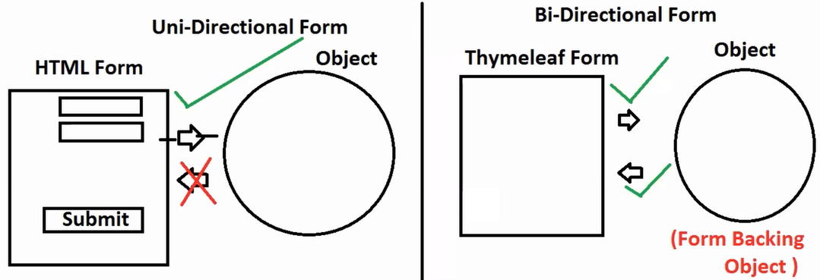

**Thymeleaf FORM:**

* It is also called as Dynamic, Bi-Directional Form. It means we can load Object Data into Form Inputs TODO Edit Operation.
* It supports even dynamic inputs. Like Dynamic DropDown,Checkboxes etc..,

Cascading Drop Down: <https://github.com/javabyraghu/SpringBoot2CascadeDropDownEx>

1. This time object creation code should be given by Programmer using Controller and Model Memory.

Why model? To Send : Controller to UI(FORM)

2. Bind Form input with field (variable in model class)

<select th:field= “* {variableName}”> </select>

<textarea th:field= “* {variableName}”> </textarea>

<input type= “” th:field = “* {variableName}” />

3. Bind Object with Form

<form th: action = “@{fullPath}” method = “POST”

th: object = “ $ {objectNameSentFromController}”>

</form>

* To create Dynamic Compoents at Form:

Step1: create Map data/Get Data from DB using query

Map<String, String> data=Map.*of*(

"1","QA",

"2","BA",

"3","DEV",

"4","PROD"

);

Step2: send data to UI using Model memory

model.addAttribute("map", data);

Step3: Define Form input and bind with model class variable.

<select th:field=*"*{empDept}"*>

</select>

Step4: use forEach (th:each) and display value and text value from Map.key and text for Map.value

<option th:each=*"ob:${map}"* th:value=*"${ob.key}"* th:text=*"${ob.value}"*>

</option>

-- **Full Code** --

**Name:** SpringBootThymeleafFormEx

**Dependenices:** Web, lombok, devtools, Thymeleaf

**1. Model calss**

**package** com.SpringBootWebMVC.model;

**import** java.util.List;

**import** lombok.Data;

@Data

**public** **class** Employee {

**private** Integer empId;

**private** String empName;

**private** String empGen;

**private** String empDept;

**private** List<String> empLangs;

}

**2. Controller**

package com.SpringBootWebMVC.controller;

import java.util.Arrays;

import java.util.Map;

import org.springframework.stereotype.Controller;

import org.springframework.ui.Model;

import org.springframework.web.bind.annotation.GetMapping;

import org.springframework.web.bind.annotation.RequestMapping;

import com.SpringBootWebMVC.model.Employee;

@Controller

@RequestMapping("/employee")

public class EmployeeController {

//1. show Edit Form with Data

@GetMapping("/edit")

public String showEdit(Model model) {

Employee e=new Employee();

e.setEmpId(7);

e.setEmpName("MS DHONI");

e.setEmpGen("Male");

//e.setEmpDept("DEV");

e.setEmpDept("1");

e.setEmpLangs(Arrays.asList("ENG","TEL"));

model.addAttribute("employee", e);

//dynamic dropdown data (Consider we got from DB)

Map<String, String> data=Map.of(

"1","QA",

"2","BA",

"3","DEV",

"4","PROD"

);

model.addAttribute("map", data);

Map<String, String> langs=Map.of(

"ENG","ENGLISH",

"TEL","TELUGU",

"HIN","HINDI",

"TAM","TAMIL"

);

model.addAttribute("langs", langs);

return "EmployeeEdit";

}

//2. Read Form data back to controller on submit

}

**3. UI: EmployeeEdit.html**

<!DOCTYPE html>

<html xmlns:th=*"https://www.thymeleaf.org/"*>

<head>

<meta charset=*"ISO-8859-1"*>

<title>Employee Edit Form</title>

</head>

<body>

<h3>Employee Edit Form</h3>

<form th:action=*"@{/employee/update}"* method=*"POST"* th:object=*"${employee}"*>

<pre>

Employee Id: <input type=*"text"* th:field=*"*{empId}"*/>

Employee Name: <input type=*"text"* th:field=*"*{empName}"*/>

Employee Gender:

<input type=*"radio"* th:field=*"*{empGen}"* value=*"Male"*/> Male

<input type=*"radio"* th:field=*"*{empGen}"* value=*"Female"*/> Female

Employee Department:

<select th:field=*"*{empDept}"*>

<option value=*""*>--SELECT--</option>

<option th:each=*"ob:${map}"*

th:value=*"${ob.key}"*

th:text=*"${ob.value}"*>

<!-- th:label="${ob.value}"> -->

</option>

</select>

Employee Languages:

<input type=*"checkbox"* th:field=*"${empLangs}"* th:each=*"ob:${langs}"* th:value=*"${ob.key}"* th:text=*"${ob.value}"*>

<input type=*"submit"* value=*"Update Employee"*/>

</pre>

</form>

</body>

</html>

**4. Run application and enter URL:**

[**http://localhost:9090/employee/edit**](http://localhost:9090/employee/edit)

**Spring Boot : Mini Project (CurdApp)**

**Concepts:**

Web MVC

Data JPA

Thymeleaf

MySQL Database

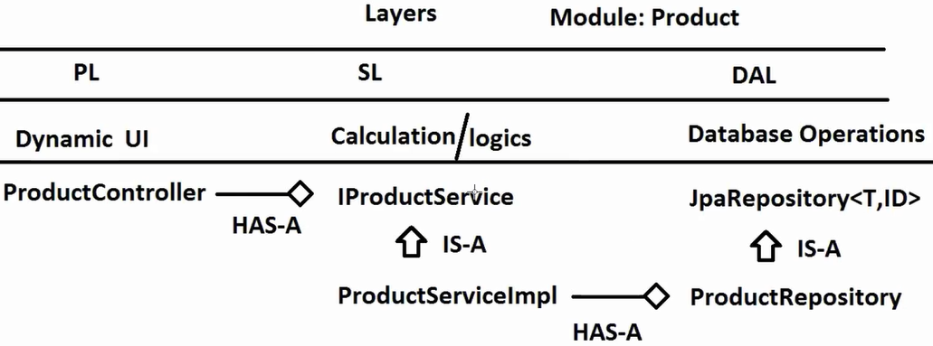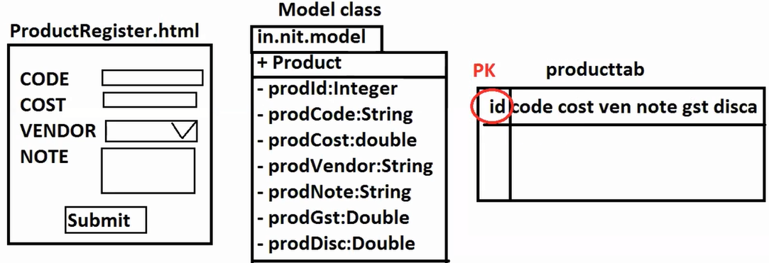

**Name:** SpringBootWebMVCMySQLCURD

**Dependencies:** Web, Devtools, Lombok, MySQL, Data Jpa, Thymeleaf

**1. Properties**

#server

server.port=8686

#Datasource

spring.datasource.driver-class-name=com.mysql.cj.jdbc.Driver

spring.datasource.url=jdbc:mysql://localhost:3306/bootapp

spring.datasource.username=root

spring.datasource.password=vine96

#JPA Properties

spring.jpa.show-sql=true

spring.jpa.hibernate.ddl-auto=create

spring.jpa.database-platform=org.hibernate.dialect.MySQLDialect

**2. Model class**

**package** com.SpringBootWebMVC.model;

**import** jakarta.persistence.Column;

**import** jakarta.persistence.Entity;

**import** jakarta.persistence.GeneratedValue;

**import** jakarta.persistence.Id;

**import** jakarta.persistence.Table;

**import** lombok.AllArgsConstructor;

**import** lombok.Data;

**import** lombok.NoArgsConstructor;

@Data

@AllArgsConstructor

@NoArgsConstructor

@Entity

@Table(name = "prodtab")

**public** **class** Product {

@Id

@Column(name = "pid")

@GeneratedValue

**private** Integer prodId;

@Column(name = "pcode")

**private** String prodCode;

@Column(name = "pcost")

**private** Double prodCost;

@Column(name = "pven")

**private** String prodVen;

@Column(name = "pnote")

**private** String prodNote;

@Column(name = "pgst")

**private** String prodGst;

@Column(name = "pdisc")

**private** Double prodDisc;

}

**3. Repository interface**

**package** com.SpringBootWebMVC.repository;

**import** org.springframework.data.jpa.repository.JpaRepository;

**import** com.SpringBootWebMVC.model.Product;

**public** **interface** ProductRepository **extends** JpaRepository<Product, Integer> {

}

**4. Service interface**

**package** com.SpringBootWebMVC.service;

**import** java.util.List;

**import** java.util.Optional;

**import** com.SpringBootWebMVC.model.Product;

**public** **interface** IProductService {

Integer saveProduct(Product p);

**void** updateProduct(Product p);

**void** deleteProduct(Integer id);

Optional<Product> getOneProduct(Integer id);

List<Product> getAllProduct();

}

**5. Service impl**

package com.SpringBootWebMVC.service.impl;

import java.util.List;

import java.util.Optional;

import org.springframework.beans.factory.annotation.Autowired;

import org.springframework.stereotype.Service;

import com.SpringBootWebMVC.model.Product;

import com.SpringBootWebMVC.repository.ProductRepository;

import com.SpringBootWebMVC.service.IProductService;

@Service //calc + opr/Tr Management

public class ProductServiceImpl implements IProductService {

@Autowired

private ProductRepository repo;

@Override

public Integer saveProduct(Product p) {

p=repo.save(p);

return p.getProdId();

}

@Override

public void updateProduct(Product p) {

//is exist then update

repo.save(p);

}

@Override

public void deleteProduct(Integer id) {

repo.deleteById(id);

}

@Override

public Optional<Product> getOneProduct(Integer id) {

Optional<Product> opt= repo.findById(id);

return opt;

}

@Override

public List<Product> getAllProduct() {

List<Product> list=repo.findAll();

return list;

}

}

**6. Controller**

**package** com.SpringBootWebMVC.controller;

**import** org.springframework.beans.factory.annotation.Autowired;

**import** org.springframework.stereotype.Controller;

**import** org.springframework.ui.Model;

**import** org.springframework.web.bind.annotation.GetMapping;

**import** org.springframework.web.bind.annotation.ModelAttribute;

**import** org.springframework.web.bind.annotation.PostMapping;

**import** org.springframework.web.bind.annotation.RequestMapping;

**import** com.SpringBootWebMVC.model.Product;

**import** com.SpringBootWebMVC.service.IProductService;

@Controller

@RequestMapping("/product")

**public** **class** ProductController {

@Autowired

**private** IProductService service; //HAS-A

//1. show Register Page

@GetMapping("/register")

**public** String showReg() {

**return** "ProductRegister";

}

//2. save on click submit

@PostMapping("/save")

**public** String saveProduct(@ModelAttribute Product product, Model model) {

Integer id=service.saveProduct(product);

String msg="Product Created with id: "+id;

model.addAttribute("message", msg);

**return** "ProductRegister";

}

//3. display all products

//4. delete product by id

//5. show Edit Page with data

//6. on click update modify in db

}

**7. UI Pages**

**Register.html**

<!DOCTYPE html>

<html xmlns:th=*"https://www.thymeleaf.org/"*>

<head>

<meta charset=*"ISO-8859-1"*>

<title>Insert title here</title>

</head>

<body>

<h3>Product Register Page</h3>

<form th:action=*"@{/product/save}"* method=*"POST"*>

<pre>

CODE : <input type=*"text"* name=*"prodCode"*/>

COST : <input type=*"text"* name=*"prodCost"*/>

VENDOR : <select name=*"prodVen"*>

<option value=*""*>-SELECT-</option>

<option value=*"NIT"*>NIT</option>

<option value=*"TEST"*>TEST</option>

<option value=*"ORACLE"*>ORACLE</option>

</select>

NOTE : <textarea name=*"prodNote"*></textarea>

<input type=*"submit"* value=*"Create"*/>

</select>

</pre>

</form>

<span th:text=*"${message}"*></span>

</body>

</html>

**Data.html**

**Edit.html**

**AGILE (THEORY)**

**PO :** Product Owner

**EPIC :** FULL DOCUMNET OF PROJECT CREATED BY BA.

**EPIC => SMALL PARTS => STORIES**

**STORY :** IT INDICATES WORK TO BE DONE IN PROJECT

**Ex:** USER REGISTER AND LOGIN

USER SEARCH ITEMS

ADD ITEMS TO CART

PAYMENT MODULES

…ETC

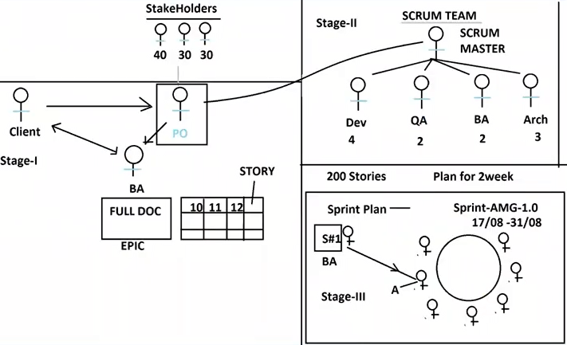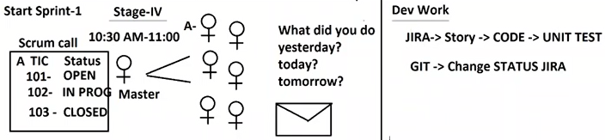

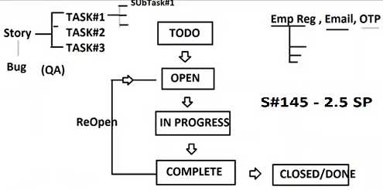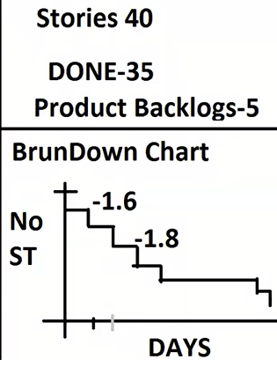

* Story Contains what?

Ticket Id - Ex: AMG-8569

Title - USER SEARCH ITEMS

Acceptance Criteria - What are need to be implemented in Step by Step

Description

Documents, Videos etc.,

* **SCRUM TEAM :** Group of people who need for Project Development.
* **Sprint Planning (**Mile Stone Planning**) :** For a Period of time what should be done.
* **Efforts Estimation (**Time taken to Develop given Story**)**

**Ex:** 1 day = 8Hrs = 1 SP (Story Point)

* 1. days = 2.5 SP.
* Total – 200 Stories

40 are planned in – Sprint 1

160 – Backlogs (Product Backlogs) [Yet to be planned]

**Eclipse Debugging**

**Bug:** It is a problem in application

**Debug:** Identify bug in application.

* Code is executed step by step (Block by block / Method by Method)